
554 Old Spanish Trail
Slidell, LA 70458
Phone: 985-649-5832
dammonengineering.com
info@dammonengineering.com

August 18, 2021

Don McMath
McMath Construction
1125 Causeway Blvd.
Mandeville, LA 70471

Re: Helenbirg Drive Apartments

Mr. McMath,

Thank you for considering Dammon Engineering. We are pleased to propose our services for the subject project in Covington La.

Our understanding is that there will be 5 different apartment layouts with a total of 250 units in the apartment complex.

Our proposed scope of services will include Structural Wood Framing, Mechanical, Electrical & Plumbing for these 250 units.

We propose a fee as follows:
- Structural Wood Framing $12,500.00
- Electrical $12,500.00
- Mechanical $12,500.00
- Plumbing $12,500.00

If selected, we will bill 100% of the total after the plans have been provided to your office.

Fees above do not include the cost of designs for the sales office nor any other building(s) that are not an apartment. Our fee does not include the cost of designing sprinkler or fire alarm systems, soils analysis, survey, drainage studies, wetlands determination, or other engineering studies that may be required by government agencies nor does it include the cost of plan review or permits by the municipality. These items, if provided by Dammon Engineering, will be billed at a "cost plus" fee.

We look forward to working with you on this project. Please indicate your acceptance of the above fee by signing below. If you have any questions, or require any further information, please feel free to call.

Sincerely,

If you have any questions, please contact me.

Thank You,

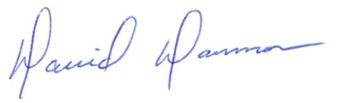
David Dammon __________________________________
President Don McMath

