
554 Old Spanish Trail
Slidell, LA 70458
Phone: 985-649-5832
Fax: 985-641-5950
www.dammonengineering.com
info@dammonengineering.com

February 6, 2020

Don McMath
McMath Construction
1125 N Causeway Blvd,
Mandeville, LA 70471

RE: MEP’s for St. Joachim Church in Marrero

Thank You for considering Dammon Engineering to design the Mechanical, Electrical and Plumbing system(s) for subject project.

We propose a fee of $1,500.00 for the design of the Mechanical system, $2,000.00 for the design of the electrical systems and $1,500.00 for the design of the plumbing system for the subject project. These fees do not include site visits which will be billed at our standard hourly rate if requested.

We look forward to working with you on this project. Please indicated your acceptance of the above by signing below. If you have any questions, or require any further information please feel free to contact us.

Thank You,

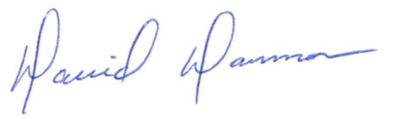
David Dammon
President
Dammon Engineering, Inc.
(985) 649-5832

Accepted: ___________________________ Date: ___________________
Don McMath

