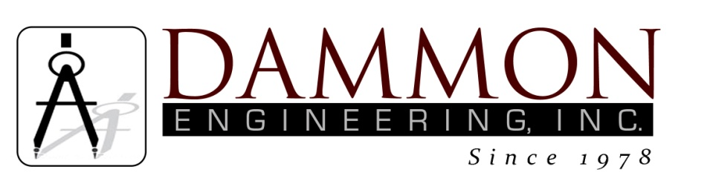
554 Old Spanish Trail
Slidell, LA 70458
Phone: 985-649-5832
www.dammonengineering.com
info@dammonengineering.com

BRIDGE CITY CENTER FOR YOUTH
SEWER SYSTEM RENOVATION
BRIDGE CITY, LOUISIANA
State Project #’s: 08-403-11-01, PART 01 &
08-403-04B-01, PART 20 & 01-107-06B-11, Part U7
Engineer’s Project: 2156
Construction Meeting Minutes

November 28, 2017
10:45 a.m.

Attendees:
David Dammon, Dammon Engineering, Inc
Curtis Badon, OJJ Central Office
Sterling White, BCCY Maintenance
A.J. Bouchon, ARC Mechanical

Minutes:
- The follow issues were discussed during the meeting:

- Work has been stopped on the lateral for Bldg K, until a change order has been issued for the conflicts between the building and the manhole.
- ARC Mechanical is currently working on the service lateral for Mechanical/Laundry Bldg. The piping near the main entrance has been completed. The Storm Water catch basin has been removed at the corner of the walkways. The concrete walkways have not been re-poured and the soil in the yard has not been leveled as of this visit. The piping for the Mechanical Rm, behind the Director’s Residence, also has been completed. During the excavation, behind the Director’s Residence, additional laterals were discovered. The crew found that the lateral continues past the restroom in the Mechanical Rm. An additional clean-out has been installed to allow servicing of the remaining service lateral segment.
- The crew will start on the last segment of piping at the dining hall to complete the sewer piping project.

Note: A final meeting will be scheduled for the end of project.

