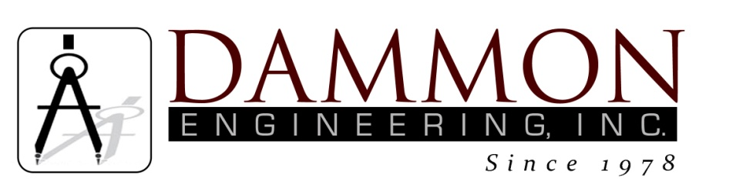
554 Old Spanish Trail
Slidell, LA 70458
Phone: 985-649-5832
www.dammonengineering.com
info@dammonengineering.com

BRIDGE CITY CENTER FOR YOUTH
SEWER SYSTEM RENOVATION
BRIDGE CITY, LOUISIANA
State Project #’s: 08-403-11-01, PART 01 &
08-403-04B-01, PART 20 & 01-107-06B-11, Part U7
Engineer’s Project: 2156
Pre-Construction Meeting Minutes

May 30, 2017
10:30 a.m.

Attendees:
David Dammon, Dammon Engineering, Inc
Creighton Stout, FP&C
Curtis Badon, OJJ Central Office
Sterling White, BCCY Maintenance
Tim Marlowe, ARC Mechanical

Minutes:
- Meeting opened with sign in of attendees.
- The follow issues were discussed during the meeting:

- Original signed copies of Change Order #1 were submitted to FPC.
- The water level of the Mississippi River is still above the level for the contractor to resume digging. The estimate from the US Army Corps of Engineers is sometime after the beginning of July before the water level on the Mississippi River will drop to a safe level.
- Building K on the site has had a water leak from under the building. This water leak will preclude the contractor from performing the tasks needed to complete this portion of work until the water leak has been resolved.
- Manhole #12 has been identified on the contract documents to have a 5 ft x 6 ft concrete pad installed with bollards around the manhole. The installation of a new security fence inside the exterior perimeter has caused an issue with the installing bollards around the manhole. A change order will be requested to lower the manhole frame and install a concrete pad that is capable of being driven over with a delivery vehicle.
- Scheduled construction meetings will be held monthly on the last Tuesday of the each month at 10:30 am; the next monthly meeting is scheduled for June 30, 2017.

