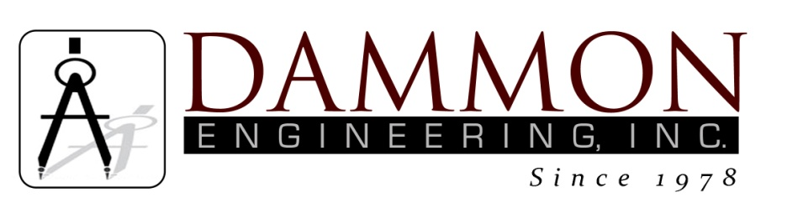
554 Old Spanish Trail
Slidell, LA 70458
Phone: 985-649-5832
www.dammonengineering.com
info@dammonengineering.com

BRIDGE CITY CENTER FOR YOUTH
SEWER SYSTEM RENOVATION
BRIDGE CITY, LOUISIANA
State Project #’s: 08-403-11-01, PART 01 &
08-403-04B-01, PART 20 & 01-107-06B-11, Part U7
Engineer’s Project: 2156
Construction Meeting Minutes

July 31, 2018
10:30 a.m.

Attendees:
David Dammon, Dammon Engineering, Inc
Creighton Stout, FP&C
Curtis Badon, OJJ Central Office
Nick Zinni, BCCY Deputy Director
Reginald Robinson, BCCY
Sterling White, BCCY Maintenance
Tim Marlowe, ARC Mechanical

Minutes:
- This is the final monthly meeting; substantial completion has been achieved. The follow remaining items were discussed during the meeting:

- The project included “Turf and Grass” to manage erosion; however, erosion has not been a concern for this project. BCCY Maintenance requested that equal amounts of sand and aggregate be provided to replace the Turf and Grass. Arrangements will be made between BCCY Maintenance, the engineer and contractor to deliver the sand and aggregate.
- Punchlist items were provided and are attached to these meeting minutes. The contractor has 45 days to complete the punchlist items.

