December 16,2016

REQUEST FOR WRITTEN QUOTES

The City of Slidell is soliciting written quotes for the project entitled “Possum Hollow Basketball Court”. The project is located at 801 Cousin Street, Slidell La. Quotes will be received until ????10:00 am Friday, June 28, 2013 and shall be hand delivered to the Purchasing Department located at 1329 Bayou Lane or mailed to P.O. Box 828, Slidell, LA. 70459, Attn: Purchasing Agent.

Quotes must be submitted in a sealed envelope and clearly marked:

Quote: Possum Hollow Park Basketball Court
Quote #?????13-Q016
File Number 5000-32

Due: ?????June 28, 2013, 10:00 AM CST

Drawings are attached.

For the successful quote exceeding $25,000, the contractor will be required to provide a payment and performance bond in the amount of not less than 100% of the awarded contract amount.

*Quotes exceeding $50,000 – A Louisiana State Contractor License is required to perform the work and your license number shall be included in your quote. The Contractor shall hold a Louisiana Contractor’s license in Building Construction or Municipal and Public Works Construction.

An executed affidavit will be required prior to award of contract. Certificate of Liability Insurance (listing the City of Slidell as “additionally insured) and Statutory Limits Worker’s Compensation must be submitted prior to award of contract.

Contractor shall have 45calendar days to complete this project from the date of Notice to Proceed. The contractor will be charged liquidated damages of One Hundred Fifty Dollars ($150.00) per calendar day in excess of the stated time of completion.

Quote submissions: Quotes shall be submitted on the forms provided and signed by an authorized company representative.

Any questions concerning this project shall be directed to Blaine Clancy, City Engineer, at
(985) 646-4270.

QUOTE FORM for Possum Hollow Basketball Court

City of Slidell, LA
Job No: 5000-32 Quote # ???13-Q016

ITEM NO. | ITEM DESCRIPTION | QUAN. | UNIT | UNIT  PRICE | EXTENSION
A-1 | Mobilization | 1 | L.S.
A-2 | Muck out (12” minimum) and store materials | 20 | N.C.Y.
A-3 | Muck out (12” minimum) and dispose of materials | 220 | N.C.Y
A-4 | Structural Fill (12” minimum) | 240 | N.C.Y
A-5 | Six inch thick post tension foundation | 523 | S.Y
A-6 | Install two City owned basketball goals | 2 | L.S.
A-7 | Paint basketball court striping on concrete | 1 | L.S.
A-8 | Construct six foot chain link fence with (3) three (3) three foot wide personnel gates and (1) one (6) six foot wide double gate. | 368 | L.F.
A-9 | Install seed | 3274 | S.F.
NOTE: The above quantities are approximate and will be adjusted to fit the budget.

TOTAL QUOTE PRICE IN FIGURES OF BASKETBALL COURT

TOTAL QUOTE PRICE IN WORDS OF BASKETBALL COURT

N/A

TOTAL QUOTE PRICE IN FIGURES OF ALTERNATE

N/A
TOTAL QUOTE PRICE IN WORDS OF ALTERNATE

*LA. LICENSE NUMBER SIGNATURE

COMPANY NAME SIGNER’S NAME (PRINTED)

Possum hollow basketball court

City of Slidell, LA

Quote # 13-Q016
Slidell File No. 5000-32
SPECIFICATIONS
This project consists of a new post tension concrete basket ball court; Excavate earth to a minimum of 12 inches and replace it with a minimum of 12 inches of compacted fill, a 50’x 94’post tension concrete court, the grade for the finished foundation shall be 6” higher than natural grade and sloped 6’out to 1 on 12 pitch, the City Of Slidell Recreation Department shall furnish the basketball goals for the contractor to install, the court shall be striped as noted on the drawings and enclosed with a 6’ high chain link fence having 3ea three foot gates and 1ea double gate, the perimeter shall be seeded. A description of pay items, including measurement and payment is given below:

Mobilization
This work consists of preparatory work and operations, including those necessary for movement of personnel, equipment, supplies, and incidental to the project site; the establishment of facilities necessary for the work on the project; the costs of bonds and any required insurance; and other preconstruction expenses necessary for start of the work, excluding the cost of construction materials. In addition the contractor shall provide and install in place as directed by the Engineer, two project signs as per details included in this section.
The Contractor shall provide all necessary materials and equipment necessary to complete all work associated with this item as shown on the plans or as directed by the Engineer.
Measurement and Payment for the items of work in this section will be under:
Item No. Pay Item Pay Unit
1 Mobilization Lump Sum

General Excavation
The contractor shall furnish all materials, labor, and equipment necessary to remove all earth, rock, water, debris, tree stumps and other materials to the extent required by the Engineer in preparation for the concrete foundation base. Excavation will be paid per cubic yard by net section. Some topsoil shall be retained to slope the finished grade as per plans. Disposal of excavated material shall be included in this pay item. Responsibility for disposal of all excavated material to satisfy all local, state, and federal regulation rests with the Contractor.
Do not commence site clearing operations until temporary erosion- and sedimentation-control measures are in place. Verify that flows of water redirected from construction areas or generated by construction activity do not enter or cross protection zones
Protect existing site improvements to remain from damage during construction.

Page 1 of 8

Remove any sod and grass before stripping topsoil. Strip topsoil to a depth of 6 inches in a manner to prevent intermingling with underlying subsoil or other waste materials. Stockpile topsoil away from edge of excavations without intermixing with subsoil. Grade and shape stockpiles to drain surface water. Cover to prevent windblown dust and erosion by water.
Excavate to indicated elevations and dimensions within a tolerance of plus or minus 1 inch. Do not disturb bottom of excavation. Excavate by hand to final grade just before placing concrete reinforcement. Trim bottoms to required lines and grades to leave solid base to receive other work.

Structural Fill
Specifications for backfill shall be sandy clays or clayey sands.
Structural fill material shall conform to the following requirements:
Liquid limit (maximum) 40% (percent)
Plasticity index (max) 18% (percent)
Structural fill shall be placed in maximum lifts of six (6) inches of loose material and shall be compacted to 95% of the maximum dry density determined by ASTM D 698, standard proctor. If water must be added, it should be uniformly applied and thoroughly mixed into the soil by disking or scarifying. In-place density measurements should be taken to assure that the above degree of compaction is achieved. The compacted structural fill should extend five (5) feet beyond the perimeter of the building prior to sloping. Adequate drainage should be provided prior to and during site work. The site should be graded to promote rapid runoff.
Structural fill material will be paid for per cubic yard by net section. The bid price shall include all costs for material, labor, equipment, hauling, placing, spreading, compacting and grading for this item. Granular fill shall be uniformly compacted to at least 95% modified proctor of maximum dry weight density.

Post Tension Concrete Foundation

Submittals
- Product Data: For each type of product indicated.
- Concrete Design Mixture.
- Steel Reinforcement Shop Drawings: Placing drawings that detail fabrication, bending, and placement.
- Tendon Shop Drawings: Detailing tendon layout and installation procedures.
Design, construct, erect, brace and maintain formwork and formwork accessories according to ACI 301.
Concrete design mix shall be in accordance with the A.C.I. building code requirements. The firm shall be experienced in manufacturing ready-mixed concrete products and they shall comply with ASTM C 94 requirements for production facilities and equipment.

Use the same type, brand and source of concrete cementitious material throughout the entire project.

Page 2 of 8
- The minimum compressive strength of concrete shall be as indicated on drawings.
- Concrete shall have a slump limit of 5 inches.
- Portland cement shall meet ASTM C 150.
- Aggregates shall meet ASTM C 33.
- Limit water to 30 gallons per cubic yard.
- Type A Water Reducer shall meet ASTM C 494.
- Air entrainment 5% by volume, use per manufacturers specifications.
- Provide a light broom finish over the entire slab.
Ready-Mixed Concrete: Measure, batch, and mix concrete materials and concrete according to
ASTM C 94 and ASTM C 1116. Furnish batch ticket certificates for each batch discharged and used in the work.

All reinforcing bars shall meet the requirements of ASTM A 615, Grade 60, deformed.
Installer shall comply with ACI 318 requirements unless more stringent requirements are indicated on drawings. Consolidate concrete with mechanical vibrating equipment.
Post-tension system shall be manufactured by a Fabricating plant certified by PTI according to procedures set forth in PTI’s "Manual for Certification of Plants Producing Unbonded Single Strand Tendons”.
Post-tension system shall be furnished, placed, and stressed by a firm specializing in post-tension systems. Post-tension supplier shall be PTI certified. Post-Tension contractor supervisor and 50% of the installation personnel must be certified as having completed the PTI Level 1 – Field Fundamentals Program. Also, all personnel involved in the stressing operation must be certified as having completed the PTI Level 1 – Field Fundamentals Program.

Deliver, store, and handle post-tensioning materials according to PTI's "Field Procedures Manual for Unbonded Single Strand Tendons."
Comply with ACI 423.6, "Specification for Unbonded Single Strand Tendons," unless otherwise indicated in these Contract Documents. All prestressing steel shall consist of seven-wire low-relaxation, 0.5 inch diameter strand conforming to ASTM A-416. Minimum ultimate tensile strength shall be 270,000 p.s.i.. Strands shall be coated with a permanent rust preventive lubricant and a plastic sheath. The plastic sheathing shall have a minim thickness of 0.05 inches for polyethylene or polypropylene with a minimum density of 0.034 lb/cubic inch. The plastic sheathing shall be continuous over the length of tendon to provide a watertight encapsulation of the strand and between the anchorages to prevent intrusion of cement paste.

Court Paint
Apply paint with mechanical equipment to produce pavement markings of dimensions indicated with uniform, straight edges. Apply at manufactures recommended rates.
Apply line paint after final surfacing coat is thoroughly dried. Lines must be 2” in width.
Painting materials shall not be applied when temperatures are below 50 degrees Fahrenheit or if temperatures are above 130 degrees Fahrenheit. Do not apply material if slab is wet or if rain is apparent. Do not store materials in direct sunlight. Do not allow material to freeze. Keep containers sealed until use.

Page 3 of 8
Chain Link Fences & Gates

Provide the following submittals.
- Product Data: For each type of product indicated..
- Shop Drawings: Include plans, elevations, sections, details, and attachments to other work.

Provide Manufacturer's standard Warranty form in which Installer agrees to repair or replace components of chain-link fences and gates that fail in materials or workmanship within five (5) years from date of Substantial Completion.

Provide chain-link fence fabric in one-piece with heights measured between top and bottom of outer edge of selvage knuckle or twist. Comply with CLFMI Product Manual.

Fence framing posts and rails shall comply with ASTM F 1043 for framing, including rails, braces, and line; terminal; and corner posts. Provide members with minimum dimensions and wall thickness according to ASTM F 1043 and as indicated on drawings.

Swing gates shall comply with ASTM F 900 for gate posts and single or double swing gate types. Gate hinges shall operate with 360-degree inward and outward swing. Latches shall operate from either side of gate with a provision for padlocking.

Do not begin installation before final grading is completed.

Stake the locations of fence lines, gates, and terminal posts. Do not exceed intervals of 250 feet or line of sight between stakes. Indicate locations of utilities, lawn sprinkler system, underground structures, benchmarks, and property monuments.

Install chain-link fencing to comply with ASTM F 567 and any more stringent requirements indicated on drawings.

Install gates according to manufacturer's written instructions, level, plumb, and secure for full opening without interference. Attach fabric as for fencing. Attach hardware using tamper-resistant or concealed means. Install ground-set items in concrete for anchorage. Adjust hardware for smooth operation and lubricate where necessary.
Adjust gates to operate smoothly, easily, and quietly, free of binding, warp, excessive deflection, distortion, nonalignment, misplacement, disruption, or malfunction, throughout entire operational range. Confirm that latches and locks engage accurately and securely without forcing or binding.

Turf and Grasses

Contractor shall provide grass seed that is fresh, clean, dry, new crop seed. The quality shall be State-certified seed of Rye and Bermuda Mix.

Page 4 of 8
Provide a slow-release fertilizer that is granular or pelleted which consist of 50% water-insoluble nitrogen, phosphorus, and potassium in the following composition: 20 percent nitrogen, 10 percent phosphorous, and 10 percent potassium, by weight.
Sow seed with spreader or seeding machine. Do not broadcast or drop seed when wind velocity exceeds 5 mph.

END OF SPECIFICATION SECTION

Page 5 of 8

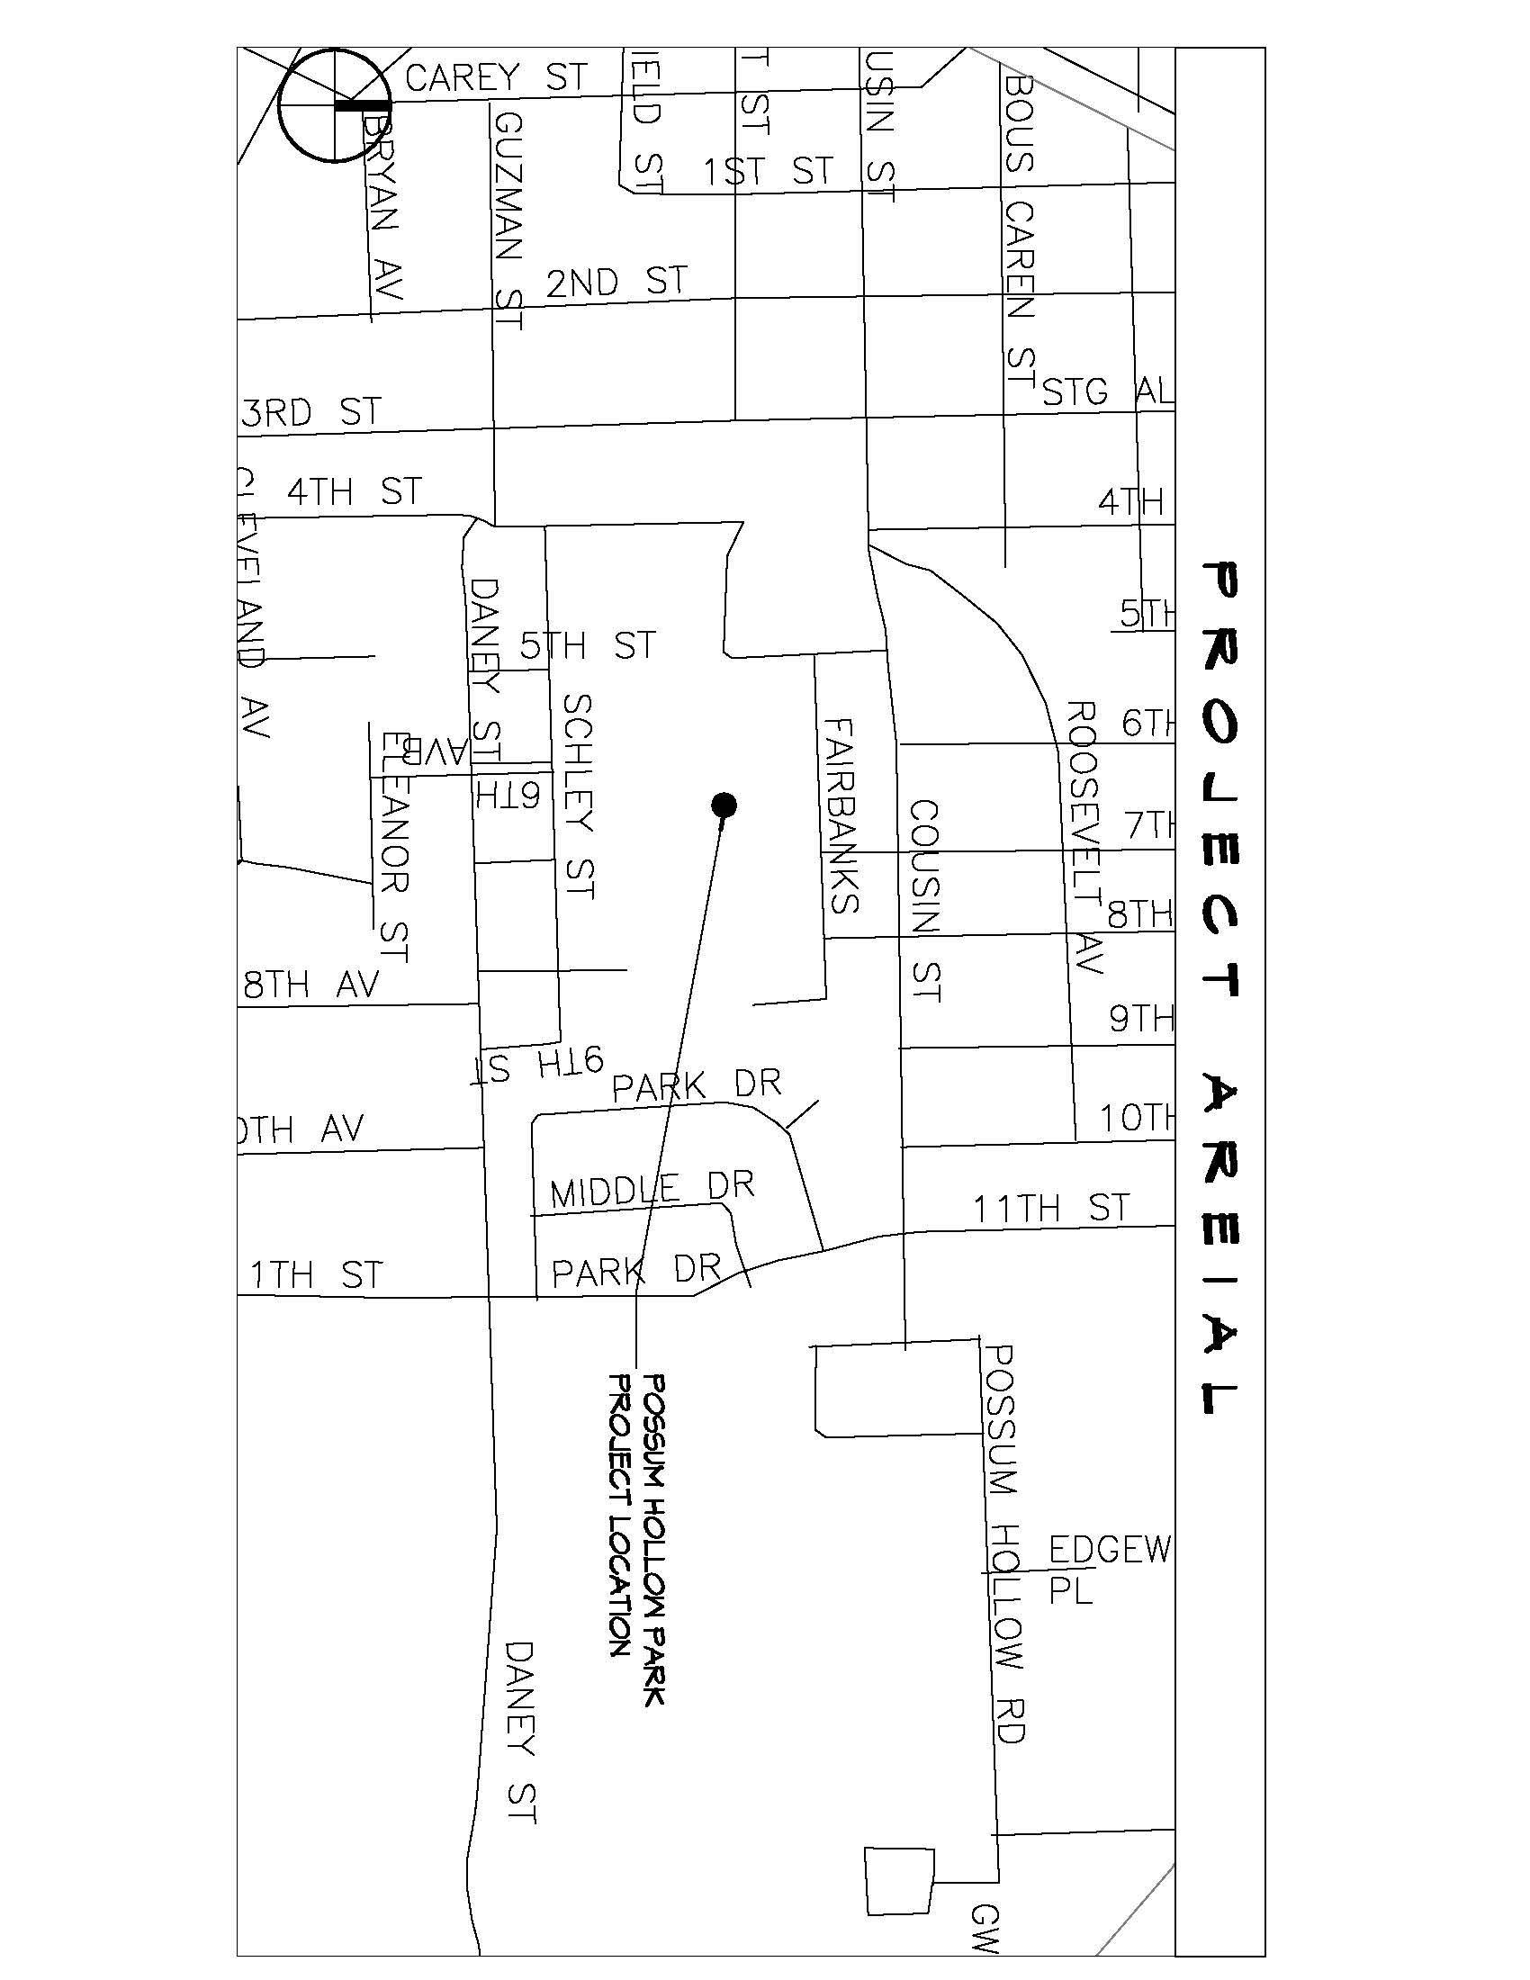

VICINITY MAP
Possum Hollow Park
Basketball Court
Project 5000-32

Page 6 of 8

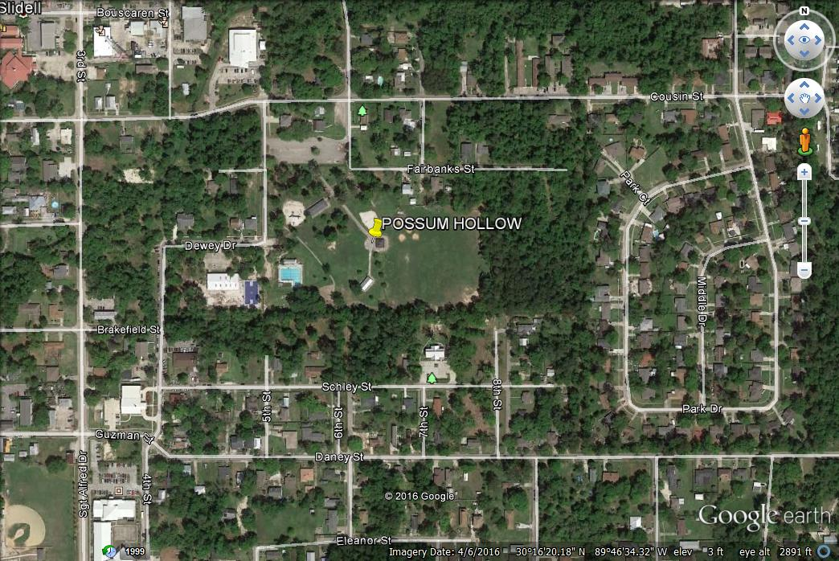
Page 7 of 8
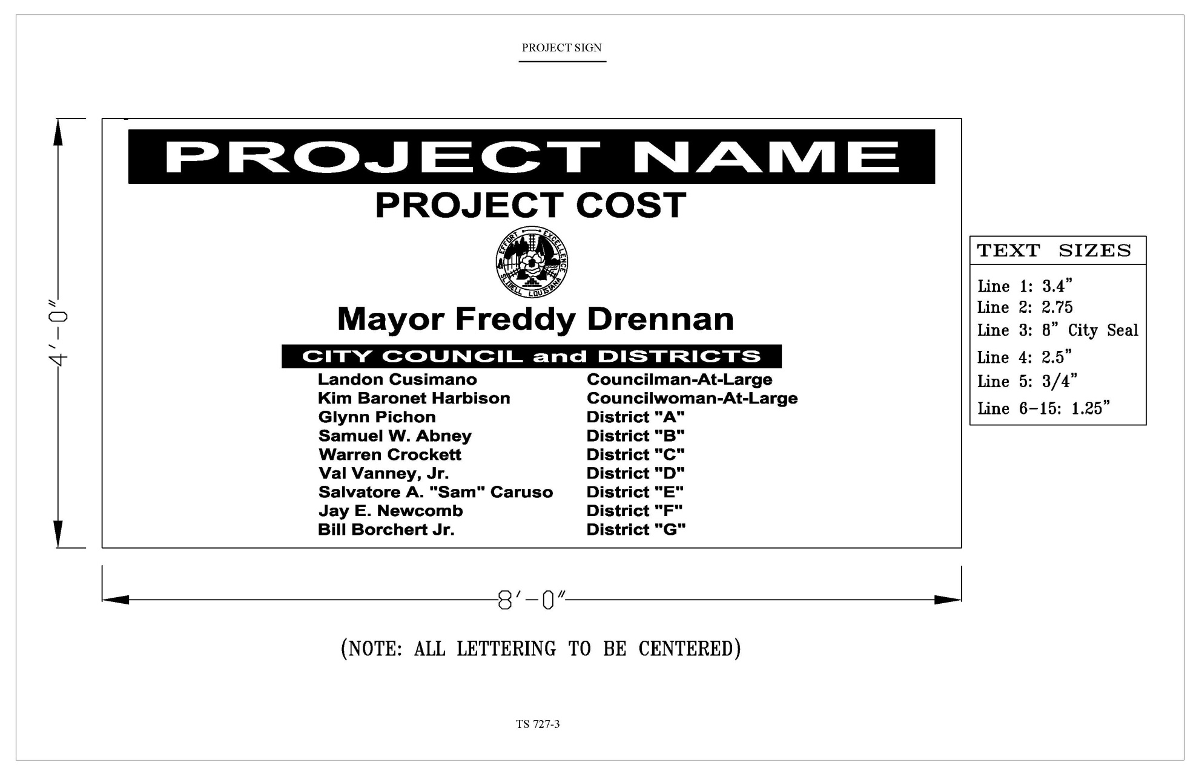

Page 8 of 8

