
554 Old Spanish Trail
Slidell, LA 70458
Phone: 985-649-5832
dammonengineering.com
info@dammonengineering.com

January 20, 2022

Don McMath
McMath Construction
1125 Causeway Blvd.
Mandeville, LA 70471

Re: Original Proposal for Design Bid Hontas MOB Addition

Mr. McMath,

Thank you for considering Dammon Engineering for the design bid project to construct an MOB Addition. We are pleased to propose our services for the subject project in Covington La.
We propose a fee of $106,646.00 for Architectural, Civil, Electrical and Mechanical/Plumbing. This fee includes redesigning the original building addition plans to add an additional 15 feet to our original plan. This also includes a determination of the existing rainwater runoff and calculations for no net increase to the state highway.
In order to complete this project a new survey showing all existing improvements, utilities and subsurface drainage will be required. A copy of the soils analysis will also be required.
If selected we will bill on the following schedule. Original plan has been previously billed and paid at $12,232.50 by …. . The remainder will billed at 60% once construction drawings are complete and the remainder 40% once the project is 50% complete.
Our fee does not include the cost of landscaping design, designing a post tension slab, sprinkler or fire alarm systems, soils analysis, survey, drainage studies, wetlands determination, or other engineering studies that may be required by government agencies nor does it include the cost of plan review or permits by the municipality. These items, if provided by Dammon Engineering, will be billed at a "cost plus" fee.
We look forward to working with you on this project. Please indicate your acceptance of the above fee by signing below. If you have any questions, or require any further information, please feel free to call.

Sincerely,

If you have any questions, please contact me.

Thank You,

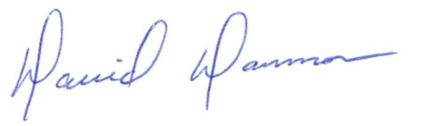
David Dammon __________________________________
President Don McMath

