
554 Old Spanish Trail
Slidell, LA 70458
Phone: 985-649-5832
dammonengineering.com
info@dammonengineering.com

January 21, 2022

Don McMath
McMath Construction
1125 Causeway Blvd.
Mandeville, LA 70471

Re: Revised Original Proposal for Design-Build Hontas MOB Addition

Mr. McMath,

Thank you for considering Dammon Engineering for the design-build project to construct a 6,396 s.f. MOB addition at Dr. Hontas practice. We are pleased to propose our services for the subject project located in Covington La.
We propose a fee of $52,682.00 for Architectural, Civil, Electrical and Mechanical/Plumbing plans. This fee also includes cost related to a Landscape Architect, to provide landscaping and irrigation plans. This fee includes the amount that was previously billed for the design-build of 5,276 s.f. addition, that is now being increased to 6,396 s.f. addition.
If selected we will bill on the following schedule:
- Original plans for the 5,276 s.f. addition has been previously billed and paid at $12,232.50. This amount will not be billed again.
- 60% of the remainder will be billed once construction drawings are complete.
- The remaining fee will be billed once the construction reaches 50% complete.
Our fee does not include the cost of sprinkler or fire alarm systems, soils analysis, survey, drainage studies, wetlands determination, or other engineering studies that may be required by government agencies nor does it include the cost of plan review or permits by the municipality. These items, if provided by Dammon Engineering, will be billed at a "cost plus" fee.
We look forward to working with you on this project. Please indicate your acceptance of the above fee by signing below. If you have any questions, or require any further information, please feel free to call.

Sincerely,

If you have any questions, please contact me.

Thank You,

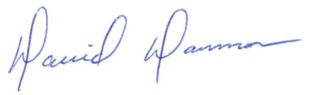
David Dammon __________________________________
President Don McMath

