
554 Old Spanish Trail
Slidell, LA 70458
Phone: 985-649-5832
dammonengineering.com
info@dammonengineering.com

June 2, 2016

Jefferson Parish
Inspections and Code Enforcement
400 Maple Ave.
Harvey, LA 70058

RE: Permit Application #16-350045
Blueline Rentals Wash Rack

Sir/Madam,

The following responses to your May 19th review of subject project are provided:

- “Please provide a recent survey of property. Survey submitted was not a clear copy.”
Response: Please see attached survey.

- “Revise site plan to indicate any servitude on lot.”

Response: Please see attached site plan.
- “The Design Professional shall include a statement on the drawings to the effect that: "I have researched the building and related codes of Jefferson Parish and the Louisiana State Uniform Construction Code and to the best of my knowledge and belief these drawings are in compliance therewith." This can be handled with a letter to this effect.”

Response: Please see attached letter.
- “Design professional to indicate pile load capacity in tons.”

Response: Please see revised S101 attached.

- “Design professional to indicate if this building will meet the BFE of AE 5.5 or H.E.A.G. 36" or Flood Proofing certificate? “

Response: This building is designed as a utility structure; it was designed to be constructed 6” above existing elevation, which is below BFE and 36” H.E.A.G. This utility structure has been designed as a partially enclosed building with a cased opening on the northside of the building; the cased opening has the following dimensions = 16’ x 16’; this area is sufficient for flood waters to enter and recede from the interior of the building.
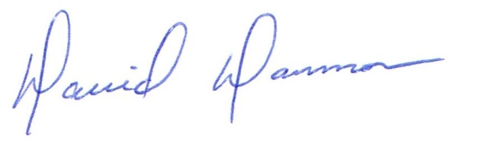

David Dammon
Dammon Engineering, Inc

