GULF COAST ELECTRIC CO., LLC

554 Old Spanish Trail
Slidell, Louisiana, 70458
985-290-3888/ Fax 985-641-5950
Email: gulfcoastelect@bellsouth.net

Louisiana License # 46737

APPLICATIONS $80.00 each plus shipping
For accenting architecture or lighting landscape areas

TYPICAL MOUNTING HEIGHT
8 to 15 feet
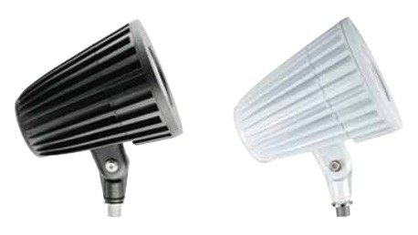
Catalog Number | E-GL1F03N2W
Description | 38W LED Neutral white
Height | 8-1/2-in
Width | 6-1/2-in
Depth | 7-3/4-in
Weight (.lbs) | 6.20
Input Voltage | 120V-277V
Delivered Lumen Output | 2000 Delivered Lumens
Beam Angle/Photometric Distribution | 40˚ Flood
CCT | 4100K
Comparable To | 70W PSMH
Lamp Type | 38-Watt LED
Color Rendition | 74 CRI
Minimum Starting Temperature | -40° F

