
It's Time to call all Men to MONDAY NIGHT MEN at Camp Living Waters.
March 5th @ 5:30 PM
Living Waters Monday Night Men has grown into one of the best Men’s events in Southeast Louisiana. AND It's that time again. We will start serving Supper at 5:30 and work-clothes are welcome. We will serve right up to 7:00 and then we will have a great time of fellowship, worship and a message from God's word especially for Men.
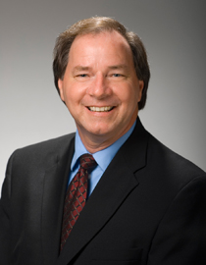
Our speaker is Dr Argile Smith. Dr Smith currently serves as Associate Dean of Christian Ministry of the Caskey School of Divinity at Louisiana College. He has served Churches in Louisiana and Mississippi and New Orleans Baptist Theological Seminary. But most of all He is a dynamic communicator and rightly divides the Word.

Our Music will be the Men’s Quartet from Bethlehem Baptist Church in Albany. Dennis Walker is the director and these guys will have you clapping and patting your feet as we sing to the Lord.

As always we will have some great food, door prizes, and lot's of fun.

Please sign the sign-up sheet in the foyer or contact Pastor Robby or Rick Cottrell, Men’s Ministry Leader.
Hope to see every man there on March 5th.

