GULF COAST ELECTRIC CO., LLC
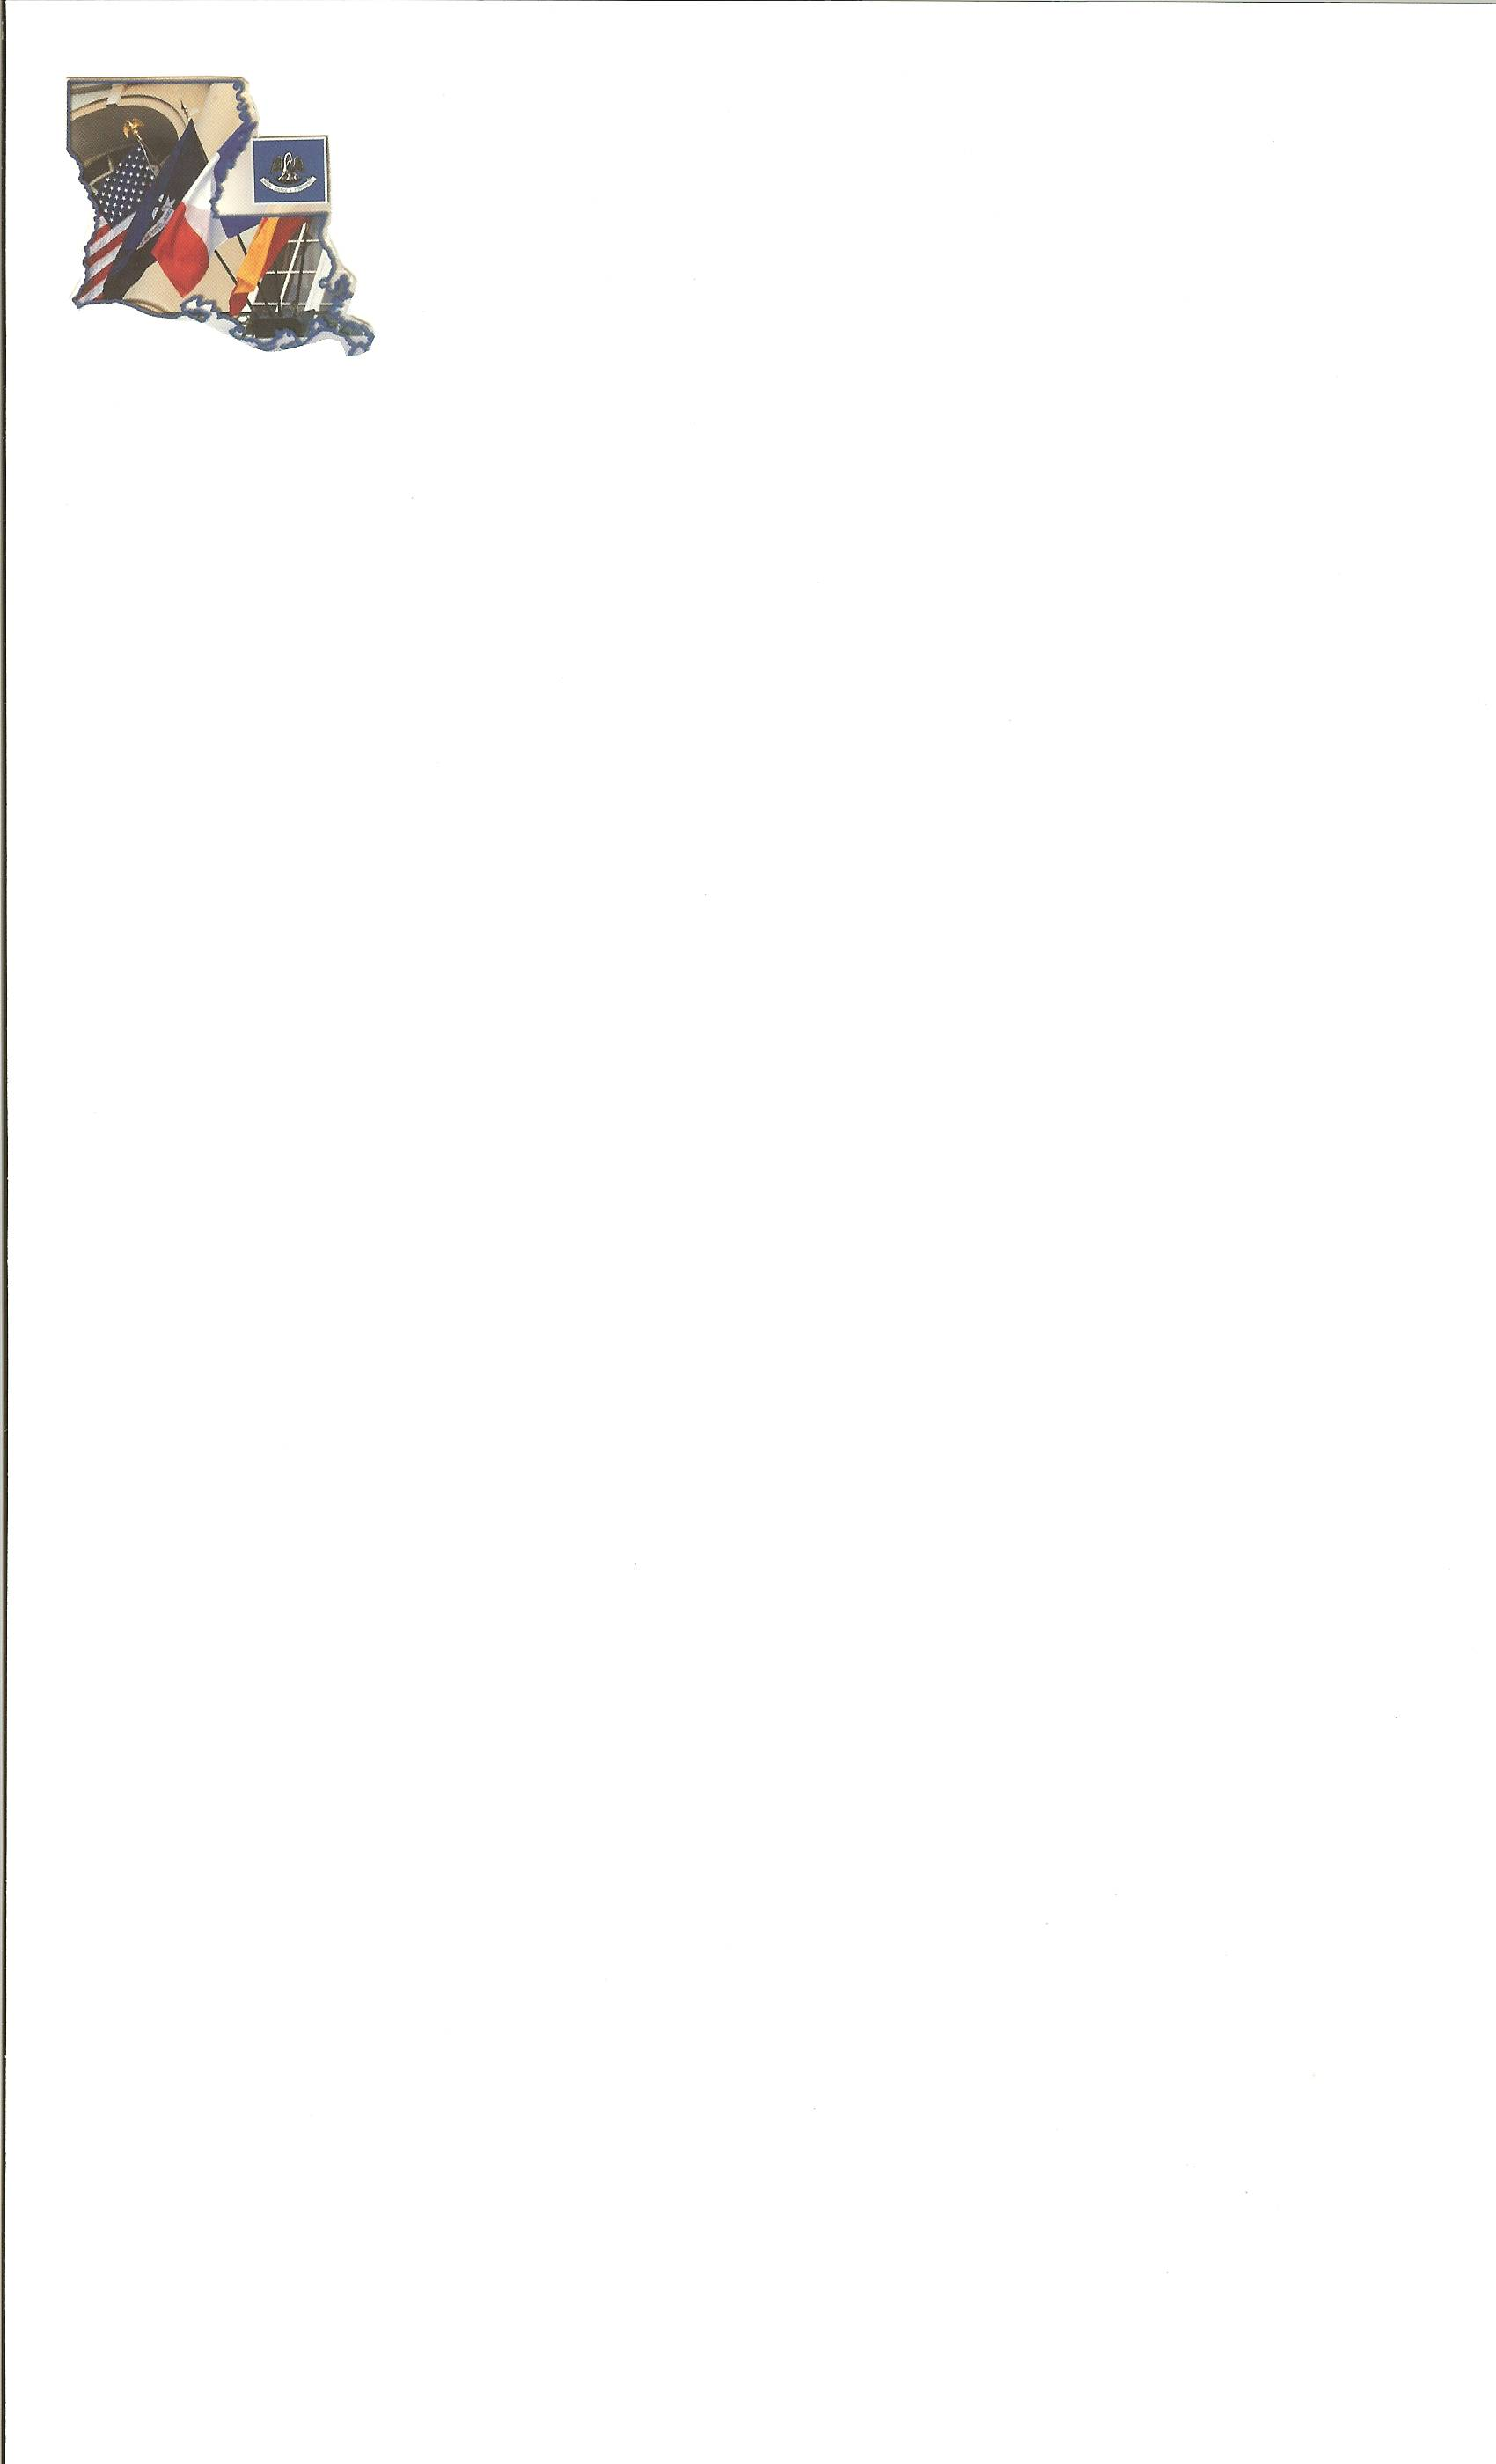 554 Old Spanish Trail
Slidell, Louisiana 70458
985-649-5832/fax: 985-641-5950
Email: gulfcoastelect@bellsouth.net

SUBCONTRACTOR’S RELEASE

State of ______________________________________________

Parish of _____________________________________________

This is to certify that all invoices for materials, payrolls and other obligations incurred by us in connection with work performed on _____Yat Shack/Violet, Louisiana___________________
________________________________________________________________________________________________________________________________________________________
As per subcontract have been paid by us in full and that there are no outstanding obligations against us applicable to this project.

For and in consideration of the final payment in the amount of $1,100.00 and payments heretofore made, the Total of which is $___10,563.00____, the undersigned Subcontractor hereby released and discharges Al Navia/Destiny Builders, LLC from all liabilities, obligations and claims whatsoever under or arising out of said subcontract, except the following claims:___________________________________________________________
________________________________________________________________________________________________________________________________________________________

Signed this ____________ day of _________ 20____

_________Gulf Coast Electric, LLC_________________
Company

By _____________________________________

Sworn to and subscribed before me, this the ___________ day of ________________ 20____.

_________________________
Notary Public

