
Submittal

Trane U.S. Inc.

  Prepared For:
  Date:
  7/7/2015
  <customer>
  Customer P.O. Number:
  <company>
  Customer Project Number:
  Sold To:
  Job Number:
  Job Name:
  1581 Magazine
Trane is pleased to provide the enclosed submittal for your review and approval.

Product Summary

Qty | Model Description
1 | Horizon™ (B/G) - Packaged curb mounted multi-function heating, cooling and ventilation unit

The attached information describes the equipment we propose to furnish for this project and is submitted for your approval.

  Product Data -
  Packaged curb mounted multi-function heating, cooling and ventilation unit
Size | Qty | Description | Model Number
G210 | 1 | Packaged curb mounted multi-function heating, cooling and ventilation unit | OAGD210A3-D10000BC-A0E0000000-000B00000

  Tag(s): | OAU-1
  Unit Voltage: 208-3-60
Evaporator Coil: DX 6 Row Interlaced
Hot Gas Reheat: Modulating
Heat Type: Indirect Fired (IF)
439 Stainless Steel Furnace: 150 Mbtu/h, (10:1 Turndown NG, 8:1 Turndown LP)
Filters: MERV-8
Curb Selection: Standard Knockdown Curb

Supply Discharge Air Sensor (FLD)
2 inch Double Wall Construction
Stainless Steel Drip Pan
Blower HP - 4
Blower RPM - 1407
Supply Fan - GKHM_450

  Tag:
  OAU-1
  Comments:

Unit Information
Model: | Horizon™ (B/G) |  | Unit Length: | 160 | in
Size: | G210 |  | Unit Width: | 74 | in
Quantity: | 1 |  | Unit Height: | 67 | in
Supply Airflow: | 2,500 | CFM | Elevation: | 0 | ft
Outside Airflow: | 2,500 | CFM | Ambient Air DB: | 95 | F

  Weight Operating:
  2587
  lb*
  Note:
  Weight does not include CURB weight. See CURB submittal for actual
Refrigerant Charge
Circuit 1: | 24.09 | lbs
Circuit 2: | 18.9 | lbs

Cooling Performance
Gross Total Capacity: | 225.1 |  |  | MBh |  | Evaporator Face Area: | 12.08 |  |  | sq ft
Gross Sensible Capacity: | 108.8 |  |  | MBh |  | Evaporator Rows / FPI: | 6 | / | 12
Net Total Capacity: | 221.9 |  |  | MBh |  | Condenser Face Area: | 37.29 |  |  | sq ft
Net Sensible Capacity: | 105.6 |  |  | MBh |  | Condenser Rows / FPI : | 2 | / | 14
Entering Air DB / WB (Coil): | 95 | / | 80 | F |  | Air Velocity: | 206 |  |  | fpm
Leaving Air DB / WB (Coil): | 56.1 | / | 55.5 | F |  | Coil Air PD: | 0.24 |  |  | in H2O
Leaving Air DB / WB (Reheat): | 85.15 | / | 66.01 | F |  | EER: | 12.3
Leaving Air DB / WB (Unit): | 86.6 | / | 66.5 | F |  | Watts: | 18111

Heating Performance
Heat Type: | Gas Furnace |  |  | Entering Air DB: | 30 | F
Input Capacity | 150 | MBh |  | Leaving Air DB: | 74.4 | F
Output Capacity: | 120 | MBh |  | Coil Air PD: | 0.28 | in H2O

  Supply Fan
  GKHM_450
 |  | 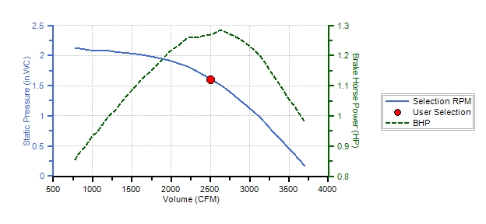
Supply Pressure Drop Summary |  |  |  | Supply Fan Conditions
External Static Pressure: | 1.00 | in H2O |  | Fan Motor BHP: | 1.27 | BHP
Internal Pressure Drop: | 0.60 | in H2O |  | Operating RPM: | 1407 | RPM
Total Static Pressure: | 1.60 | in H2O |  | Minimum RPM: | 1126 | RPM

Unit Electrical Data
Unit Voltage-Ph-Hz: | 208-3-60 |  |  | Min Circuit Ampacity - MCA: | 92.1 | Amps
Unit Amps - FLA: | 84.4 | Amps |  | Maximum Fuse Size - MFS: | 110 | Amps

Electrical Summary
Component | Fan Service | Qty | HP (ea.) | FLA (ea.) | RLA (ea.) | LRA (ea.)
Scroll |  | 2 |  |  | 30.7 | 203
 | Supply | 1 | 4 | 8
 | Condenser | 3 | 1 | 4.2
Controls |  | 1 |  | 2.4

Notes
1. See option list schedule for selected options.
2. See catalog for dimension and weight
3. For single point power connection, Unit Electrical amps include the greater of compressor or electrical heat amps
4. For dual point power connections (electrical heat), Unit Electrical Data does not include electric heat power requirements

Unit Dimensions - 10-30 Ton R-410A PKGD Unitary Cooling Rooftop
Qty: 1 Tags: OAU-1
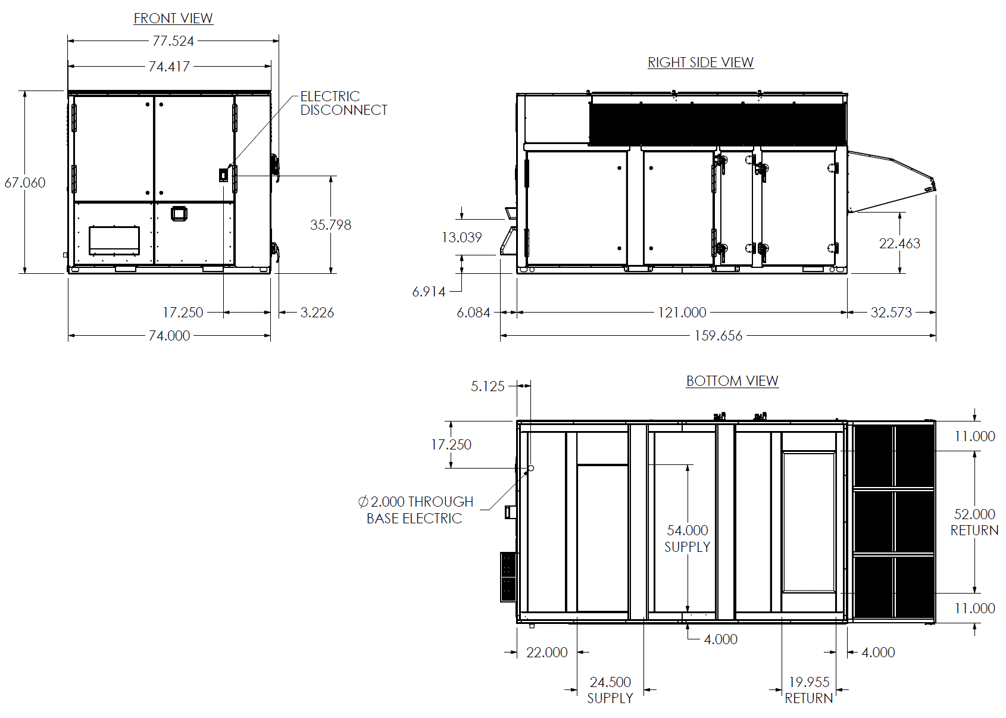

Cabinet Layout - 10-30 Ton R-410A PKGD Unitary Cooling Rooftop
Qty: 1 Tags: OAU-1
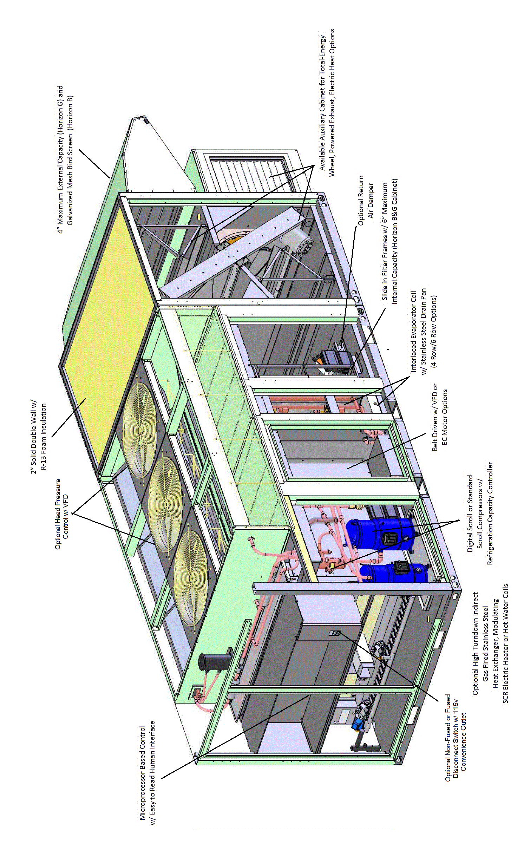

Rigging Diagram - 10-30 Ton R-410A PKGD Unitary Cooling Rooftop
Qty: 1 Tags: OAU-1
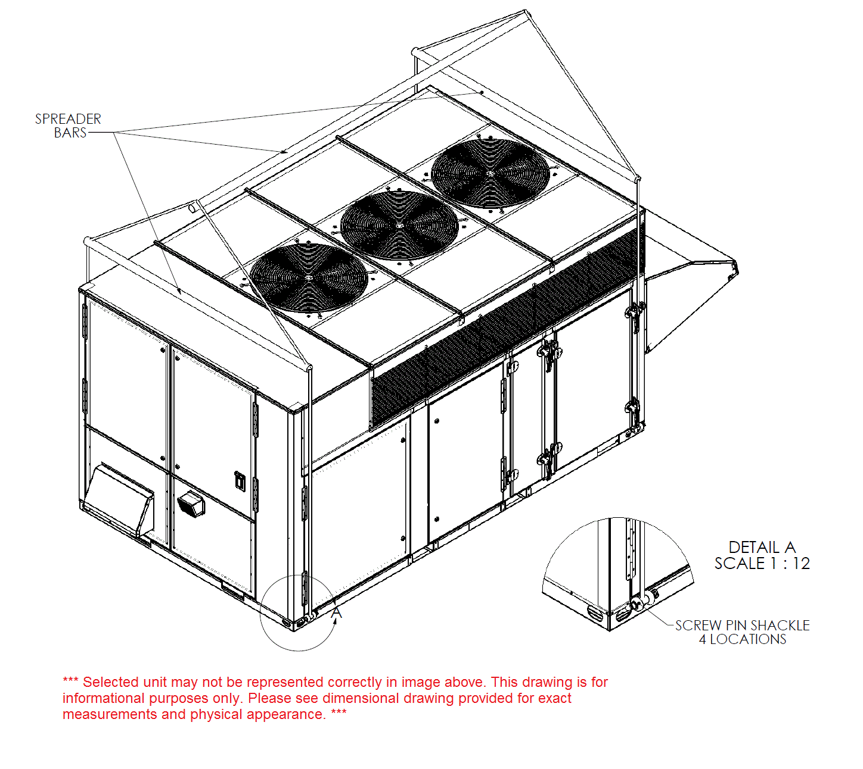

Field Wiring - 3-54 Ton R-410A PKGD Unitary Cooling Rooftop
Qty: 1 Tags: OAU-1
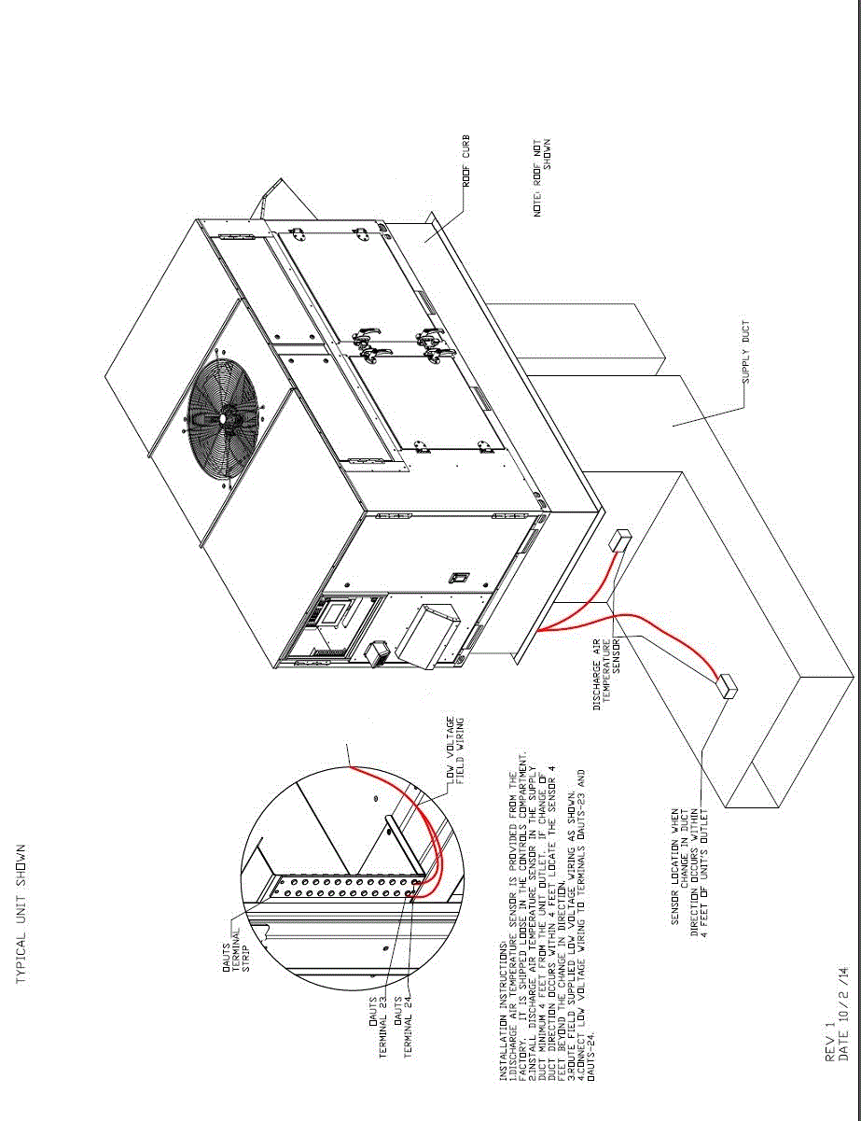

Field Wiring - 3-54 Ton T-410A PKGD Unitary Cooling Rooftop
Qty: 1 Tags: OAU-1
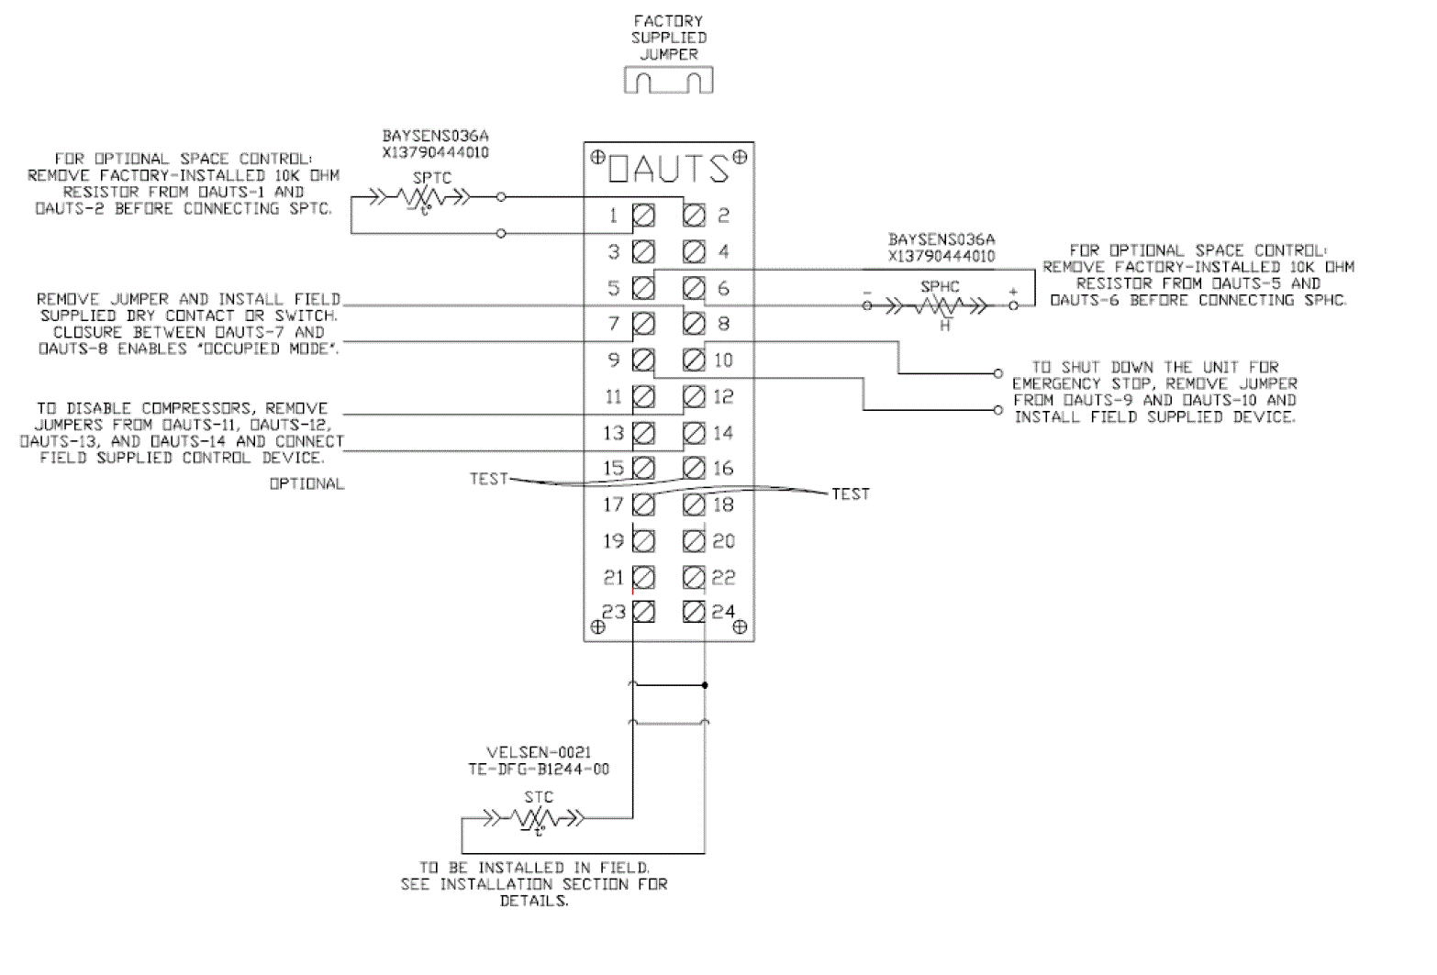

Utility Connections - 10-30 Ton R-410A PKGD Unitary Cooling Rooftop
Qty: 1 Tags: OAU-1
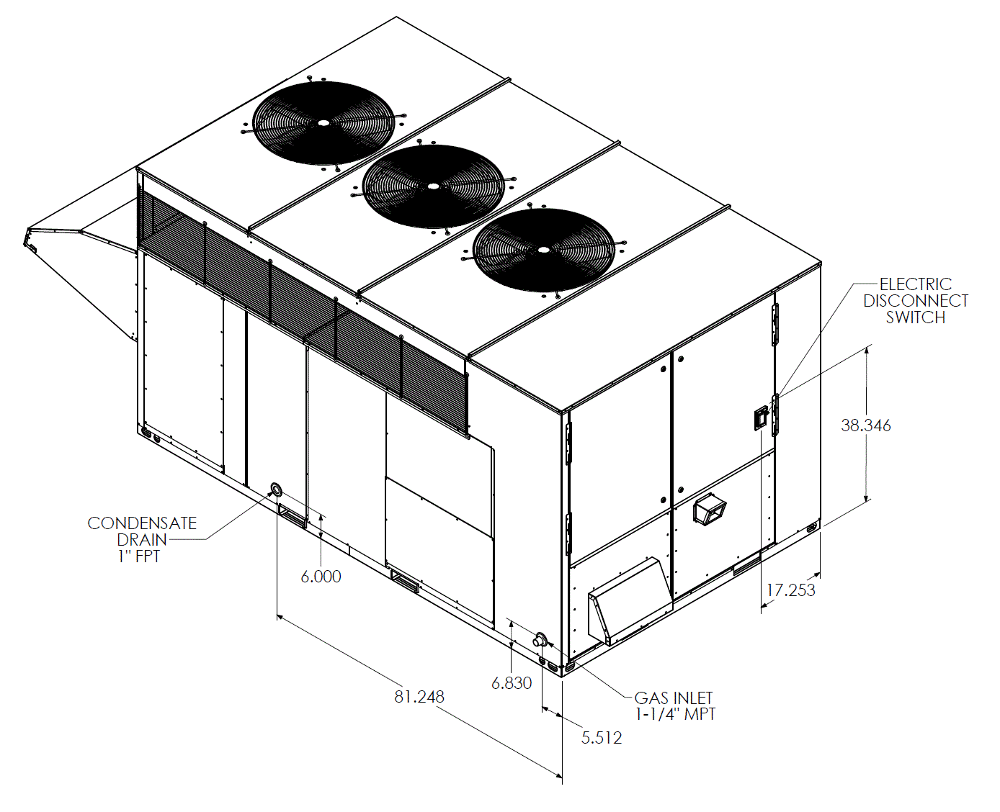

Clearance Diagram - 3-9 Ton R-410A PKGD Unitary Cooling Rooftop
Qty: 1 Tags: OAU-1
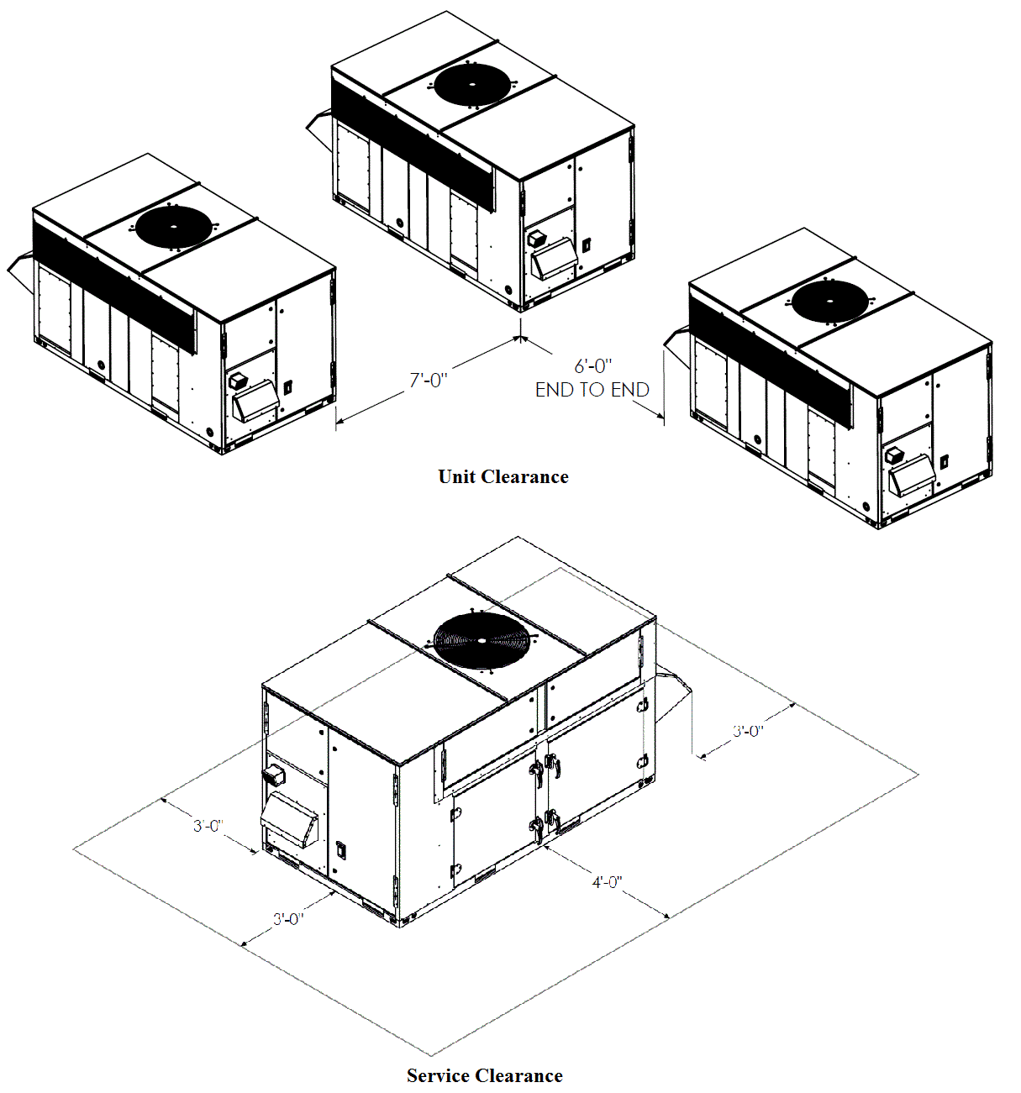

Roof Curb - 10-30 Ton R410A PKGD Unitary Cooling Rooftop
Qty: 1 Tags: OAU-1
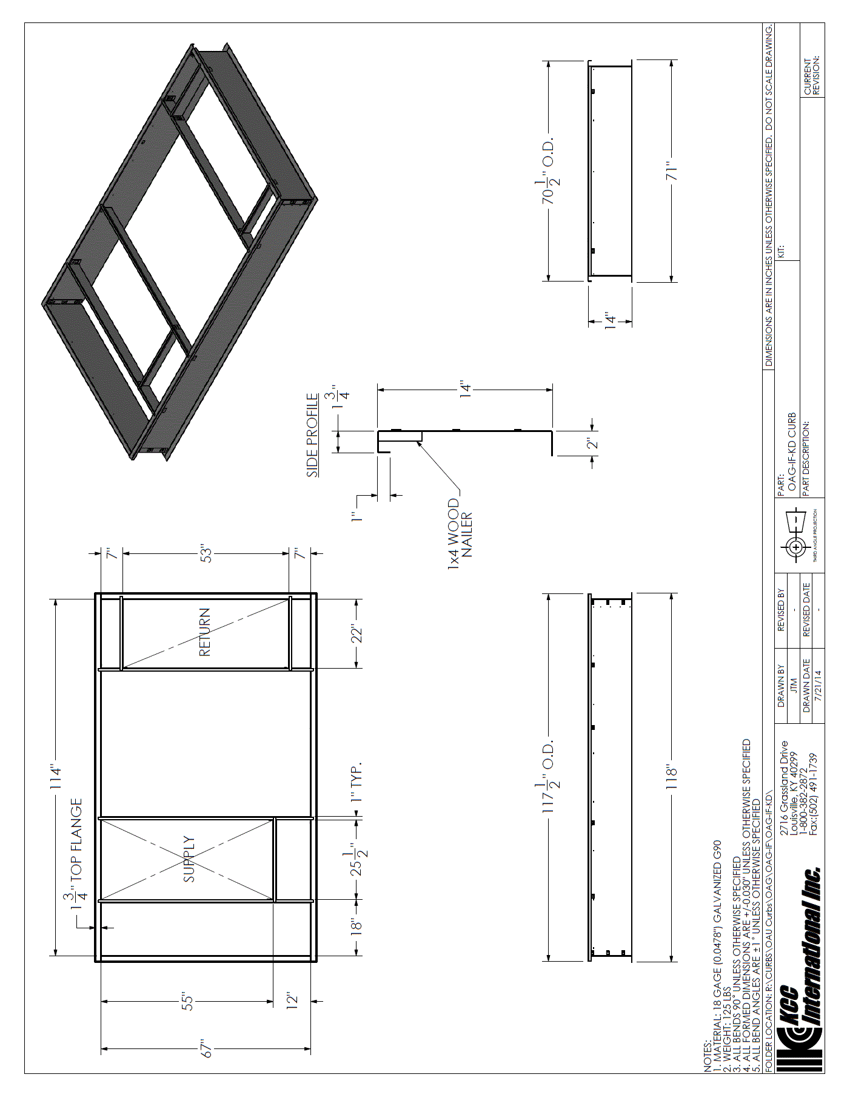

Options - 2 Position Damper Actuator
Qty: 1 Tags: OAU-1
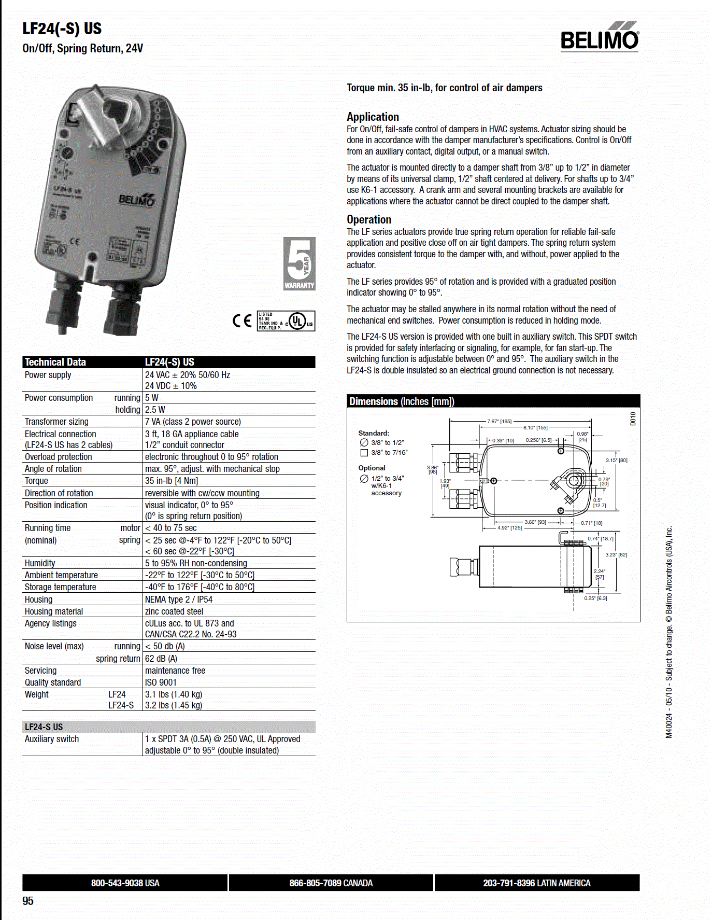

  Mechanical Specifications -
  Tag(s):
  OAU-1

General
The unit shall be field convertible between Down/Horizontal discharge for both Supply and Return Openings. Cooling performance shall be rated in accordance with ARI testing procedures. All units shall be factory assembled, internally wired, fully charged with R-410A, and 100 percent run tested to check cooling operation, fan and blower rotation, and control sequence before leaving the factory. Wiring internal to the unit shall be colored and numbered for simplified identification. Units shall be ETL listed and labeled, classified in accordance to UL 1995/CAN/CSA No. 236-M40 for Central Cooling Air Conditioners. Canadian units shall be CSA Certified.
Casing
Unit casing shall be constructed of zinc coated, heavy gauge, galvanized steel. Exterior surfaces shall be cleaned, phosphatized, and finished with a weather-resistant baked enamel finish. Unit's surface shall be tested 1000 hours in a salt spray test in compliance with ASTM B45. Unit shall have a 2 inch thick Antimicrobial Insulation. All insulation edges shall be either captured or sealed. The unit's base pan shall have no penetrations within the perimeter of the curb other than the raised downflow supply/return openings to provide an added water integrity precaution, if the condensate drain backs up.
Unit Top
The top cover shall be one piece construction or, where seams exist, it shall be double-hemmed and gasket-sealed. The ribbed top adds extra strength and enhances water removal from unit top
Sensors
A factory installed combination outdoor air sensor located in the outdoor air hood is designed to sense both outdoor air temperature and relative humidity for use by the microprocessor controller to make required ventilation, cooling, dehumidification and heating decisions. Refer to the Sequence of Operations section of the Installation, Operation and Maintenance manual for detailed unit control and operational modes. A factory installed sensing tube is designed to sense the supply air temperature downstream of the indoor fan section.
Evaporator Coil: DX 6 Row Interlaced
Internally finned, 5/16 inch copper tubes mechanically bonded to a configured aluminum plate fin shall be standard. Coils shall be leak tested at the factory to ensure the pressure integrity. The evaporator coil shall be leak tested to 500 psig and pressure tested to 500 psig. A Stainless Steel double-sloped condensate drain pan with provision for through the unit wall condensate drain is standard. Evaporator coil will have 6 interlaced rows for superior sensible and latent cooling.
Hot Gas Reheat: Modulating
This option shall consist of a modulating hot-gas reheat coil located on the leaving air side of the evaporator coil pre-piped and circuited with a low pressure switch. Refer to the Sequence of Operations section of the Installation, Operation and Maintenance manual for detailed unit control and operational modes.
439 Stainless Steel Furnace: 150 Mbtu/h, (10:1 Turndown NG, 8:1 Turndown LP)
Primary heat is supplied using indirect fired gas heating. The heating section shall have a progressive tubular heat exchanger design using Stainless Steel burners and type 439 Stainless Steel tubes. An induced draft combustion blower shall be used to pull the combustion products through the firing tubes. The heater shall use a direct spark ignition (DS) system. On initial call for heat, the combustion blower shall purge the heat exchanger for 20 seconds before ignition. After three unsuccessful ignition attempts, the entire heating system shall be locked out until manually reset at the thermostat/zone sensor. Units shall be comply with the California requirement for low NOx emissions. Unit shall be suitable for use with Natural Gas.
Filters: MERV-8
Aluminum Mesh Filters (D, K and N Cabinets) and Galvanized Mesh Bird Screen (B and G Cabinets) shall be installed on the intake of the unit. In addition, one row of 2 inch MERV-8 rated filters (30 percent) shall be installed prior to the evaporator coil.

