
554 Old Spanish Trail
Slidell, LA 70458
Phone: 985-649-5832
dammonengineering.com
info@dammonengineering.com

3 January 2024

Don McMath
McMath Construction
1125 Causeway Blvd.
Mandeville, LA 70471

Re: Square 5 Condos - Covington

Mr. McMath,

Thank you for considering Dammon Engineering. We are pleased to propose our services for the subject project in Covington La.
Our understanding is that this agreement is for the mechanical, electrical and plumbing plans for 2 buildings housing approximately 16 condo units, 5 commercial units and 16 storage units; both buildings have approximately 31,500 s.f. overall.
We propose a fee $22,815.00 based on the information above.

Sincerely,

If you have any questions, please contact me.

Thank You,

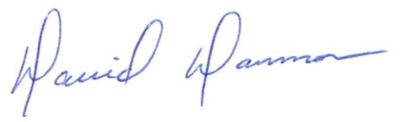
David Dammon
President

