Depending on the average operating pressure desired, approximately 60 psi or 50psi) there are two booster pumps recommended :

33GB15 – 7 Stage(+/- 60 psi)
33GB10 – 5 Stage (+/- 50 psi)

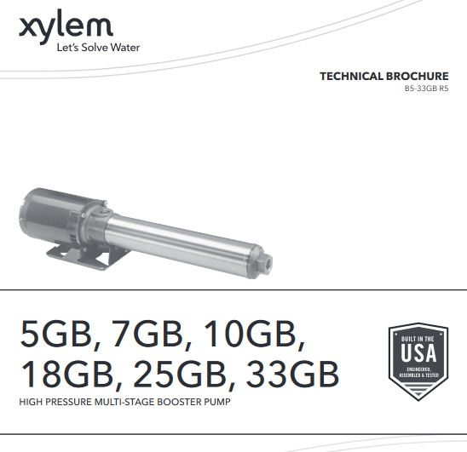
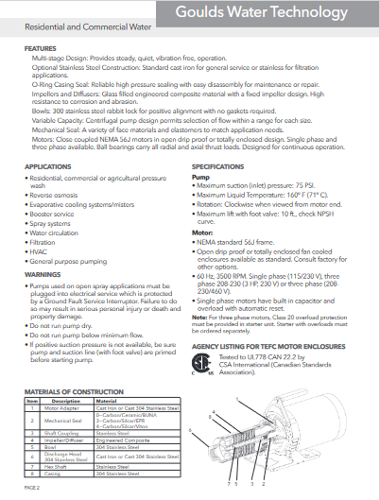

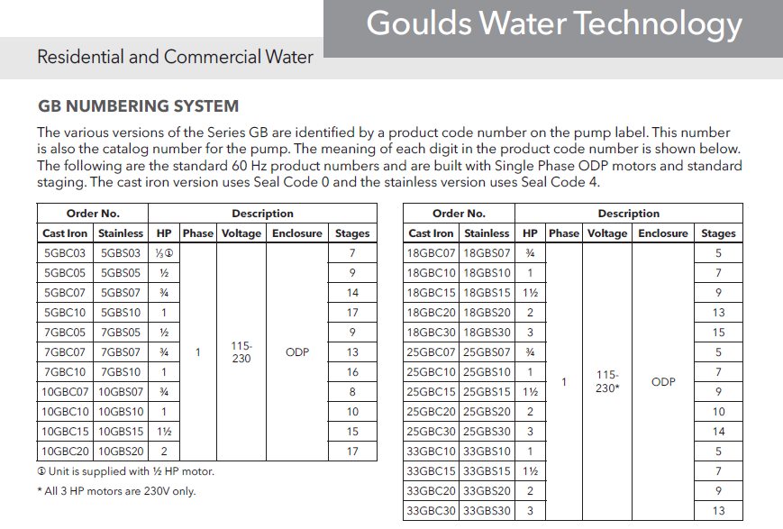
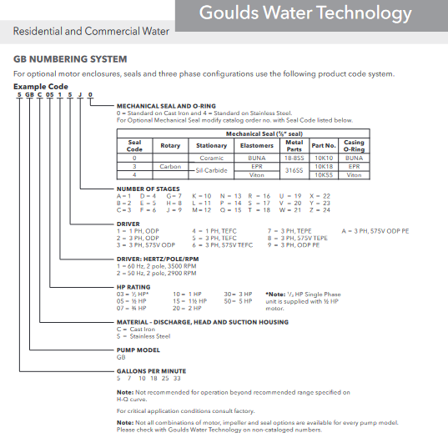
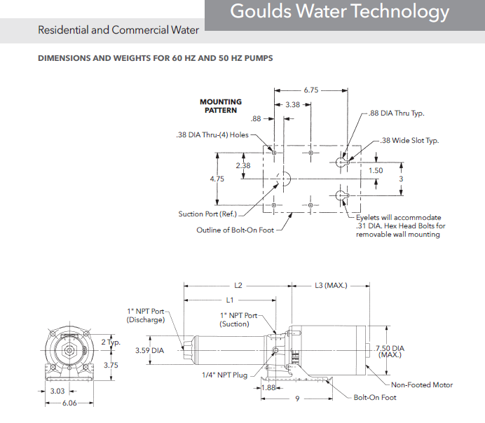
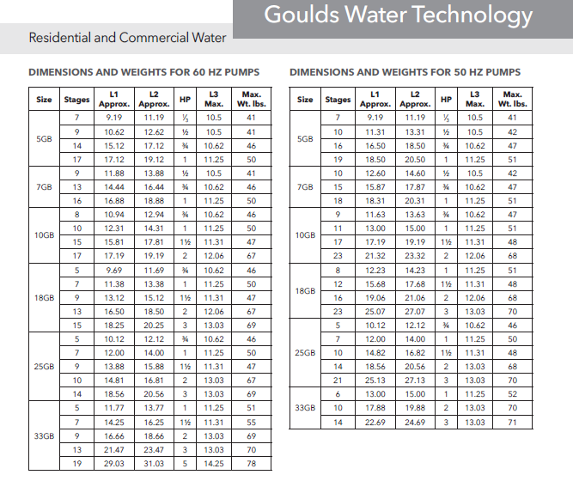

33GB PERFORMANCE CURVES
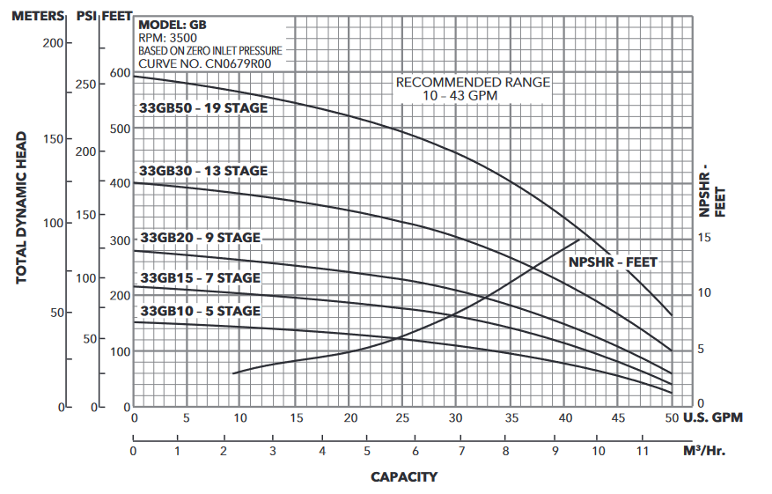

Recommended Chemical Injection unit for Disinfection
STENNER Model #45MPHP2
