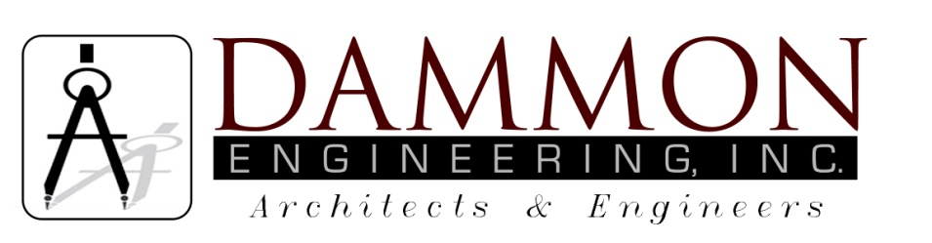
554 Old Spanish Trail
Slidell, LA 70458
Phone: 985-649-5832
Fax: 985-641-5950
dammonengineering.com
dammoneng@bellsouth.net

Bridge City Center for Youth
Project No. 08-403-11-01, Part 01
Pre-Bid Meeting Minutes

June 14, 2013
10:00 a.m.

Attendees:
Mark Abshier, Hydro Air, Inc.
J. Blakely, Industrial Mechanical
Neil Shearer, Insituform
Simon Fontenot, Industrial Mechanical
Lance Daniels, Bridge City Center for Youth
Kevin Kinchen, Dammon Engineering, Inc.
Aubrey Moore, Bridge City Center for Youth
David Dammon, Dammon Engineering, Inc.

Minutes:
- Meeting opened with sign in of attendees.

- The follow questions were broached during the pre-bid meeting:

- What equipment can stay in the work area overnight?

Answer: The Contractor and all Subcontractors will be allowed to leave equipment that is not self propelled or drivable within the secure area overnight. All other tools, equipment and selective demolition materials must be removed from inside the BCCY security enclosure to one of the staging areas at the end of each workday.

- Work hours flexibility, can overtime be authorized?

Answer: No.

- Which facilities can operate without sewer service during the relining?

Answer: All sewer outages will be scheduled with BCCY personnel in advance. There are 3 facilities which cannot be shut down for more than 2 hours, they are: Bldg J (dormitory), Bldg K (dormitory) and Bldg 18 (infirmary).

- Availability of independent 3rd party inspectors, can in-house inspectors be approved?

Answer: Addendum #1 adds that in-house Quality Control inspector or an in-house Engineer can be used in lieu of 3rd party inspector upon written notification to the Engineer of the inspector’s identity and qualifications. If an in-house inspector is used, a notarized affidavit will be required attesting that s/he personally performed the inspection. Test results submitted by an in-house inspector must be notarized.

- Can future site visits after the pre-bid conference be arranged?

Answer: Yes, site visits may be scheduled up to 24 hours prior to bid opening; However prior arrangements must be made with BCCY staff.

- Can pressure testing be used to test the CIPP installation instead of exfiltration?

Answer: Addendum #1 adds that pressure testing is allowed.

