
554 Old Spanish Trail
Slidell, LA 70458
Phone: 985-649-5832
Fax: 985-641-5950
dammonengineering.com
dammoneng@bellsouth.net

September 30, 2013

For: Mr. David Champagne
124 Kilgore Court
Slidell, LA 70461

Re: La Mason Charles
3801 St. Charles Ave., Unit #301
New Orleans, La.

Determine if a 2” hole can be cut in existing 10” C-channel

w loading for existing 10” C-channel:

Lighting 1 psf
Hvac ductwork 2 psf
5/8” Sheetrock ceiling 2.8 psf
Metal decking for concrete 2.5 psf
3” concrete floor 3/12 * 120 pcf = 30 psf
Hardwood floor 4 psf
Each C-channel is approximately 24” o.c. so the floor area supported is approximately 24” wide x 12” along the C-channel: 42.3 psf x 2’ x1’ = 84.6 plf
Assumption : 10” C-channel weights 7 plf
Adding these together we get 84.6 plf + 7 plf = 91.6 plf along each C-channel
The DEAD LOAD from each C-channel supported by load bearing wall =
[(19.5’ / 2) + (9.5’ / 2)] x 91.6 plf = 1328.2 #/lf (1.3k/lf)
LIVE LOAD on each C-channel @ 40 psf =
[(19.5’ / 2) + (9.5’ / 2)] x 2s.f. x 40psf = 1160 #/lf (1.2k/lf)
LRFD Loads 1.2 D + 1.6 L
w = [(1.3k x 1.2) + (1.2k x 1.6)] = 3.48 k/lf

V_{max} = 3.48k/lf x 19.5’/2 = 33.93k
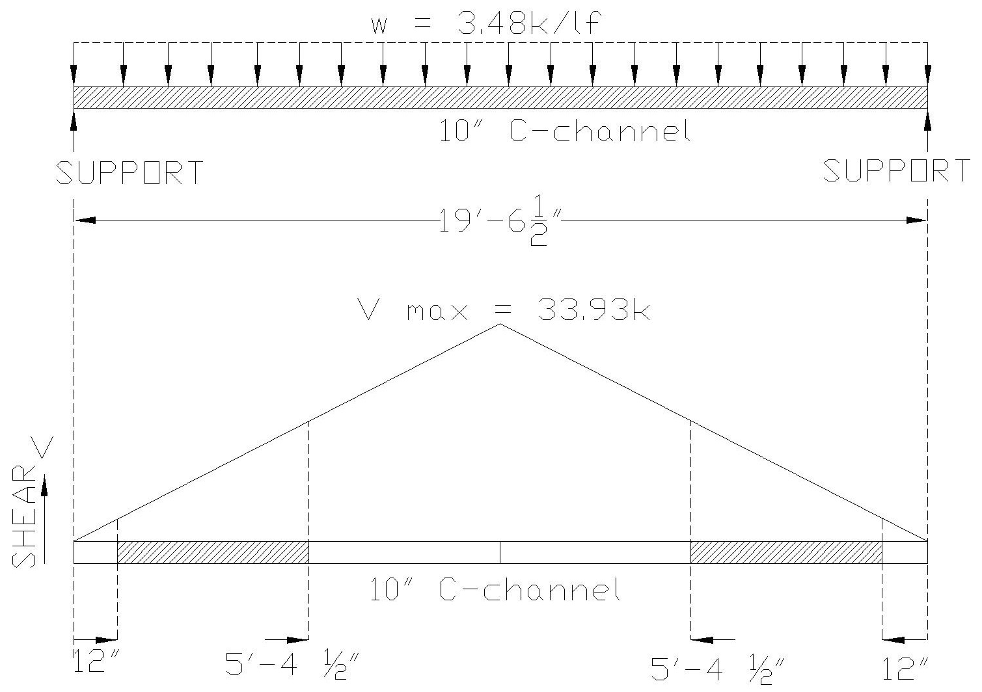

@ 1’ from either support the shear = V/1 = 33.93k/9.75; V = 3.48k
@ 5.375’ from either support the shear = V/5.375 = 33.93k/9.75; V = 18.7k
Assume 10” C-channel F_{y} = 50ksi
Assume 10” C-channel t_{w} = 0.083” thick
Available shear at any point = d * t_{w} * F_{y} 10 * .083 * 50ksi = 41.5 ksi
2” hole @ 1’ from support V_{avail} = (10”-2”) * .083 * 50ksi = 33.3k > 3.48k
2” hole @ 5.375’ from support V_{avail} = (10”-2”) * .083 * 50ksi = 33.3k > 18.7k

Recommendations: It is highly recommended to drill holes only after 1ft of the end support and within the first and last 25% remaining of the beam. ( i.e. (19’-6 ½” – 2ft) / 4 ) It is also highly recommended to leave a 6” space horizontally between holes.

Sincerely,

Emmett G. (Pete) Dammon, P.E.

