
554 Old Spanish Trail
Slidell, LA 70458
Phone: 985-649-5832
www.dammonengineering.com
info@dammonengineering.com

Southern Bancorp Bank Sept. 10, 2019
Attn: Mr. Joey Temples
9 Lakeshore Dr., Carriere, MS 39426
P.O. Box 1760, Picayune, MS 39466
(601) 799-4320 (office) Ext. 4104
(601) 347-2615 (mobile)
Re: Pay App Inspections for Holiday Inn Express Picayune
Mr. Temples,
It was a pleasure to talk with you about the plans to make renovations at the subject location. Dammon Engineering, Inc. is pleased to propose our Engineering services to provide you inspection services for pay apps.
We propose a fee of $95 per hour with a minimum of three hours per inspection. A preliminary inspection would be required to validate the existing conditions, prior to construction, in order to know whether improvements have been performed.
We look forward to working with you on this project. Please indicate your acceptance of the above fee by signing below. If you have any questions, or require any further information, please feel free to call.
If you have any questions, please contact us.
Thank You,

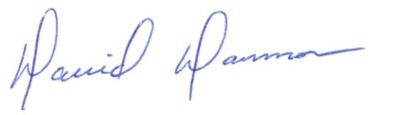
David Dammon __________________________________
President Southern Bancorp Bank
Mr. Joey Temples

