
554 Old Spanish Trail
Slidell, LA 70458
Phone: 985-649-5832
dammonengineering.com
info@dammonengineering.com

July 23, 2021

Jeanette De Melo

1305 DEREK HAMMOND LLC
(205) 478-0892
J Rose DeMelo <jrosedemelo@gmail.com>

Re: Derek Dr. Office Building Edward Jones Build-Out

Ms. De Melo,

Thank you for considering Dammon Engineering. We are pleased to propose our services for the subject project in Hammond La.
We propose a fee of $3,500.00 for this project.
If selected, we will bill 100% of the total after the plans have been accepted the State Fire Marshal.
Our fee does not include the cost of sprinkler or fire alarm systems, soils analysis, survey, drainage studies, wetlands determination, or other engineering studies that may be required by government agencies nor does it include the cost of plan review or permits by the municipality. These items, if provided by Dammon Engineering, will be billed at a "cost plus" fee.
We look forward to working with you on this project. Please indicate your acceptance of the above fee by signing below. If you have any questions, or require any further information, please feel free to call.

Sincerely,

If you have any questions, please contact me.

Thank You,

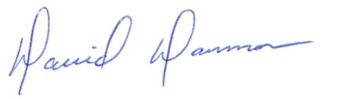
David Dammon __________________________________
President Jeanette De Melo

