
554 Old Spanish Trail
Slidell, LA 70458
Phone: 985-649-5832
dammonengineering.com
info@dammonengineering.com

February 3, 2023

Francisco Bermudez
(985) 201-6377

Re: Plans for Suite Separation and Restrooms at 2767 Sgt Alford Drive Slidell La

Mr. Bermudez,

Thank you for considering Dammon Engineering. We are pleased to propose our services for the subject project in Slidell La.
We propose a design fee of $1,500.00 for plans to provide Suite Separation and Restrooms at subject project. The plans will have Fire Marshal approval including International Building Code review.
Our fee does not include the cost of sprinkler or fire alarm systems as these companies are separately licensed by the State Fire Marshal, the cost of soils analysis, survey, drainage studies, wetlands determination, or other engineering studies that may be required by government agencies nor does it include the cost of plan review or permits by the municipality. These items, if provided by Dammon Engineering, will be billed at a "cost plus" fee.
We look forward to working with you on this project. Please indicate your acceptance of the above fee by signing below. If you have any questions, or require any further information, please feel free to call.

Sincerely,

If you have any questions, please contact me.

Thank You,

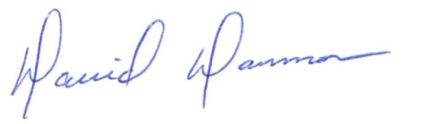
David Dammon __________________________________
President Francisco Bermudez

