554 Old Spanish Trail
Slidell, LA 70458
Phone: 985-649-5832
Fax: 985-641-5950
dammonengineering.com
dammoneng@bellsouth.net

April 23, 2015

Tara Ingram-Hunter
City of Slidell
Department of Planning & Building Safety
2056 2nd St.
Slidell, LA 70458

RE: 227 Cousin St.
Slidell, LA 70458

Dear Tara,

We have been contracted by BSD Construction, LLC, on behalf of the Owner of the property located at 227 Cousin St., to request an extension from the State Fire Marshal for the referenced plans.

We have requested an extension from the State Fire Marshal to allow time for the contractor to obtain his permit.

If you have any questions, or require any additional information, please feel free to call.

Sincerely,
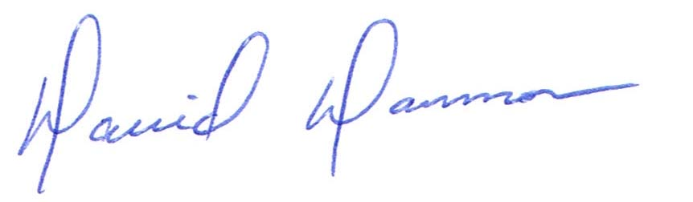
David Dammon, VP
Dammon Engineering, Inc.

