
554 Old Spanish Trail
Slidell, LA 70458
Phone: 985-649-5832
dammonengineering.com
info@dammonengineering.com

September 28, 2022

Scott Morrison

Slidell Refrigeration & Metal
1543 U.S. Hwy 190,
Slidell, LA 70460

Re: Lutheran High School Bldg One Renovations

Mr. Morrison,

Thank you for considering Dammon Engineering. We are pleased to propose our services for the subject project in Metairie La.
Our understanding is that this agreement is for the mechanical and plumbing plan of the approximate 11,700 s.f. Building One. We propose a fee $5,800.00.
If selected, we will bill 100% of the total after the plans have been provided to your office.

Our fee does not include the cost of designing sprinkler or fire alarm systems, soils analysis, survey, drainage studies, wetlands determination, or other engineering studies that may be required by government agencies nor does it include the cost of plan review or permits by the municipality. These items, if provided by Dammon Engineering, will be billed at a "cost plus" fee.

We look forward to working with you on this project. Please indicate your acceptance of the above fee by signing below. If you have any questions, or require any further information, please feel free to call.

Sincerely,

If you have any questions, please contact me.

Thank You,

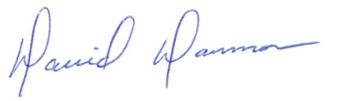
David Dammon __________________________________
President Don McMath

