GULF COAST ELECTRIC CO., LLC
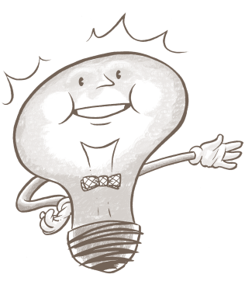
554 Old Spanish Trail
Slidell, Louisiana, 70458
985-290-3888/ Fax 985-641-5950
Email: gulfcoastelect@bellsouth.net

Louisiana License # 46737

SCHEDULE OF VALUES

Lift Station 10, Covington, La

ELECTRICAL

10160 Demo $2,160.00

10240 Electrical Underground Work and grounding $5,850.00

10280 Electrical Controls $12,870.00

10500 Electrical Testing and system service $2,520.00

Total Contract $23,400.00

