Fundraiser for jason dammon

HELPING TO SUPPORT ONE OF ST. TAMMANY’S DEPUTY SHERIFF’S

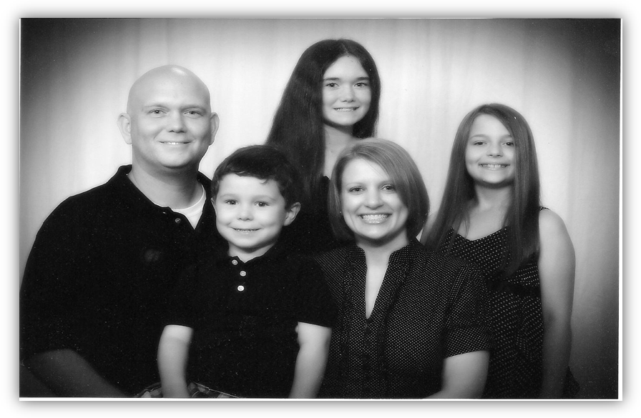

Jason Bree Tyler Alaina Cherrie

Jason was diagnosed with Stage 3 Predominant Hodgkin’s Lymphoma in February 2011. He has received Chemotherapy for the last 8 months and is expected to continue treatments through November of this year. Your contribution will go directly to help pay Jason’s medical expenses.
Thank you for your love & support.
Jambalaya Meal - $7.00 Per Plate - Pick up or Dine In
Monday September 26th - 11 Am to 2 PM at the Church

