
554 Old Spanish Trail
Slidell, LA 70458
Phone: 985-649-5832
dammonengineering.com
info@dammonengineering.com

March 30, 2023

Don McMath
McMath Construction
1125 Causeway Blvd.
Mandeville, LA 70471

Re: Square 5 Condos - Covington

Mr. McMath,

Thank you for considering Dammon Engineering. We are pleased to propose our services for the subject project in Covington La.
Our understanding is that this agreement is for the mechanical, electrical and plumbing plans for 2 buildings housing approximately 12 condo units per building; both buildings have approximately 27,378 s.f. of living space and totals 38,688 s.f. overall. We propose a fee $18,000.00 based on the information above, once plans are available this fee could be adjusted.

Sincerely,

If you have any questions, please contact me.

Thank You,

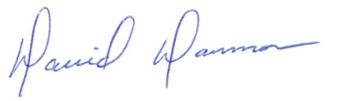
David Dammon
President

