
554 Old Spanish Trail
Slidell, LA 70458
Phone: 985-649-5832
dammonengineering.com
info@dammonengineering.com

October 18, 2024

Re: 1st Baptist Church Restroom Bldg Buoyancy Calcs

Assumptions :

Density of concrete = 150 #/ft³
Density of water (ρ)= 62.4 #/ft³
g = 32.2 ft/s²

Estimate the weight of the building

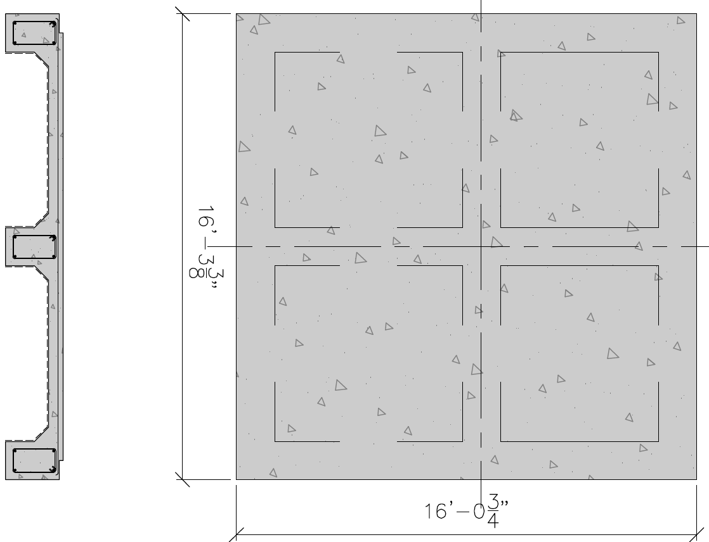

The foundation weight is estimated :

14.47 s.f. x 16lf = 231.5 cu ft x 150 #/cu ft of CONCRETE = 34,728 #
+ 2.68 s.f x (16.25 x 3) = 130.65 cu ft x 150 #/cu ft of CONCRETE =19,597.5#

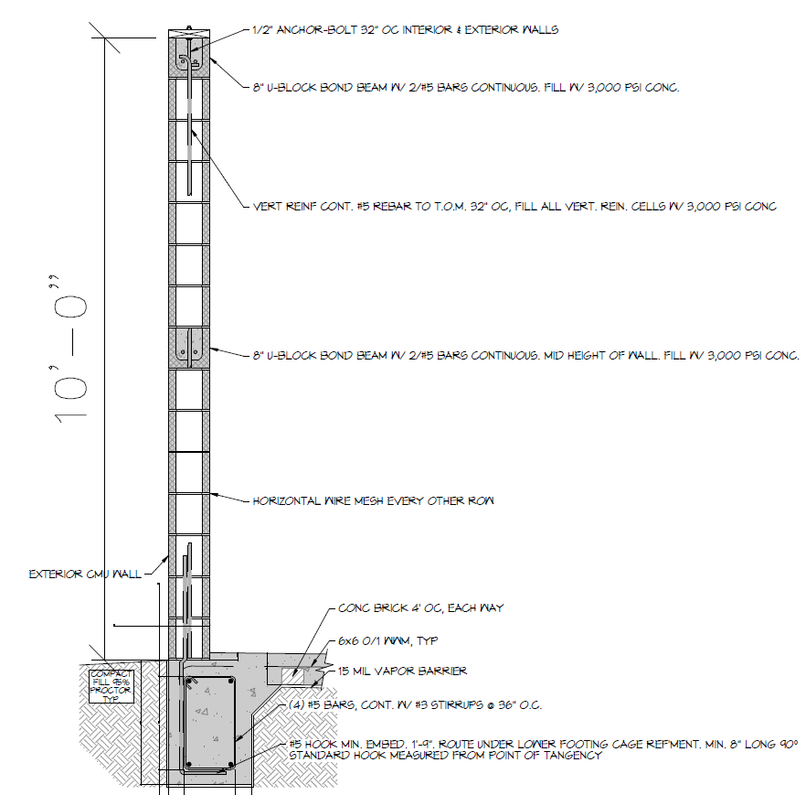

The weight of the CMU filled walls are estimated :
6.65 s.f. x (84.7-9 (doors)) lf = 503.4 cu ft x 150 #/cu ft of CONCRETE = 75,510.75#

The total weight of the concrete building is estimated :

34,728# + 19,597.5# + 75,510.75# = 129,836.25#

*************************************************************************

The formula for buoyancy :

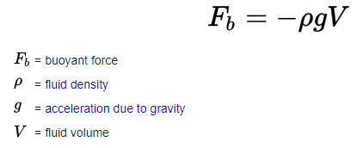

Volume of the building below static water level (BFE) :

Natural Grade = 8.4 ft
BFE = 14.0 ft
Depth of building below BFE = 14 – 8.4 = 5.6 ft
Area of building = 16.25 x 16 = 260 ft²
Volume of displaced water = 260 ft² x 5.6 ft = 1,456 ft³

F_{b} = - [62.4 #/ft³] x [32.2 ft/s²] x [1,456 ft³] = - (-) 2,925,511.68#

since the weight of the concrete bldg is less than the buoyancy force the bldg will float.

129,836.25# < 2,925,511.68#

Thank You,


David Dammon

