April 23, 2015

Mr. David Jones, Architect
Louisiana State Fire Marshal
8181 Independence Blvd.
Baton Rouge LA 70806

RE: PO419526
DE Project No. 2146

Dear Mr. Jones,

On October 24, 2013 you approved our request for an extension for the above referenced project. Due to unforeseen circumstances, the owner of the property was not able to obtain a building permit prior to the 4/22/2014 date stipulated in your previous extension.
This project is for a "Shell Only" review.
The Owner has requested an extension to the construction start date. Therefore, we request that you extend the construction start date in order to allow the contractor to obtain his permit and start work in the coming weeks.
Thank you for your help with this matter.

Sincerely,
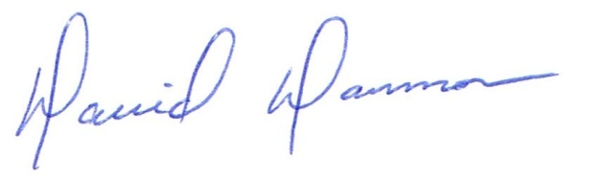
David Dammon, VP
Dammon Engineering, Inc.

