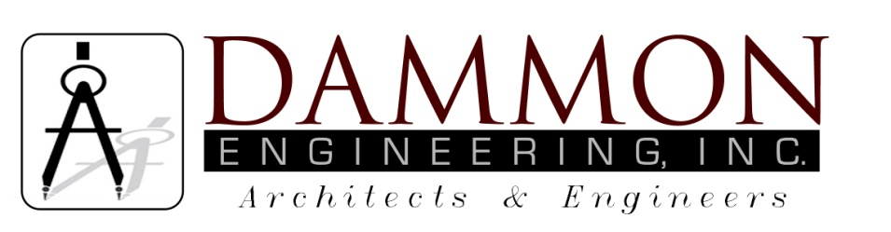
554 Old Spanish Trail
Slidell, LA 70458
Phone: 985-649-5832
Fax: 985-641-5950
dammonengineering.com
dammoneng@bellsouth.net

Certificate of Completion

This is to certify the below project:

Rainforest Carwash
5026 Hardy St.
Hattiesburg, Mississippi
Job#2176
Dated 6-28-13

Was periodically observed by me, by my consultants and /or by others in my employ during construction and, to the best of my knowledge, information and belief, has been completed in accordance with the safety provisions which were shown in the plans and specifications.

