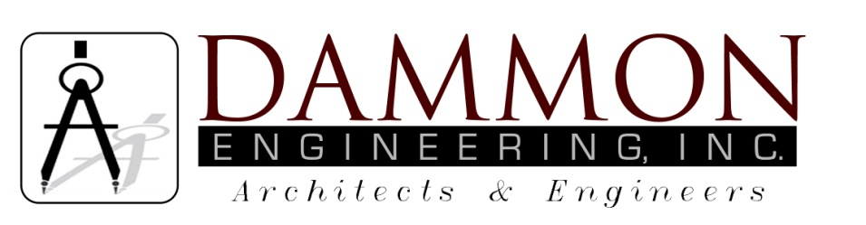
554 Old Spanish Trail
Slidell, LA 70458
Phone: 985-649-5832
Fax: 985-641-5950
dammonengineering.com
dammoneng@bellsouth.net

January 14, 2014

To: Nicholson Water & Sewer Association, Inc
Subject: Dreamland Mobile Home Park

As you are aware, there is no centralized sewerage system available for the Dreamland Mobile Home Park. The park is located remotely down the end of Emmett Meitzler Road in an area where the sewer district has not provided wastewater services. To connect to the Nicholson Sewer system the Dreamland Park owner will take it upon himself to construct a holding tank, a pump station, and a transmission line to the first available manhole, which is a substantial distance away and will cost a significant sum for the owner to instate.

Mr. Smith indicates that your sewer system is incapable of handling its current flows during storm periods, however he provides no exacting engineering data to substantiate the claim that 12,000 gallons per day (in this case at night) will be the tipping point that the system will no longer be viable. We have no doubt that the system suffers from inflow and infiltration and that an upgrade of the transmission force mains is advisable, however, we feel that the additional 12KGPD, when introduced in a calculated systematic manner will not greatly impact a system capable of 100K+ of gallons of flow. If the system is so overburdened then it is incumbent that the upgrade cost be shared by all users and not just one customer.

The recommendation from Mr. Smith “that you not allow them to put in the holding tank or the on-site system” and “that you ask them to cost share in upgrading your lift station……… running a larger force main 6”….. “Places an undue burden on one single customer by requiring an excessive amount money to receive services that other customers have not had to pay.

The Dreamland Mobile Home utility upgrade project has been stalled for several years while a public health risk increases within its borders. The holding tank proposal is a sound remedy; 300 gallons per Mobile Home Park site is a reasonable/reliable maximum usage approximate, and the implementation of the project will improve the lives of the park residents, improve the environment, provide better living condition for families, and insure a monthly income to the Sewer District in perpetuity.

The owner is willing to provide a fair inducement; however, negotiations cannot be based on monetary compulsions. With that said, it is suggested that you make a just and balanced offer. This project upgrade is well overdue and further delays will not be in any ones interest. We wish a prompt reply before the February meeting.

We await your response.

Respectfully,

Brian A. Mistich, P.E.
Mississippi Registration #20971

