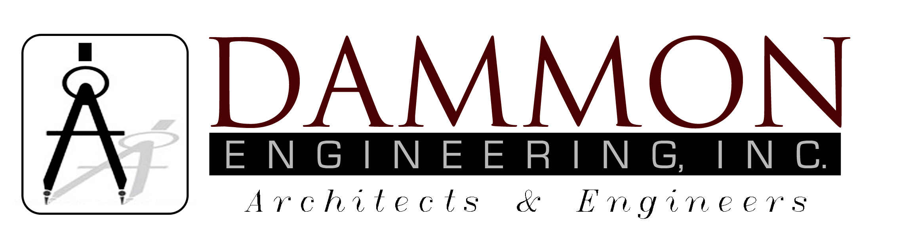554 Old Spanish Trail
Slidell, LA 70458
Phone: 985-649-5832
Fax: 985-641-5950
dammonengineering.com
dammoneng@bellsouth.net

April 1, 2015

Mr. Kevin Bates
Sr. Technical Inspector
City of Hattiesburg
200 Forrest St.
Hattiesburg, MS 39401

RE: Rain Forest Car Wash/Hwy 49

Mr. Bates,

Please accept this letter as verification that I have performed the required inspections on the CMU walls for the referenced project and they were all installed per plans.

If you have any questions, or require any additional information, please feel free to call.

Thank you,

Chuck Dammon

