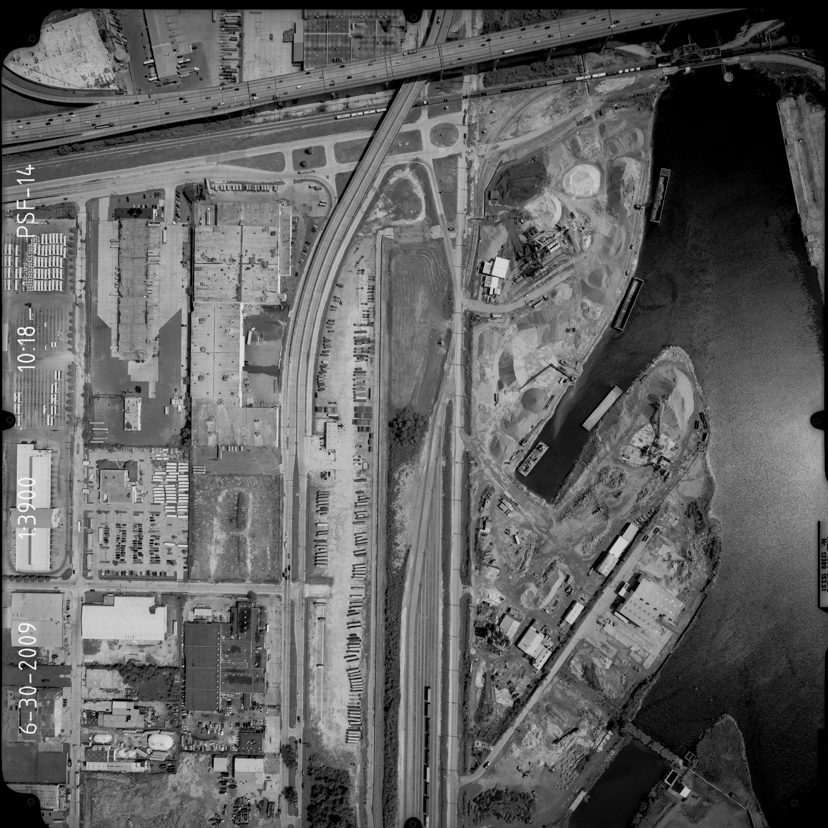
Vicinity Map
New Scale Location

