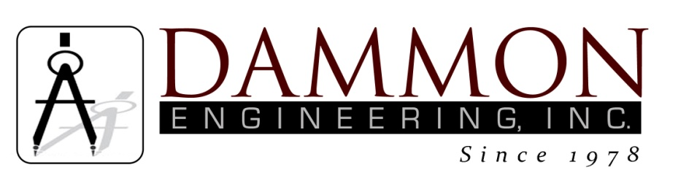
554 Old Spanish Trail
Slidell, LA 70458
Phone: 985-649-5832
www.dammonengineering.com
info@dammonengineering.com

BRIDGE CITY CENTER FOR YOUTH
SEWER SYSTEM RENOVATION
BRIDGE CITY, LOUISIANA
State Project #’s: 08-403-11-01, PART 01 &
08-403-04B-01, PART 20 & 01-107-06B-11, Part U7
Engineer’s Project: 2156
Pre-Construction Meeting Minutes

November 2, 2017
10:45 a.m.

Attendees:
David Dammon, Dammon Engineering, Inc
Creighton Stout, FP&C
Curtis Badon, OJJ Central Office
Leroy Crawford, Assistant Director of Maintenance
Sterling White, BCCY Maintenance
A.J. Bouchon, ARC Mechanical

Minutes:
- The follow issues were discussed during the meeting:

- ARC Mechanical is currently working on the service lateral for the Bldg K. This service lateral has many obstructions between the building and the manhole that it is connected to.
  - There is a 20 inch storm water pipe that runs perpendicular to the location where the service lateral is shown to cross the large courtyard and is at the same elevation where the lateral would need to be installed. This storm water pipe is running parallel to the breezeway in front of Bldg K about 3 to 4 feet inside the large courtyard.
  - About 10 feet further inside the large courtyard there is a concrete duct bank that runs perpendicular to the location where the service lateral is shown to cross the large courtyard and is at the same elevation where the lateral would need to be installed.
  - Closer to the manhole there is another concrete duct bank that runs perpendicular to the location where the service lateral is shown to cross the large courtyard and is at the same elevation where the lateral would need to be installed. The bottom of the existing service lateral is actually below the elevation where it deposits into the manhole.
All of these obstructions cause the new gravity fed lateral to be installed at a lower elevations than the location where it will be connected to the manhole. Three options have been proposed to be able to fix these issues:
- Option 1 is to route the new lateral into the 8” main rather than into the manhole. (Note, since the meeting other obstacles that may pose an issue with this option have been dug up. About 5 feet in the direction of where we proposed to cut into the main, some steam pipes cross over the main sewer line.)
- Option 2 is to cut out the storm drain and install two catch basins on both sides of the location where the lateral crosses. These two catch basins would have a wide short rectangular pipe installed between them to allow for the sewer line to cross over the top. At this elevation it would cross over the two concrete duct banks in the large court yard.
- Option 3 is to install a lift station and run a 2” force-main to the manhole.

Note: The next regular scheduled monthly meeting is scheduled November 28 @ 10:30am.

