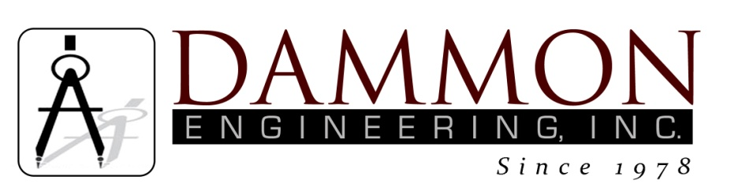
554 Old Spanish Trail
Slidell, LA 70458
Phone: 985-649-5832
www.dammonengineering.com
info@dammonengineering.com

BRIDGE CITY CENTER FOR YOUTH
SEWER SYSTEM RENOVATION
BRIDGE CITY, LOUISIANA
State Project #’s: 08-403-11-01, PART 01 &
08-403-04B-01, PART 20 & 01-107-06B-11, Part U7
Engineer’s Project: 2156
Pre-Construction Meeting Minutes

July 26, 2017
11:00 a.m.

Attendees:
David Dammon, Dammon Engineering, Inc
Creighton Stout, FP&C
Curtis Badon, OJJ Central Office
John Vititoe, BCCY Maintenance
Tim Marlowe, ARC Mechanical
Arthur Bouchon (AJ), ARC Mechanical

Minutes:
- Meeting opened with sign in of attendees.
- The follow issues were discussed during the meeting:

- The service lateral along the admin building, an electrical duct bank that caused the service lateral to terminate short of the gymnasium.
- The requirements to abandon the manhole that was discovered behind the residence building.
- The new lateral at the Pavilion has been terminated at the new fence line. The existing lateral at the new fence line turned down deep and would not cause issues with proper flow. It was discussed how any work under the new fence would need to be uncovered and recovered all in the same day. The replacement cover would need to extend a minimum of 3 ft on each side before the end of the work day.
- Building K has had a water leak from under the building. This water leak has been repaired; the contractor will give the area time to absorb the water that was standing in the courtyard.

The next scheduled monthly meeting is scheduled for August 29th at 10:30 am.

