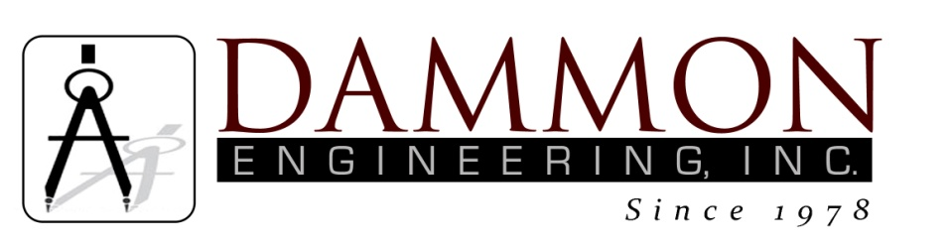
554 Old Spanish Trail
Slidell, LA 70458
Phone: 985-649-5832
www.dammonengineering.com
info@dammonengineering.com

BRIDGE CITY CENTER FOR YOUTH
SEWER SYSTEM RENOVATION
BRIDGE CITY, LOUISIANA
State Project #’s: 08-403-11-01, PART 01 &
08-403-04B-01, PART 20 & 01-107-06B-11, Part U7
Engineer’s Project: 2156
Pre-Construction Meeting Minutes

September 26, 2017
10:45 a.m.

Attendees:
David Dammon, Dammon Engineering, Inc
Creighton Stout, FP&C
Curtis Badon, OJJ Central Office
Jacqueline Page, Deputy Asst Secretary/SE Regional Director
Sterling White, BCCY Maintenance
A.J. Bouchon, ARC Mechanical

Minutes:
- Meeting opened with sign in of attendees.
- The follow issues were discussed during the meeting:

- ARC Mechanical is currently working on the service lateral for the Infirmary. Starting tomorrow, 9/27/2017 they will be cutting the concrete walkway that is the primary access path for individuals that need to gain access to the Infirmary. This primary path will not be accessible during the work, which is estimated to take 2 work days.

- One of the upcoming issues will be during the period of time that ARC Mechanical will need to open a trench under the security fencing near the rear gate. This process is expected to take 2 work days with the trench under the fence being left open overnight. Extra Security will be required to monitor this opening overnight.

Note: The next regular scheduled monthly meeting is scheduled October 31 @ 10:30am.

