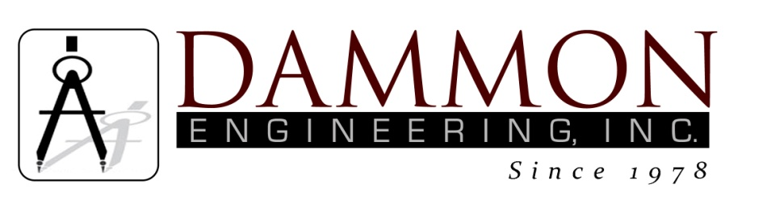
554 Old Spanish Trail
Slidell, LA 70458
Phone: 985-649-5832
www.dammonengineering.com
info@dammonengineering.com

BRIDGE CITY CENTER FOR YOUTH
SEWER SYSTEM RENOVATION
BRIDGE CITY, LOUISIANA
State Project #’s: 08-403-11-01, PART 01 &
08-403-04B-01, PART 20 & 01-107-06B-11, Part U7
Engineer’s Project: 2156
Construction Meeting Minutes

January 30, 2018
10:30 a.m.

Attendees:
David Dammon, Dammon Engineering, Inc
Curtis Badon, OJJ Central Office
Leroy Crawford, BCCY Assistant Director of Maintenance
Monique Fisher, BCCY Safety Officer
Sterling White, BCCY Maintenance
Tim Marlowe, ARC Mechanical
A.J. Bouchon, ARC Mechanical

Minutes:
- The follow issues were discussed during the meeting:

- Work is continuing on the conflict box for Bldg K and the piping has been installed from the manhole up to where the conflict box is being constructed.
- Four options were submitted from ARC Mechanical for the lift station(s). The options for the lift station(s) were discussed, mainly about the difference between the grinder unit(s) and the grinder pump(s). The grinder unit is a self contained unit that is placed at the point where the inflow discharges into the wet well. This grinder unit shreds almost anything, i.e. tennis shoes, that come into the unit. The grinder pump is a standard grinder pump that grinds normal household waste into a slurry.
- A quote for the repair work of the floor drain in the Mechanical Room discussed and drawings were located that show the grade beams for the building in relation to the location of the floor drain(s). It appears that the floor drain in question is sitting directly next to a grade beam.

Note: The next construction meeting is scheduled for February 27th at 10:30am in the conference room at BCCY.

