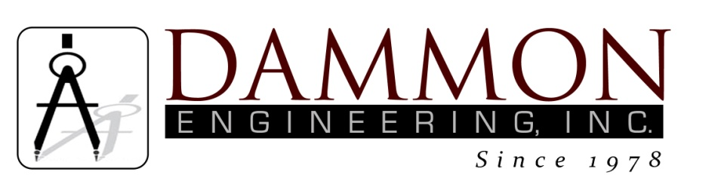
554 Old Spanish Trail
Slidell, LA 70458
Phone: 985-649-5832
www.dammonengineering.com
info@dammonengineering.com

BRIDGE CITY CENTER FOR YOUTH
SEWER SYSTEM RENOVATION
BRIDGE CITY, LOUISIANA
State Project #’s: 08-403-11-01, PART 01 &
08-403-04B-01, PART 20 & 01-107-06B-11, Part U7
Engineer’s Project: 2156
Construction Meeting Minutes

January 9, 2018
10:30 a.m.

Attendees:
David Dammon, Dammon Engineering, Inc
Creighton Stout, FP&C
Dr. James Bueche, OJJ Deputy Secretary
Curtis Badon, OJJ Central Office
Nick Zinni, BCCY Director of Maintenance
Sterling White, BCCY Maintenance
A.J. Bouchon, ARC Mechanical

Minutes:
- The follow issues were discussed during the meeting:

- Work has progressed on the Dining Hall, the new service lateral and grease trap has been installed and connected to the Dining Hall. The area(s) that have been disturbed while installing the service lateral and grease trap still need to be graded and have the clean-outs installed.
- Work has been restarted on the service lateral(s) for Bldg K, the conflict box for the center courtyard of Bldg K has been approved. While working on the north end and south end of Bldg K more concrete conflicts have been discovered. After discussing the options for alternate routes of piping it was determined to install a lift station to support the north side of Bldg K and another lift station to support the south side of Bldg K. Power for the lift stations will need to come from the existing 480V service to the building. The existing service disconnect to the building will need to be upgraded to a 480V 200 amp Service Switchboard. A change order request will be sent to ARC Mechanical for the lift stations and electrical work.
- The Mechanical Room had about 8 floor drains originally installed; however over the years all of the floor drains have stopped working and during heavy rain(s), water backs up from the soil below the slab up into the room. The staff currently has a sump pump that they use to drain the water from the Mechanical Room. It was requested to obtain a quote from ARC Mechanical to have at least one of the drains repaired and properly connected to the sewer line that runs just outside the mechanical building.

Note: The next scheduled meeting will be held January 30th at 10:30am in the conference room at BCCY.

