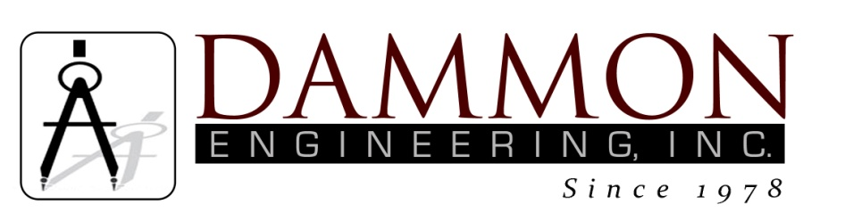
554 Old Spanish Trail
Slidell, LA 70458
Phone: 985-649-5832
www.dammonengineering.com
info@dammonengineering.com

BRIDGE CITY CENTER FOR YOUTH
SEWER SYSTEM RENOVATION
BRIDGE CITY, LOUISIANA
State Project #’s: 08-403-11-01, PART 01 &
08-403-04B-01, PART 20 & 01-107-06B-11, Part U7
Engineer’s Project: 2156
Construction Meeting Minutes

June 26, 2018
10:30 a.m.

Attendees:
David Dammon, Dammon Engineering, Inc
Creighton Stout, FP&C
Nick Zinni, BCCY Deputy Director
Lance Daniels, Sr., BCCY JJS-7
Chelsea Brown, BCCY Admin Coordinator
A.J. Bouchon, ARC Mechanical

Minutes:
- The follow issues were discussed during the meeting:

- The floor drain repair has been completed for a single floor drain inside the Mechanical Room. Before the repair, none of the floor drains were operating.
- The installation of the 2 lift stations for Bldg K has begun. It was discussed why lift stations were needed at these locations and how they will operate.
- This project is getting close to being complete. BCCY personnel should make notes about areas where this project has impacted the site and items that need to be attended. There is a limited amount of grass that has been allocated to this project, site personnel should assist in determining the best use of the grass to keep the site from eroding.

Note: The final construction meeting is scheduled for July 31th at 10:30am in the conference room at BCCY.

