
554 Old Spanish Trail
Slidell, LA 70458
Phone: 985-649-5832
www.dammonengineering.com
info@dammonengineering.com

Mr. Mark E Bradley August 15, 2019
Project Manager FP&C
1450 Poydras St., Suite 1130
New Orleans, LA 70112
Re: Justification for Sole Source : Troop L : HVAC Replacement
Project No 01-107-06B-11, F.01003807; State ID: S00814; Site Code: 1-52-004
Mr. Bradley,
Examples of circumstances which could necessitate sole source procurement are: a. where the compatibility of equipment, accessories, or replacement parts is the paramount consideration

The existing HVAC is currently connected to a proprietary Fire Alarm System that is maintained by Advantage Alarm. During the replacement of the Air Handler Unit (AHU) this device must be disconnected from the alarm system and reconnected to the AHU by a certified installer approved by the State Fire Marshal’s office. Since the system is a proprietary system that is currently maintained by
If you have any questions, please contact us.
Thank You,

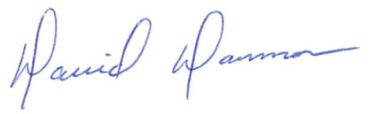
David Dammon
President

