REQUEST FOR WRITTEN QUOTES

The City of Slidell is soliciting written quotes for the CDBG Sidewalks and Drainage Improvements on 2nd Street – Phase II project. The project is located on Cleveland Ave. between Lincoln Ave. and 8th St. & also at 2nd St. between Cleveland Ave. and Guzman St., Slidell La. Quotes will be received until 10:00 am Wednesday, February 28, 2018 and shall be hand delivered or mailed to the Purchasing Department located at 1329 Bayou Lane, Slidell, LA 70460, Attn: Purchasing Agent.

Quotes must be submitted in a sealed envelope and clearly marked:

Quote: CDBG Sidewalks and Drainage Improvements on 2nd Street – Phase II
Quote # _________
File Number 5000-36

Due: February 28, 2018, 10:00 AM CST

Drawings are attached.

For the successful quote exceeding $25,000, the contractor will be required to provide a payment and performance bond in the amount of not less than 100% of the awarded contract amount.

*Quotes exceeding $50,000 – A Louisiana State Contractor License is required to perform the work and your license number shall be included in your quote. The Contractor shall hold a Louisiana Contractor’s license in Building Construction or Municipal and Public Works Construction.

An executed affidavit will be required prior to award of contract. Certificate of Liability Insurance and Statutory Limits Worker’s Compensation must be submitted prior to award of contract.

Contractor shall have 45 calendar days to complete this project from the date of Notice to Proceed. The contractor will be charged liquidated damages of Five Hundred Dollars ($500.00) per calendar day in excess of the stated time of completion.

Quote submissions: Quotes shall be submitted on the forms provided and signed by an authorized company representative. The City of Slidell reserves the right to reject any and all quotes.

Any questions concerning this project shall be directed to Mr. Blaine Clancy, City Engineer, at (985) 646-4270.

1 | Mobilization and Demobilization | 1 | L.S.
2 | Muck Out & Dispose of Materials | 245 | N.C.Y
3 | Removal and Disposal of 12” RCP | 40 | L.F.
4 | Granular Fill (Sand Base Course) | 84 | N.C.Y
5 | 15” RCPA | 380 | L.F.
6 | 4” PVC Type PSM Sewer Piping for Yard Drains | 25 | L.F.
7 | 6” PVC Type PSM Sewer Piping for Connection from existing 6” PVC Pipe | 15 | L.F.
8 | Concrete Drop Inlet, 24” x 24” | 7 | E.A.
9 | Polypropylene Yard drains, 12”x12” | 5 | E.A.
10 | 5’ Wide Sidewalk with Exposed Aggravate Concrete and Brick Pavers | 280 | S.Y
11 | Asphalt Concrete Pavement (Type 3) | 643 | S.Y.
12 | Pavement Markings (Striping) | 944 | L.F.
13 | Crushed Stone Aggregate (#57 Limestone) | 3 | N.C.Y.
14 | Sodding | 515 | S.Y.
15 | St. Charles Light Pole | 14 | E.A.
16 | Wiring for Light Poles | 700 | L.F.
17 | Conduit, Wiring and NEMA 3R photoelectric switch with dust to dawn control | 1 | L.S.
18 | Ground Rods | 14 | E.A..
1312 | Wiring for Light Poles with existing conduit, switched with Dusk to Dawn PhotocellPaint Parking Stripes | 700944 | L,F.L.F.
1413 | Installed Ground Rods for Light PolesWiring for Light Poles with existing conduit, switched with Dusk to Dawn Photocell | 14700 | E.A.L,F.
1514 | Installed St. Charles Light PoleInstalled Ground Rods for Light Poles | 1414 | E.A.E.A.
15 | Installed St. Charles Light Pole | 14 | E.A.
Note: The above quantities are approximate and will be adjusted to fit the budget.

TOTAL QUOTE PRICE IN FIGURES

TOTAL QUOTE PRICE IN WORDS

*LA. LICENSE NUMBER
SIGNATURE

COMPANY NAME
SIGNER’S NAME (PRINTED)

ADDRESS

PHONE NUMBER

EMAIL

SPECIFICATIONS

STATEMENT OF WORK

- This project consists of constructing new sidewalks, drainage, and new asphalt parking on the East side of 2nd Street between Cleveland Ave and Guzman Street. Install new St Charles light poles and wiring on existing concrete pedestals and existing conduit runs on the East side of 2nd Street between Cleveland Ave and Guzman Street.
- A description of pay items, including measurement and payment is given below:

DAVIS BACON ACT

- This project requires that Davis Bacon Act wages be paid, see “General Decision Number: LA180015” dated 01/05/2018 attached.

WARRANTY

- Contractor shall warranty all work and materials for one (1) year.

TRAFFIC CONTROL

- Any work within the roadway or adjacent to the roadway causing interference to vehicular traffic requires prior approval from the city of Slidell, and must conform to the requirements set forth by the manual of uniform traffic control devices. The contractor must furnish all necessary traffic signs and/or barricades and maintain them during construction activity.

- Payment for Traffic Control will be included in each line item that requires traffic control and shall not be a direct pay item.

MOBILIZATION

- This work consists of preparatory work and operations, including those necessary for movement of personnel, equipment, supplies, and incidentals to the project site; the establishment of facilities necessary for the work on the project; the costs of bonds and any required insurance; and other preconstruction expenses necessary for start of the work, excluding the cost of construction materials. In addition the contractor shall provide and install in place as directed by the Engineer, two project signs as per details included in this RFQ package.

- The Contractor shall provide all necessary materials and equipment necessary to complete all work associated with this item as shown on the plans or as directed by the Engineer.
- Payment for Mobilization shall be made at the lump sum contract unit price.

GENERAL EXCAVATION

- The contractor shall furnish all materials, labor, and equipment necessary to remove all earth, rock, water, debris, tree stumps and other materials to the extent required by the Engineer in preparation for the pipe bedding and concrete foundation base. Excavation will be paid per cubic yard by net section. Some topsoil shall be retained to slope the finished grade as per plans. Disposal of excess excavated material shall be included in this pay item. Responsibility for disposal of all excavated material to satisfy all local, state, and federal regulation rests with the Contractor.
- Protect existing site improvements to remain from damage during construction.
- Remove any sod and grass before stripping topsoil. Strip topsoil to a depth of 6 inches in a manner to prevent intermingling with underlying subsoil or other waste materials. Stockpile borrowed topsoil away from edge of excavations without intermixing with subsoil. Grade and shape the stockpile to drain surface water. Cover to prevent windblown dust and erosion by water.
- Excavate surfaces under new walkways and drainage piping to obtain indicated elevations shown on the drawings. Notify Engineer when excavations have reached required subgrade. If Engineer determines that unsatisfactory soil is present, continue excavation and replace with compacted backfill or fill material as directed.
- Payment for excavation will be made at the contract unit price per net cubic yard and include all costs for material, labor, and equipment.

REMOVAL AND DISPOSAL OF 12” RCP

- This work consists of removing and disposing existing 12” RCP in accordance with these plans and specifications and in conformity with the grades shown on the plans or established. Excavation, backfill, and compaction for the installing of the catch basin shall be included in the bid price for each catch basin.
- All workmanship, construction methods, and material shall be in accordance with Louisiana Standard Specifications for Roads and Bridges, 2016 edition, Section 701.
- Payment for removal and disposal of RCP shall be paid for at the contract unit price per linear foot, which shall be full compensation for all required materials, tools, equipment, labor, disposal and incidental work necessary to complete this work.

GRANULAR FILL (SAND BASE COURSE)

- Bedding and backfill shall be non-plastic and siliceous material. Granular fill shall be uniformly compacted to at least 95% modified proctor of maximum dry weight density.
- Granular material shall conform to the following requirements:
        - Liquid limit (maximum) 25% (percent)
        - Plasticity index (max) 6% (percent)
        - U.S. Sieve Metric Sieve Percent Passing

½ inch 12.5 mm 100

No. 10 2.0 mm 75-100

No. 200 75 mm 0-10
- Granular fill material shall be paid for per net cubic yard. The quote shall include all costs for material, labor, equipment, hauling, placing, spreading, compacting and grading for this item.

STORM UTILITY DRAINAGE PIPE

- This work consist of installing Reinforced Concrete Piping-ARCH (RCPA) as shown on the plans that conforms to ASTM C506 and the Louisiana Specifications for Roads and Bridges, 2016 edition, Section 701.
  - The pipe shall be Class II, Wall B.
  - To form the pipe bed, the compacted earth cushion shall have a thickness under the pipe of at least 1/2 inch per foot of fill height over the top of the pipe with a minimum thickness of 6 inches. When a suitable foundation cannot be obtained, unstable soil below established grade shall be removed and replaced with granular bedding material.
  - The pipe shall be laid beginning at the downstream end of the line. The pipe shall be in contact with the foundation throughout its length. Bell or groove ends of pipe shall be placed facing upstream.
  - After pipe has been laid and before backfill is placed, the engineer will inspect the pipe for alignment, grade, integrity of joints, and coating damage.
- Yard drain installation shall consist of installing PVC piping as shown on the plans that conforms to ASTM D 3034, SDR 26, PVC Type PSM Sewer Pipe with bell-and-spigot ends for gasketed joints. Fitting shall conform to ASTM D 3034, PVC with bell ends. Gaskets shall conform to ASTM F 477, elastomeric seals.
- Payment for RCPA pipe shall be paid at the contract unit price per linear foot which shall include all costs for material, labor, and equipment for installation.
- Payment for yard drain piping shall be paid at the contract unit price per linear foot which shall include all costs for material, labor, and equipment for installation.

DROP INLETS

- This work consists of installing concrete drop inlets inter-connected with RCPA pipe, above, as shown on the plans that conforms to ASTM C 478 and Louisiana Standard Specifications for Roads and Bridges, 2016 edition, Section 702.
  - The base section shall be a minimum of 6” thick for the floor slab and 4-inch minimum thickness for walls and base riser section, and separate base slab or base section with integral floor.
  - The riser section shall have a minimum thickness of 4”, with lengths to provide depth indicated.
  - The top section shall have a flat-slab-top type as indicated.
  - The Frame or Grate for the concrete drop inlet shall meet the minimum standard of ASTM A 536, Grade 60-40-18, ductile iron designed for A-16, structural loading. Include flat grate with small square or short-slotted drainage openings. The size shall be 24 by 24 inches minimum unless otherwise indicated. The grating shall have not less than 50 percent free area.

- This work consists of installing Yard drains as shown on the plans that are constructed of Polypropylene. The grate shall be 12” x 12” square grate, green color, constructed of structural foam polyolefin with a UV inhibitor. The catch basin shall be capable of adapting to 6” PVC pipe. The grate shall have a Class B load rating.
- Payment for concrete drop inlets will be made at the contract unit price per unit and includes all costs for material, labor, installation and equipment.
- Payment for Polypropylene Yard drains will be made at the contract unit price per unit and includes all costs for material, labor, installation and equipment.

FIBER-REINFORCED CEMENT PAVING WITH EXPOSED AGGREGATE

- This item covers the furnishing of all materials and installation of sidewalk pavements for thickness as shown on plans.
- Concrete Mixtures:
Prepare design mixtures as follows per cubic yard of fiber-reinforced concrete:
- 28-day strength = 4,000 psi
- Cement (ASTM C-150, Type I/II) 4.64 sacks (436 lbs.)
- Fly Ash (ASTM C-618) 1.16 sacks (109 lbs.)
- Gravel (ASTM C-33, Grade A) 1775 lbs.
- Sand (ASTM C-33) 1226 lbs.
- Water (potable) 30 gallons (250 lbs.)
- Type A Water Reducer (ASTM C-494) 16.35 lbs.
- Air entrainment 5% by volume, use per manufacturers specifications
- Fiber reinforcement 1.5 lbs/ CY microfibers, Fiber reinforcement shall be Matrix Monofilament Microfiber as manufactured by FRC Industries or approved equal, applied throughout the concrete mixture. Fiber reinforcement shall be applied at the plant. The bags must be broken before mixing. Bag size shall be one (1) pound. Alternate products must be preapproved by the Engineer in writing. Cellulose (treated or untreated), AR glass, nylon, and polyester fibers are specifically prohibited from use. Fibrillated and self-fibrillating fibers are also specifically prohibited.
- Exposed aggregate sidewalk shall be reinforced with 6x6 welded wire fabric, supported such that it is mid-depth in the finished slab.
- Provide solid brick pavers as sold by St. Joe Brick Works, Inc. or approved equal. The color of brick and exposed aggregate surface shall match existing sidewalks in the Slidell area.
- Payment for exposed aggregate sidewalks with brick pavers shall be made at the contract unit price per square yard and include all costs for material, labor, installation and equipment.

ASPHALT CONCRETE PAVEMENT (TYPE 3)

- This work consists of furnishing and constructing one or more courses of asphaltic concrete mixture applied hot in conformity with the lines, grades, thicknesses and typical sections shown on the plans. All mixtures shall be performed in accordance with Section 501 of the Louisiana Standard Specifications for Roads and Bridges, 2000 Edition (Red Book), and latest revisions, except as otherwise noted in these specifications.
- Grade to match existing roadway (after asphalt layer) grades and drainage patterns.
- Prime coat and tack coat shall comply with 2000 La DOTD Standard Specifications for Roads and Bridges (LSSRB). Prime coat shall be cured 24 hours prior to binder course application. Tack coat all vertical edges and existing pavement surfaces. No curing time for the tack coat will be required. If coated areas are damaged or unsatisfactory prior to asphalt application, those areas shall be re-coated at no direct pay.
- Design and quality control shall be in accordance with Section 501.03 of the 2000 LSSRB except City of Slidell will hire an independent testing lab to monitor plant and field operations.
- Asphalt mix shall be Type 3 with a maximum of reclaimed asphaltic pavement (RAP) as specified in Section 501 of the 2000 LSSRB or other suitable mix approved by the Slidell Engineering Department. A copy of the 2000 DOTD LSSRB specifications is available in the Slidell Engineering office for review.
- Payment for asphalt will be made at the contract unit price per square yard and include all costs for material, labor, installation and equipment. Cores will be required to verify thickness and shall be provided and repaired by contractor at no direct pay.

PAVEMENT MARKINGS (STRIPING)

- This work shall consist of painting stripes on parking areas constructed with asphalt paving. The paint shall be a latex, waterborne emulsion, lead and chromate free, ready mixed complying with FS TT-P-1952, with drying time of less than 45 minutes. The color shall be as shown on plans.
- Payment for Pavement Markings shall be paid at the contract unit price per linear foot which shall include all costs for material, labor, and equipment for installation

CRUSHED STONE AGGREGATE (#57 LIMESTONE)

- Limestone driveway shall be graded aggregate of sound crushed stone complying with ASTM D 448 for Size No. 57. The material shall consist of 100% crushed stone and be free of soil, roots, debris, rubbish, or any other materials.
- Crushed stone aggregate shall be paid for per net cubic yard. The quote shall include all costs for material, labor, equipment, hauling, placing, spreading, compacting and grading for this item.

SODDING

- This work consists of furnishing, hauling, planting, rolling, watering and maintaining live grass sod at locations shown on the plans or as directed.
- Contractor shall provide sod that is Nursery grown Grade ‘A’ Centipede. Deliver sod on pallets and protect roots from dehydration before installation. All sodding shall be in accordance with the 2016 Edition of the Louisiana Specifications for Roads and Bridges Section 714.
- Provide a slow-release fertilizer that is granular or pelleted which consist of 50% water-insoluble nitrogen, phosphorus, and potassium in the following composition: 20 percent nitrogen, 10 percent phosphorous, and 10 percent potassium, by weight.
- Sodding shall be paid per square yard. The quote shall include all costs for material, labor, equipment, hauling, planting, rolling, and watering until the project is accepted for substantial completion.

EXTERIOR ELECTRICAL & LIGHTING

          - Contractor shall provide St. Charles Light Poles which are UL 1598 classified and shall be listed and labeled for installation in wet locations by an NRTL acceptable to authorities having jurisdiction.
  - The strength of the Light Poles shall be adequate for the basic wind-load of 130 mph.
  - Luminaire attachment(s) shall comply with the luminaire manufacturers' mounting requirements. Use stainless-steel fasteners and mounting bolts unless otherwise indicated.
  - Grout shall conform to ASTM C 1107, factory-packaged, nonmetallic aggregate grout, noncorrosive, non-staining, mixed with water to consistency suitable for application and a 30-minute working time.
  - Install an LED lamp in each Light Pole that has a temperature of 5000k with 3700 lumens. Provide the owner with 50% spare lamps.
  - Payment for St. Charles Light Poles will be made at the contract unit price per unit.

          - Contractor shall de-water existing conduits and install THWN wiring to and from each light base as shown on the drawings. Contractor shall install conduit and wire from the existing panel board. All conductors shall be copper and comply with NEMA WC 70/ICEA S-95-658. The conductor insulation shall comply with NEMA WC 70/ICEA S-95-658. Copper conductors 12 AWG and smaller shall be either sold or stranded; conductors 10 AWG and larger shall be stranded. Use manufacturer-approved pulling compound or lubricant where necessary; compound used must not deteriorate conductor or insulation. Do not exceed manufacturer's recommended maximum pulling tensions and sidewall pressure values. Payment for wiring will be made at the contract unit price per linear foot.

          - Contractor shall provide and install all conduit(s), wiring and a NEMA 3R photoelectric switch with dust to dawn control. The switch shall be rated for 1800VA to operate the LED connected load. Payment for conduit, wiring and photoelectric switch will be made at the contract unit price of lump sum.

          - Contractor shall provide and install grounding electrodes at each pole location as shown in the drawings. Grounding electrodes shall be Copper-clad steel ground rods that are 5/8 inch by 96 inches. Payment for grounding electrodes will be made at the contract unit price per unit.

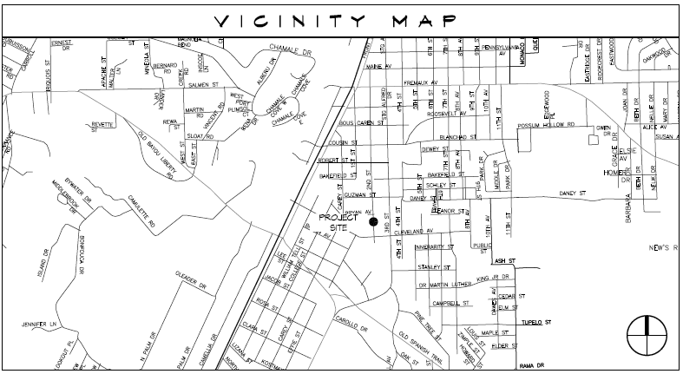

VICINITY MAP
CDBG SIDEWALKS AND DRAINAGE
IMPROVEMENTS ON 2ND STREET – PHASE II
Project 5000-36

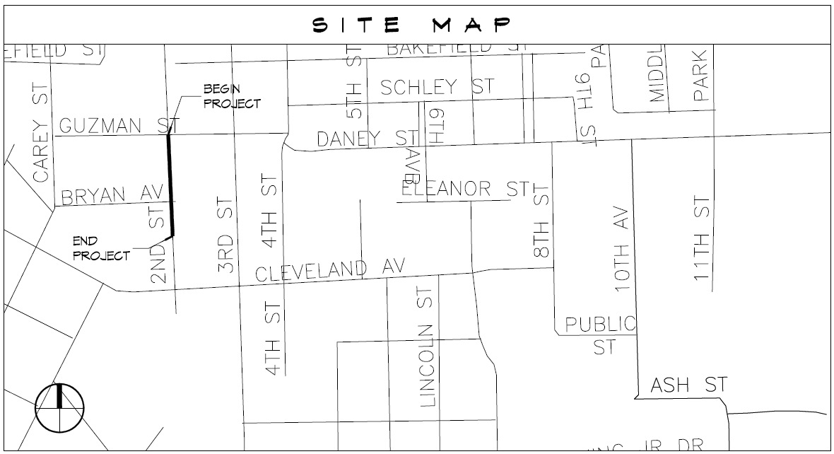

SITE MAP
CDBG SIDEWALKS AND DRAINAGE
IMPROVEMENTS ON 2ND STREET – PHASE II
Project 5000-36

