REQUEST FOR WRITTEN QUOTES

The City of Slidell is soliciting written quotes for the CDBG Sidewalks and Drainage Improvements on 2nd Street – Phase II project. The project is located on Cleveland Ave. between Lincoln Ave. and 8th St. & also at 2nd St. between Cleveland Ave. and Guzman St., Slidell La. Quotes will be received until 10:00 am Wednesday, February 28, 2018 and shall be hand delivered or mailed to the Purchasing Department located at 1329 Bayou Lane, Slidell, LA 70460, Attn: Purchasing Agent.

Quotes must be submitted in a sealed envelope and clearly marked:

Quote: CDBG Sidewalks and Drainage Improvements on 2nd Street – Phase II
Quote # _________
File Number 5000-36

Due: February 28, 2018, 10:00 AM CST

Drawings are attached.

For the successful quote exceeding $25,000, the contractor will be required to provide a payment and performance bond in the amount of not less than 100% of the awarded contract amount.

*Quotes exceeding $50,000 – A Louisiana State Contractor License is required to perform the work and your license number shall be included in your quote. The Contractor shall hold a Louisiana Contractor’s license in Building Construction or Municipal and Public Works Construction.

An executed affidavit will be required prior to award of contract. Certificate of Liability Insurance and Statutory Limits Worker’s Compensation must be submitted prior to award of contract.

Contractor shall have 45 calendar days to complete this project from the date of Notice to Proceed. The contractor will be charged liquidated damages of Five Hundred Dollars ($500.00) per calendar day in excess of the stated time of completion.

Quote submissions: Quotes shall be submitted on the forms provided and signed by an authorized company representative. The City of Slidell reserves the right to reject any and al quotes.

Any questions concerning this project shall be directed to Mr. Blaine Clancy, City Engineer, at (985) 646-4270.

QUOTE FORM for CDBG SIDEWALKS AND DRAINAGE IMPROVEMENTS ON 2ND STREET – PHASE II

City of Slidell, LA

Quote # _______

ITEM NO. | ITEM DESCRIPTION | QUAN. | UNIT | UNIT PRICE | UNIT PRICE EXTENSION
1 | Mobilization and Demobilization | 1 | L.S.
2 | Remove Existing 12” RCP | 40 | L.F.
3 | Muck Out & Dispose of Materials | 245 | N.C.Y
4 | Sand and Base Course / Backfill | 84 | N.C.Y
5 | 5’ Wide Sidewalk with Exposed Aggravate Concrete and Brick Pavers | 280 | S.Y
6 | Plastic Yard Drain, 12”x12” with 4” Drain Pipe to Catch Basin | 5 | E.A.
7 | 24” x 24” Drop Inlet | 7 | E.A.
8 | Installed 15” RCPA | 380 | L.F.
9 | Installed SOD | 515 | S.Y.
10 | Installed Dectectable Warning Pad, 2ft x 5ft | 2 | E.A.
11 | Asphaltic Concrete Wearing Courses 5” thick | 515 | S.Y.
12 | Paint Parking Stripes | 944 | L.F.
13 | Wiring for Light Poles with existing conduit, switched with Dusk to Dawn Photocell | 700 | L,F.
14 | Installed Ground Rods for Light Poles | 14 | E.A.
15 | Installed St. Charles Light Pole | 14 | E.A.
Note: The above quantities are approximate and will be adjusted to fit the budget.

TOTAL QUOTE PRICE IN FIGURES

TOTAL QUOTE PRICE IN WORDS

*LA. LICENSE NUMBER SIGNATURE

COMPANY NAME SIGNER’S NAME (PRINTED)

ADDRESS

PHONE NUMBER

EMAIL

SPECIFICATIONS

STATEMENT OF WORK

This project consists of constructing new sidewalks, drainage, and new asphalt parking on the East side of 2nd Street between Cleveland Ave and Guzman Street. Install new St Charles light poles and wiring on existing concrete pedestals and existing conduit runs on the East side of 2nd Street between Cleveland Ave and Guzman Street.

A description of pay items, including measurement and payment is given below:

GENERAL REQUIREMENTS

RETESTING: Contractor shall pay all fees and charges incurred for retesting due to failure of initial test or other deficiencies that are the contractor’s responsibility.

PROTECTION OF WORK: Until the acceptance of the work in any “Job” by the Engineer as evidenced in writing, said work shall be under the charge and care of the Contractor. The Contractor shall take every necessary precaution against damages to any part thereof by the elements or from any other cause. The Contractor shall rebuild, restore, repair, and make good, at his own expense, all injuries or damages to any portion of the work occasioned by any of the above causes before its completion and acceptance.

MAINTENANCE OF TRAFFIC: The Contractor shall provide for and maintain both through and local traffic at all times and shall conduct his operations in such manner as to cause the least possible interference with traffic at junctions with roads, streets and driveways. It shall be the Contractor’s responsibility to provide suitable warning signs, rolling barricades, flagmen, etc. in order to insure maximum safety for his workmen and the public within the construction area.

In unusual situations, where traffic and physical conditions dictate, the Contractor shall install special signs, uneven pavement markers, or other specified treatment within the construction area when directed by the Engineer.

The Contractor and the Engineer will cooperate in notifying affected residents of this project, and both parties will make a concerted effort in having any parked vehicles removed from the construction area.

TEMPORARY SIGNS AND BARRICADES: The Contractor shall furnish, install and maintain all barricades, suitable lights, danger signals, and signs; provide watchmen; and comply with all other requirements regarding the protection of the work, workmen and safety of the public.

CLEAN UP: The Contractor shall at all times keep the area free from accumulations of waste material or rubbish caused by his employees or work. The Contractor shall keep all streets clean used in his operations. Trucks hauling excavated materials, cement, sand, stone, or other loose materials from or to the site shall be loaded so that no spilling will occur. Before trucks leave the site, their loads shall be carefully trimmed to prevent spillage.

The above requirements likewise apply to suppliers making deliveries to the site and the Contractor will be held responsible for compliance by his suppliers. Upon completion and before final acceptance of the work, the Contractor shall remove all false work, timbers, all surplus dirt and materials, rubbish, temporary structures, roads or drives, shall replace or renew any fences damaged and restore in an acceptable manner all property, both public and private, which may have been used or damaged in the course of construction.

PROTECTION OF STRUCTURES AND FACILITIES: The Contractor shall assume full responsibility for the protection of all buildings and other structures, public and private, including tracks, pavements, curbs, sidewalks, driveways, fences, poles, power, communication lines, signs, hydrants, drainage structures, underground pipes, cables and conduits.

Wherever settlement or lateral movement of structures might occur, the Contractor shall install adequate shoring or underpinning or other means of support. Where necessary such support shall be installed in advance of construction.

UTILITIES: It is the Contractors responsibility to contact Louisiana One Call to locate all utility lines. The Contractor will also be responsible for contacting all utility companies prior to construction to verify line locations.

MOBILIZATION

This work consists of preparatory work and operations, including those necessary for movement of personnel, equipment, supplies, and incidentals to the project site; the establishment of facilities necessary for the work on the project; the costs of bonds and any required insurance; and other preconstruction expenses necessary for start of the work, excluding the cost of construction materials. In addition the contractor shall provide and install in place as directed by the Engineer, two project signs as per details included in this RFQ package.

The Contractor shall provide all necessary materials and equipment necessary to complete all work associated with this item as shown on the plans or as directed by the Engineer.

GENERAL EXCAVATION

The contractor shall furnish all materials, labor, and equipment necessary to remove all earth, rock, water, debris, tree stumps and other materials to the extent required by the Engineer in preparation for the concrete foundation base. Excavation will be paid per cubic yard by net section. Some topsoil shall be retained to slope the finished grade as per plans. Disposal of excess excavated material shall be included in this pay item. Responsibility for disposal of all excavated material to satisfy all local, state, and federal regulation rests with the Contractor.

Protect existing site improvements to remain from damage during construction.

Remove any sod and grass before stripping topsoil. Strip topsoil to a depth of 6 inches in a manner to prevent intermingling with underlying subsoil or other waste materials. Stockpile borrowed topsoil away from edge of excavations without intermixing with subsoil. Grade and shape the stockpile to drain surface water. Cover to prevent windblown dust and erosion by water.

Excavate surfaces under new walkways and drainage piping to obtain indicated elevations shown on the drawings. Notify Engineer when excavations have reached required subgrade. If Engineer determines that unsatisfactory soil is present, continue excavation and replace with compacted backfill or fill material as directed.

STORM UTILITY DRAINAGE

Contractor shall provide a submittal for each type of manufactured material and product indicated.

Reinforced-Concrete Storm Sewer Pipe (RCP) and Fittings shall conform to ASTM C 506. Bell-and-spigot or ends and sealant joints shall comply with ASTM C 990, bitumen or butyl-rubber sealant. The RCP shall be Class II, Wall B. Install piping according to ASTM C 1479 and ACPA’s “Concrete Pipe Installation Manual.”

PVC Type PSM Sewer Piping shall conform to ASTM D 3034, SDR 26, PVC Type PSM sewer pipe with bell-and-spigot ends for gasketed joints. Fitting shall conform to ASTM D 3034, PVC with bell ends. Gaskets shall conform to ASTM F 477, elastomeric seals.

Catch basins shall be Standard Precast Reinforced Concrete Catch Basins conforming to ASTM C 478 of depth indicated with provisions for sealant joints. The base section shall be 6-inch minimum thickness for floor slab and 4-inch minimum thickness for walls and base riser section, and separate base slab or base section with integral floor. Riser Sections shall be 4-inch minimum thickness, 48-inch diameter, and lengths to provide depth indicated. The Top Section shall be Flat-slab-top-type. Joint Sealant shall conform to ASTM C 990, bitumen or butyl rubber. Pipe Connectors shall conform to ASTM C 923, resilient, of size required, for each pipe connecting to the base section. The Frame and Grates shall conform to ASTM A 536, Grade 60-40-18, ductile iron designed for A-16, structural loading. Include flat grate with small square or short slotted drainage openings. The Grate shall be 24 by 24 inches minimum with at least 50% free area.

Yard drains shall be constructed of Polypropylene. The grate shall be 12” x 12” square grate, green color, constructed of structural foam polyolefin with a UV inhibitor. The catch basin shall be capable of adapting to 6” PVC pipe. The grate shall have a Class B load rating.

CEMENT PAVING

Contractor shall provide a submittal for each type of manufactured material and product indicated. Provide alternate mixture designs when the characteristics of materials, project conditions, weather, test results, or other circumstances warrant adjustments.

Quality Assurance:
- Manufacturer Qualifications: Manufacturer of ready-mixed concrete products who complies with American Society for Testing and Materials (ASTM) C 94/C 94M requirements for production facilities and equipment. Manufacturer certified according to National Ready Mixed Concrete Association (NRMCA)'s "Certification of Ready Mixed Concrete Production Facilities."
- ACI Publications: Comply with ACI 301, "Specification for Structural Concrete," unless modified by requirements in the Contract Documents.

Concrete Examination and Preparation:
- Examine exposed subgrade and sub-base surfaces for compliance with requirements for dimensional, grading, and elevation tolerances.
- Proceed with concrete pavement operations only after nonconforming conditions have been corrected and subgrade is ready to receive pavement.
- Remove loose material from compacted sub-base surface immediately before placing concrete.

Concrete Edge Forms and Screed Construction:
- Set, brace, and secure edge forms, and intermediate screed guides for pavement to required lines, grades, and elevations. Install forms to allow continuous progress of work and so forms can remain in place at least 24 hours after concrete placement.
- Form Materials: Plywood, metal, metal-framed plywood, or other approved panel-type materials to provide full-depth, continuous, straight, smooth exposed surfaces. Use flexible or curved forms for curves with a radius 100 feet or less.
- Form-Release Agent: Commercially formulated form-release agent that will not bond with, stain, or adversely affect concrete surfaces and will not impair subsequent treatments of concrete surfaces.

Prepare design mixtures as follows per cubic yard of fiber-reinforced concrete:
- 28-day strength = 4,000 psi
- Cement (ASTM C-150, Type I/II) 4.64 sacks (436 lbs.)
- Fly Ash (ASTM C-618) 1.16 sacks (109 lbs.)
- Gravel (ASTM C-33, Grade A) 1775 lbs.
- Sand (ASTM C-33) 1226 lbs.
- Water (potable) 30 gallons (250 lbs.)
- Type A Water Reducer (ASTM C-494) 16.35 lbs.
- Air entrainment 5% by volume, use per manufacturers specifications

Fiber reinforcement 1.5 lbs/ CY microfibers, Fiber reinforcement shall be Matrix Monofilament Microfiber as manufactured by FRC Industries or approved equal, applied throughout the concrete mixture. Fiber reinforcement shall be applied at the plant. The bags must be broken before mixing. Bag size shall be one (1) pound. Alternate products must be preapproved by the Engineer in writing. Cellulose (treated or untreated), AR glass, nylon, and polyester fibers are specifically prohibited from use. Fibrillated and self-fibrillating fibers are also specifically prohibited.

Measure, batch, and mix concrete materials and concrete according to ASTM C 94/C 94M and ASTM C 1116. Furnish batch certificates for each batch discharged and used in the Work. When air temperature is between 85 deg F and 90 deg F, reduce mixing and delivery time from 1-1/2 hours to 75 minutes; when air temperature is above 90 deg F, reduce mixing and delivery time to 60 minutes.

Concrete Placement:
- Moisten subbase to provide a uniform dampened condition at time concrete is placed. Do not place concrete around manholes or other structures until they are at required finish elevation and alignment.
- Comply with ACI 301 requirements for measuring, mixing, transporting, and placing concrete.
- Do not add water to concrete during delivery or at Project site.
- Deposit and spread concrete in a continuous operation between transverse joints. Do not push or drag concrete into place or use vibrators to move concrete into place.
- Consolidate concrete according to ACI 301 by hand spading, rodding, or tamping. Use only square-faced shovels for hand spreading and consolidation. Consolidate with care to prevent dislocating reinforcement, dowels, and joint devices.
- Screed pavement surfaces with a straightedge and strike off.
- Commence initial floating using bull floats or darbies to impart an open textured and uniform surface plane before excess moisture or bleed water appears on the surface. Do not further disturb concrete surfaces before beginning finishing operations or spreading surface treatments.
- Cold-Weather Placement: Comply with ACI 306.1 and as follows. Protect concrete work from physical damage or reduced strength that could be caused by frost, freezing actions, or low temperatures.
- When air temperature has fallen to or is expected to fall below 40 deg F, uniformly heat water and aggregates before mixing to obtain a concrete mixture temperature of not less than 50 deg F and not more than 80 deg F at point of placement.
- Do not use frozen materials or materials containing ice or snow.
- Do not use calcium chloride, salt, or other materials containing antifreeze agents or chemical accelerators unless otherwise specified and approved in mix designs.
- Hot-Weather Placement: Comply with ACI 301 and as follows when hot-weather conditions exist:
- Cool ingredients before mixing to maintain concrete temperature below 90 deg F at time of placement. Chilled mixing water or chopped ice may be used to control temperature, provided water equivalent of ice is calculated to total amount of mixing water. Using liquid nitrogen to cool concrete is a Contractor's option.
- Cover steel reinforcement with water-soaked burlap so steel temperature will not exceed ambient air temperature immediately before embedding in concrete.
- Fog-spray forms, steel reinforcement, and subgrade just before placing concrete. Keep subgrade moisture uniform without standing water, soft spots, or dry areas.

Concrete Finish
- General: Do not add water to concrete surfaces during finishing operations.
- Float Finish: Begin the second floating operation when bleed-water sheen has disappeared and concrete surface has stiffened sufficiently to permit operations. Float surface with power-driven floats, or by hand floating if area is small or inaccessible to power units. Finish surfaces to true planes. Cut down high spots and fill low spots. Refloat surface immediately to uniform granular texture. Medium-to-Fine-Textured Broom Finish: Draw a soft bristle broom across float-finished concrete surface perpendicular to line of traffic to provide a uniform, fine-line texture.

Concrete Protection and Curing:
- General: Protect freshly placed concrete from premature drying and excessive cold or hot temperatures.
- Comply with ACI 306.1 for cold-weather protection.
- Evaporation Retarder: Apply evaporation retarder to concrete surfaces if hot, dry, or windy conditions cause moisture loss approaching 0.2 lb/sq. ft. x h before and during finishing operations. Apply according to manufacturer's written instructions after placing, screeding, and bull floating or darbying concrete, but before float finishing.
- Begin curing after finishing concrete but not before free water has disappeared from concrete surface.
- Curing Methods: Cure concrete by moisture curing, moisture-retaining-cover curing, curing compound, or a combination of these as follows: Moist Curing: Keep surfaces continuously moist for not less than seven days with the following materials: Water. Continuous water-fog spray. Absorptive cover, water saturated and kept continuously wet. Cover concrete surfaces and edges with 12-inch lap over adjacent absorptive covers.
- Moisture-Retaining-Cover Curing: Cover concrete surfaces with moisture-retaining cover for curing concrete, placed in widest practicable width, with sides and ends lapped at least 12 inches, and sealed by waterproof tape or adhesive. Immediately repair any holes or tears during curing period using cover material and waterproof tape.
- Curing Compound: Apply uniformly in continuous operation by power spray or roller according to manufacturer's written instructions. Recoat areas subjected to heavy rainfall within three hours after initial application. Maintain continuity of coating and repair damage during curing period.
- Concrete pavement shall be cured seven (7) days unless otherwise approved by the Engineer. If Contractor uses "high early" strength concrete (3-day curing period) at his discretion, without the approval of the City Engineer, payment shall be made under the regular (7-day curing) concrete paving item. Contractor shall be responsible for proper oversight and protection of the pavement during the initial curing time until the concrete is sufficiently set to resist marring or vandalism.

Pavement Tolerances: Comply with tolerances of ACI 117 and as follows:
- Elevation: 1/4 inch.
- Thickness: Plus 3/8 inch, minus 1/4 inch.
- Surface: Gap below 10-foot- long, unleveled straightedge not to exceed 1/4 inch.
- Contraction Joint Depth: Plus 1/4 inch, no minus.
- Joint Width: Plus 1/8 inch, no minus.

Repairs and Protection:
- Remove and replace concrete pavement that is broken, damaged, or defective or that does not comply with requirements in this Section.
- Protect concrete from damage. Exclude traffic from pavement for at least 14 days after placement. When construction traffic is permitted, maintain pavement as clean as possible by removing surface stains and spillage of materials as they occur.
- Maintain concrete pavement free of stains, discoloration, dirt, and other foreign material. Sweep concrete pavement not more than two days before date scheduled for Substantial Completion inspections.

Measurement and Payment:
  - Measurement for asphaltic concrete wearing, leveling, and binder course (Type 3) shall be made by the square yard.
  - Payment will include all material, equipment, and labor necessary to perform the work and will be made at the contract unit price bid for the pay item(s).

Contractor shall warranty all work and materials for a minimum of one (1) year.

ASPHALTIC CONCRETE PAVEMENT (TYPE 3)

This work consists of furnishing and constructing one or more courses of asphaltic concrete mixture applied hot in conformity with the lines, grades, thicknesses and typical sections shown on the plans.

All mixtures shall be performed in accordance with Section 501 of the Louisiana Standard Specifications for Roads and Bridges, 2000 Edition (Red Book), and latest revisions, except as otherwise noted in these specifications.

Contractor shall provide a submittal for each type of product from a manufacturer registered with and approved by authorities having jurisdiction or the LaDOTD.

Design and quality control shall be in accordance with Section 501.03 of the “Red Book” except City of Slidell will hire an independent testing lab to monitor plant and field operations.

Materials:
  - The asphaltic concrete wearing course material shall be “Type 3” in accordance with Section 501.02 of the “Red Book.”
  - The asphaltic concrete binder course material (if used) shall be “Type 3” in accordance with Section 501.02 of the “Red Book.”
  - The asphaltic concrete leveling course material shall be “Type 3” in accordance with Section 501.02 of the “Red Book.”
  - The asphalt tack coat shall be in accordance with the requirements of Section 504.02 of the “Blue Book”.
  - The asphalt prime coat shall be in accordance with the requirements of Section 505.02 of the “Blue Book”.

Pavement-Marking Paint: Latex, waterborne emulsion, lead and chromate free, ready mixed, complying with FS TT-P-1952, with drying time of less than 45 minutes.
- Color: As required by local authorities.

Hot-Mix Asphalt shall be machine placed on prepared surface, spread uniformly, and strike off. Place asphalt mix by hand in areas inaccessible to equipment in a manner that prevents segregation of mix. Place each course to required grade, cross section, and thickness when compacted. Spread the mix at a minimum temperature of 250 deg F. Regulate paver machine speed to obtain smooth, continuous surface free of pulls and tears in asphalt-paving mat. Promptly correct surface irregularities in paving course behind paver. Use suitable hand tools to remove excess material forming high spots. Fill depressions with hot-mix asphalt to prevent segregation of mix; use suitable hand tools to smooth surface.

Construct joints shall be constructed to ensure a continuous bond between adjoining paving sections. Construct joints free of depressions, with same texture and smoothness as other sections of hot-mix asphalt course. Clean the contact surfaces and apply tack coat to the joint(s).

Begin compaction as soon as placed hot-mix paving will bear roller weight without excessive displacement. Compact hot-mix paving with hot, hand tampers or with vibratory-plate compactors in areas inaccessible to rollers. Complete compaction before mix temperature cools to 185 deg F. Compact each course to produce the thickness indicated within the following tolerances: Base Course plus or minus 1/2 inch and Surface Course plus 1/4 inch, no minus. Compact each course to produce a surface smoothness within the following tolerances as determined by using a 10-foot straightedge applied transversely or longitudinally to paved areas: Base Course 1/4 inch and Surface Course 1/8 inch.

Patching for asphalt pavement shall be saw cut around the perimeter of patch and excavate existing pavement section to sound base. Excavate rectangular or trapezoidal patches, extending 12 inches into perimeter of adjacent sound pavement, unless otherwise indicated. Cut excavation faces vertically. Remove excavated material. Recompact existing unbound-aggregate base course to form new subgrade. Before placing patch material, apply tack coat uniformly to vertical asphalt surfaces abutting the patch. Apply at a rate of 0.05 to 0.15 gal./sq. yd. Allow tack coat to cure undisturbed before applying hot-mix asphalt paving. Avoid smearing or staining adjoining surfaces, appurtenances, and surroundings. Remove spillages and clean affected surfaces. Remove spillages and clean affected surfaces. Fill excavated pavement areas with hot-mix asphalt base mix for full thickness of patch and, while still hot, compact flush with adjacent surface.

Measurement and Payment:
- Measurement for asphaltic concrete wearing, leveling, and binder course (Type 3) shall be made by the square yard.
- No measure or payment shall be made for the asphalt prime and tack coats.
- Payment will include all material, equipment, and labor necessary to perform the work and will be made at the contract unit price bid for the pay item(s).

Contractor shall warranty all work and materials for a minimum of one (1) year.

TURF AND GRASSES

Contractor shall provide sod that is Grade ‘A’ Centipede. Deliver sod on pallets and protect roots from dehydration before installation. Perform sod work in accordance with the 2006 Edition of the Louisiana Specifications for Roads and Bridges Section 714.

Provide a slow-release fertilizer that is granular or pelleted which consist of 50% water-insoluble nitrogen, phosphorus, and potassium in the following composition: 20 percent nitrogen, 10 percent phosphorous, and 10 percent potassium, by weight.

EXTERIOR ELECTRICAL & LIGHTING

Contractor shall provide luminaries which are UL 1598 classified and be listed and labeled for installation in wet locations by an NRTL acceptable to authorities having jurisdiction.
  - Each Luminare shall be installed with an LED Lamp with a temperature of 5000k, 3700 lumens. Provide the owner with 100% spare lamps.
  - The strength of the poles shall be adequate for the basic wind-load of 130 mph.
  - Luminaire attachment(s) shall comply with the luminaire manufacturers' mounting requirements. Use stainless-steel fasteners and mounting bolts unless otherwise indicated.
  - Grout shall conform to ASTM C 1107, factory-packaged, nonmetallic aggregate grout, noncorrosive, nonstaining, mixed with water to consistency suitable for application and a 30-minute working time.

Contractor shall de-water existing conduits and install THWN wiring to and from each light base as shown on the drawings. Contractor shall install conduit and wire from the existing panel board. All conductors shall be copper and comply with NEMA WC 70/ICEA S-95-658. The conductor insulation shall comply with NEMA WC 70/ICEA S-95-658. Copper conductors 12 AWG and smaller shall be either sold or stranded; conductors 10 AWG and larger shall be stranded. Use manufacturer-approved pulling compound or lubricant where necessary; compound used must not deteriorate conductor or insulation. Do not exceed manufacturer's recommended maximum pulling tensions and sidewall pressure values.

Contractor shall provide and install all conduit(s), wiring and a NEMA 3R photoelectric switch with dust to dawn control. The switch shall be rated for 1800VA to operate the LED connected load.

Contractor shall provide and install grounding electrodes at each pole location as shown in the drawings. Grounding electrodes shall be Copper-clad steel ground rods that are 5/8 inch by 96 inches.

Contractor shall warranty all work and materials for a minimum of one (1) year.

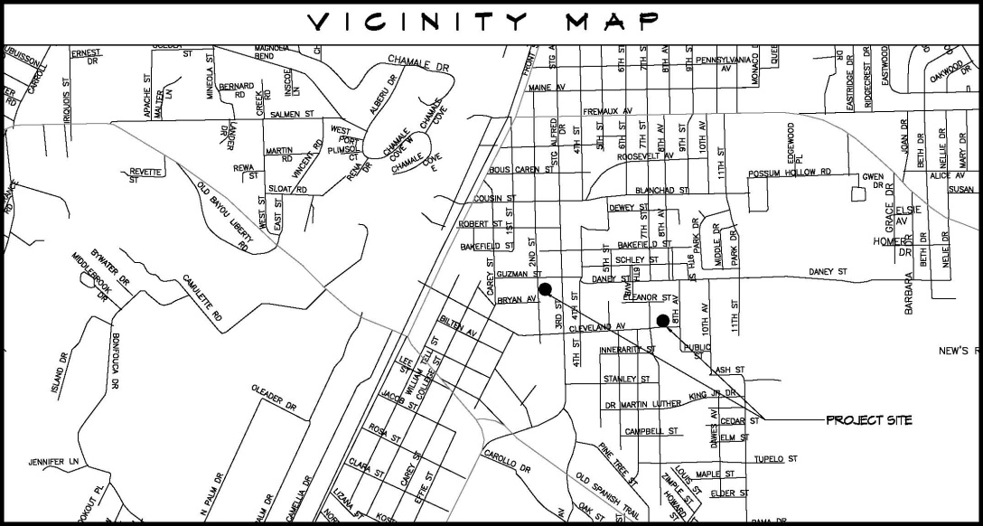



VICINITY MAP
CDBG SIDEWALKS & DRAINAGE ON
CLEVELAND AVE. & 2ND ST.; PHASE I
Project 5000-31A
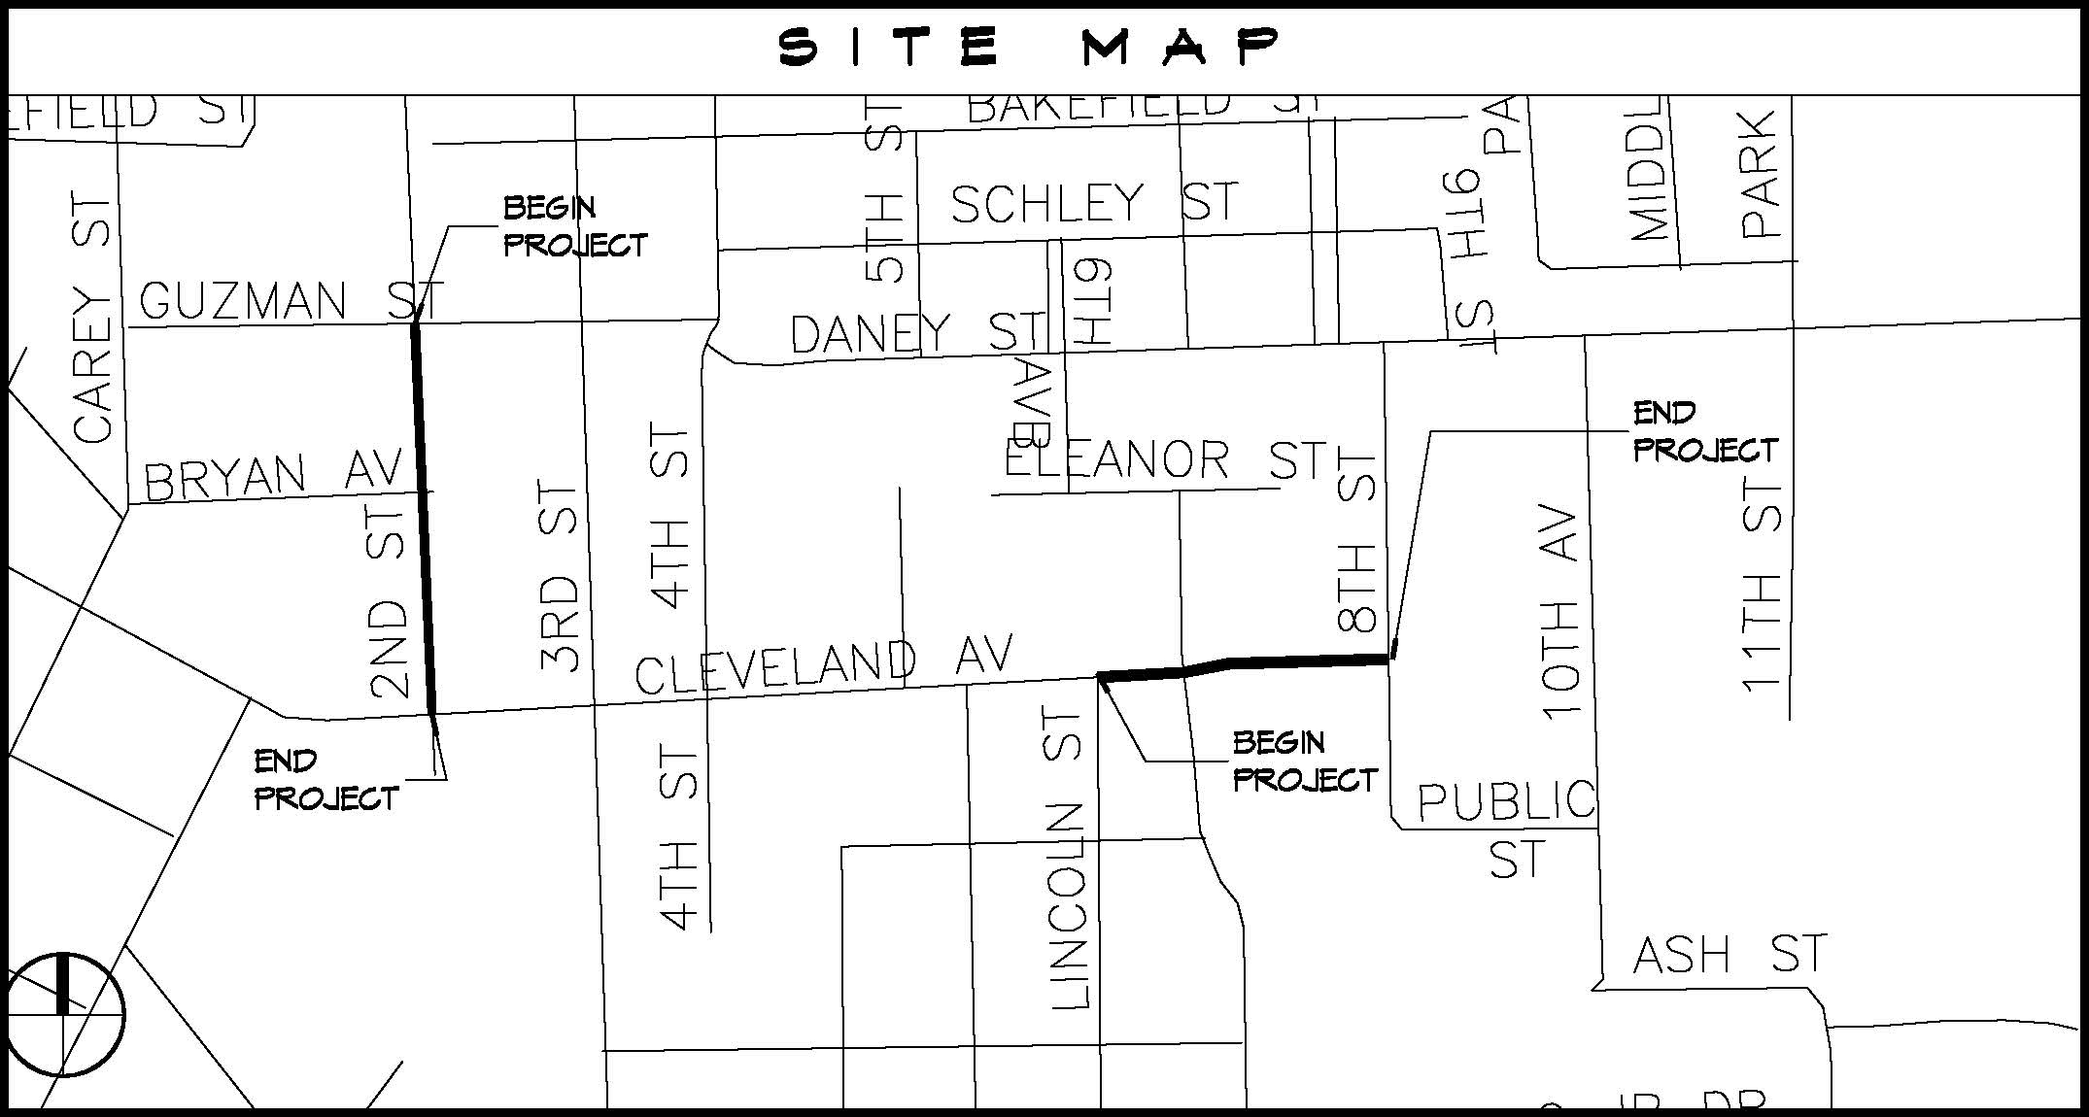

SITE MAP
CDBG SIDEWALKS & DRAINAGE ON
CLEVELAND AVE. & 2ND ST.; PHASE I
Project 5000-31A
