PROJECT SPECIFICATION
for

NEW TRAINING FACILITY
34780 S. RANGE ROAD
SLIDELL, LOUISIANA 70460

OWNER:
St. Tammany Fire Protection District No. 1
522 Robert Blvd
Slidell, Louisiana 70458

Prepared by:

ARCHITECT:
DAMMON ENGINEERING, INC.
554 OLD SPANISH TRAIL
SLIDELL, LOUISIANA 70458
Tel: (985) 649-5832
Email: info@dammonengineering.com
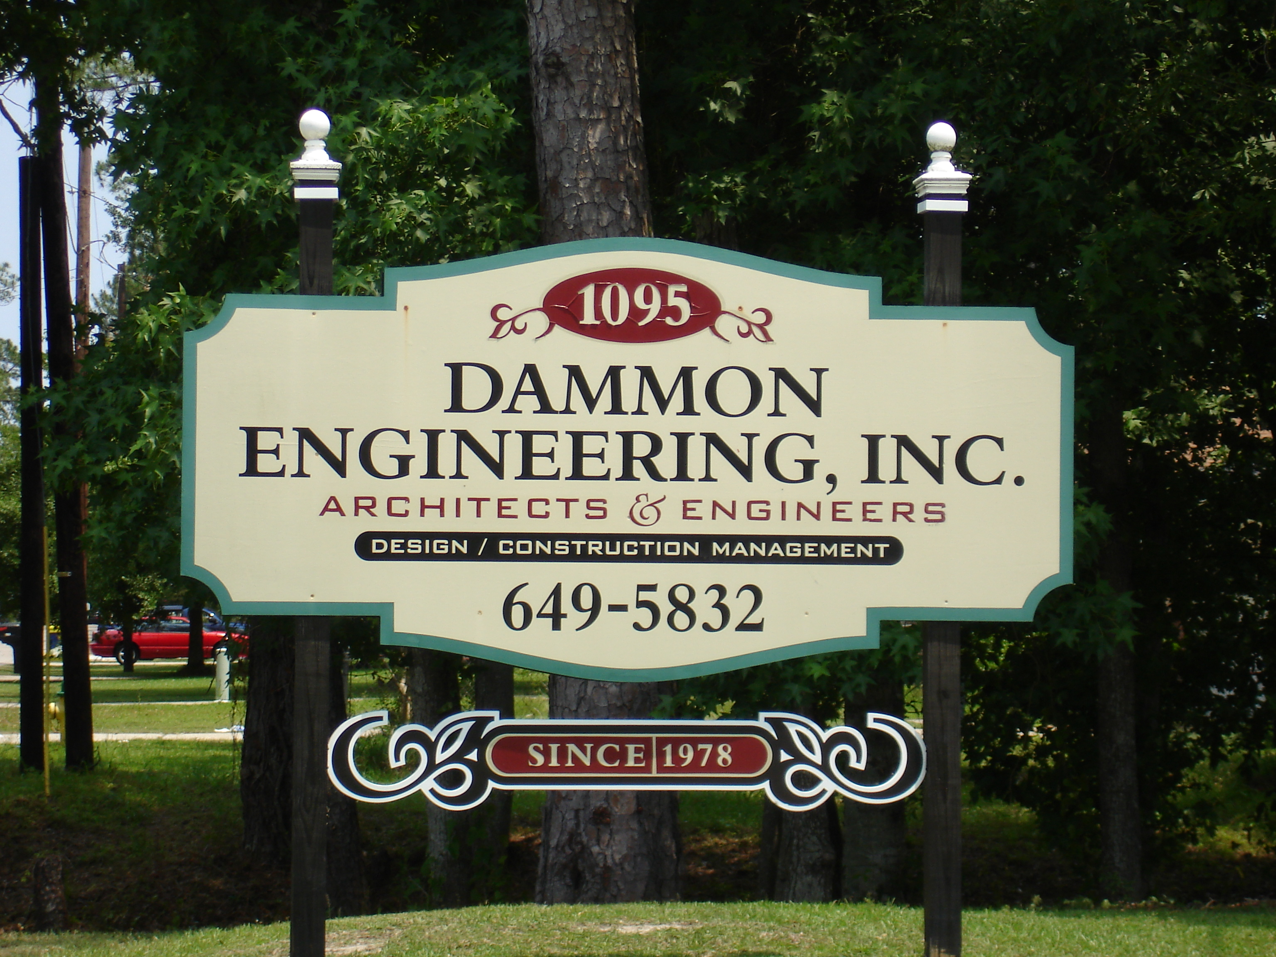

Sep 25, 2023

ARCHITECT’S PROJECT NO. 2480

