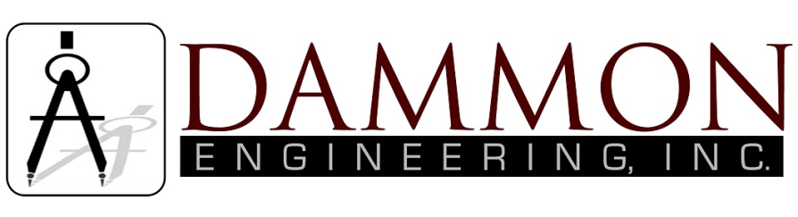
554 Old Spanish Trail
Slidell, LA 70458
Phone: 985-649-5832
Fax: 985-641-5950
dammonengineering.com
info@dammonengineering.com

Structural Inspection

December 15, 2015

For: Jay Casserta
1223 South Cleveland Street
Covington, La 70433

Re: 1223 South Cleveland Street
Covington, La 70433

Construction:
Two-story, wood frame on a raised CMU conventional foundation. The home is approximately 2 years old.

Scope:
This inspection is limited to a visual inspection of the client's areas of concern - mainly the CMU blocks that support the structure.

History:
Mr. Don McMath, with McMath Construction, contacted Dammon Engineering to request a structural inspection of the residence after the homeowner noticed several cracks in the CMU piers supporting the house.

Findings:
It was noted that 6 (six) of the CMU piers have developed cracks near the top of the pier where the structure is supported, see attached diagram and photos. One of the CMU piers, under the fireplace, shows residual evidence of glue at the line of the crack.

There were no visual indications of stresses in the framing of the structure. A review of the construction documents shows that the CMU piers were to be constructed on top of a 2.5’ wide by 2’ deep grade beam with 4 (four) #5 (number five) bars extending up into each CMU pier. A visual inspection of the piers shows that the piers have been filled with structural concrete and that they are supported on top of grade beams.

Conclusion:
Although the appearance of the CMU blocks may not be aesthetically pleasing, the piers appear to be structurally sound. The CMU blocks were used as formwork to hold the structural concrete that was poured to support the structure.

One of the CMU blocks, under the fire place, appears to have been broken before the concrete was poured and glued to hold the form for the concrete during the pour. This glue is visually evident.

It is my opinion that this home is currently structurally sound.

Sincerely,

Brian A Mistich, P.E.

