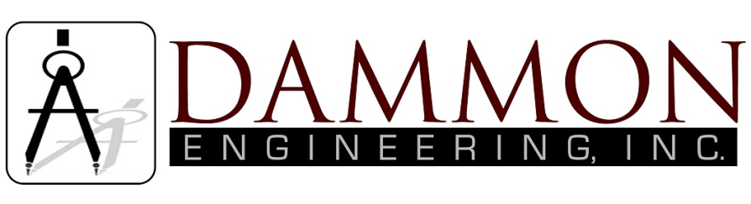
554 Old Spanish Trail
Slidell, LA 70458
Phone: 985-649-5832

dammonengineering.com
info@dammonengineering.com

Structural Inspection

October 5, 2021

Betty Williams
29326 Stein Rd
Sun, La.

Construction:
One-story, wood frame, metal roof on a CMU pier and beam foundation.

Scope:
This inspection is limited to a visual inspection of the interior of the home; No Inspection of the mechanical or electrical systems was performed. This report is as outlined by the National Academy of Building Inspection Engineers and is not an explanation of cause, effect, or engineering.

History:
Dammon Engineering was contacted to request a structural inspection of the home due to a large oak tree that fell on the roof of the home during hurricane Ida on 08-29-2021. The home is new construction.

Findings:
Upon inspection of the home, a large oak tree fell on the home causing severe structural damage to the metal roof, roof rafters, ceiling joist and top plates. All the damaged materials are still in place.

At the time of this inspection, the interior of the home was not gutted in the affected areas of roof damage. There is severe sheetrock and insulation damage in the bedrooms, bathrooms and kitchen from water intrusion.

The tree broke several roof raters, ceiling joist along with the top plates. The 2x4 gable end wall is totally crushed where the tree fell on it along with the fascia and soffit. The bathroom closet has standing water on the wood decking and has saturated the decking affecting the structural strength.

Some of the CMU pier and beam foundation pads are not aligned as originally installed.

Conclusion:
Due to the force of the impact from the tree falling on it, it has created severe damage to the structure.

Recommendation:
- Stabilize and level the CMU piers.
- Replace the saturated wood decking.
- Replace the damaged top plates.
- Replace the knee wall for the gable end.
- Replace the damaged ceiling joist.
- Replace the damaged roof rafters.
- Replace the damaged 1x4 furring strips.
- Replace the damaged fascia and soffit.
- Replace the damaged metal roof.
- Replace the damaged tyvek.
- Replace the insulation.
- Replace the sheetrock.

Sincerely,

Brian Mistich, P.E.

Pictures attached

