
554 Old Spanish Trail
Slidell, LA 70458
Phone: 985-649-5832
www.dammonengineering.com
info@dammonengineering.com

CENTURY 21 Action Realty November 12, 2020
Attn: Heather M. Laughlin
4736 W. Napoleon Avenue
Suite 100
Metairie, LA 70001
(504) 868-8821 (office)
(504) 256-6180 (mobile)

Re: Structural Inspection 6627 W Laverne St New Orleans, LA 70126
Ms. Laughlin,
It was a pleasure to talk with you about the issues at the subject location. Dammon Engineering, Inc. is pleased to propose our Engineering Inspection Services.
We propose a fee of $800.00 to perform a visual structural inspection. This inspection will be limited to a visual inspection of the shell of the building. No inspection of the mechanical or electrical systems will be performed. If certain areas of the building need to be inspected, the owner will have this area exposed for inspection prior to our arrival.
We look forward to working with you on this project. Please indicate your acceptance of the above fee by signing below. If you have any questions, or require any further information, please feel free to call.
If you have any questions, please contact us.
Thank You,

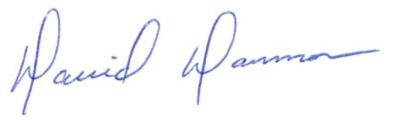
David Dammon __________________________________
President CENTURY 21
Ms. Heather M. Laughlin

