
554 Old Spanish Trail
Slidell, LA 70458
Phone: 985-649-5832

dammonengineering.com
info@dammonengineering.com

Structural Inspection

August 16, 2022

Grand Lagoon Homeowners Association
161 Marina Dr.
Slidell, La 70458

Construction:
A pile supported concrete slab, three-story wood frame, stucco veneer, with a composition shingle roof. Floors are constructed using #2 structural grade floor-joists with a ½” CDX plywood and 1-1/2” lightweight concrete covering the plywood. This lightweight concrete is considered to be a wear surface and not structural. Some original plans were provided that state the materials used during construction.

Scope:
This inspection is limited to a visual inspection of the condominiums. A visual inspection of all open ceilings that expose floor/ceiling rafters was performed. No inspection of the mechanical or electrical systems was performed. This report is as outlined by the National Academy of Building Inspection Engineers and is not an explanation of cause, effect, or engineering.

History:
Dammon Engineering was contacted to provide a structural inspection of the referenced three-story condominiums with porches and balconies to verify structural soundness.

Findings:
- The concrete floor in Unit 1155 has multiple cracks across the living room. No apparent damage or deflections were seen in the support of the concrete. See photos below:

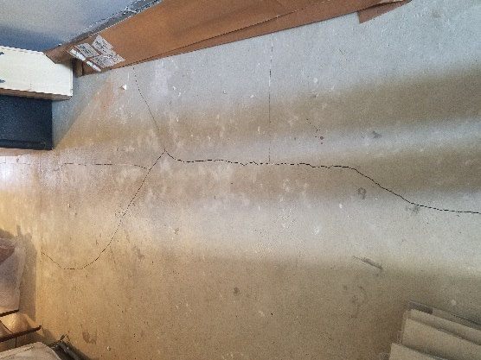
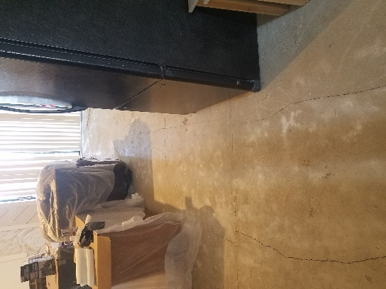
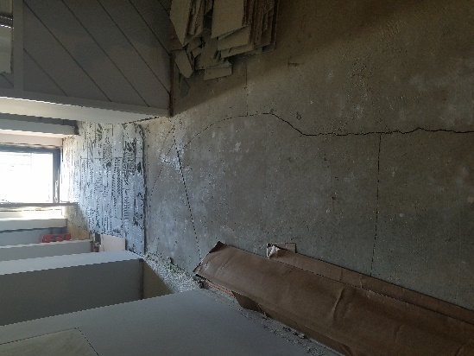

- The ceiling of Unit 1159 has been experiencing water damage and three of these locations were open for inspection along the exterior wall facing the NorthWest direction. This unit’s ceiling-joist(s) also provide support to the porch of Unit 1165 above. Water appears to have infiltrated the cavity between the porch and the ceiling gypsum via cracks in the concrete on the balcony of all three locations that were available for inspection. This infiltration appears to have been over a long period of time which has caused the plywood to deteriorate and left a discoloration in the concrete along the crack. In one location of Unit 1159 it also appears to have deteriorated the ceiling-joist. Another issue is that it appears that one of the structural columns on the porch of Unit 1165 was previously repaired, incorrectly. The column should be attached directly on top of the 2x12 Rim Joist that is supported by the wall below. Yet it appears that the column was cut and a 6” long piece of 2x4 was slipped between the new cut column and the concrete slab. See photos below:

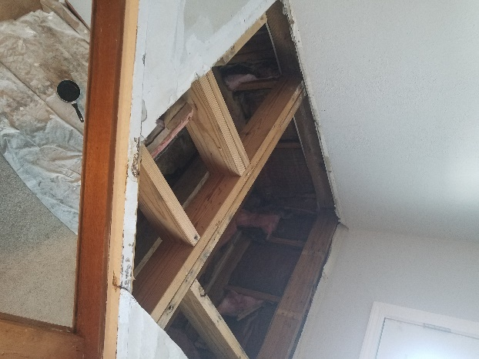
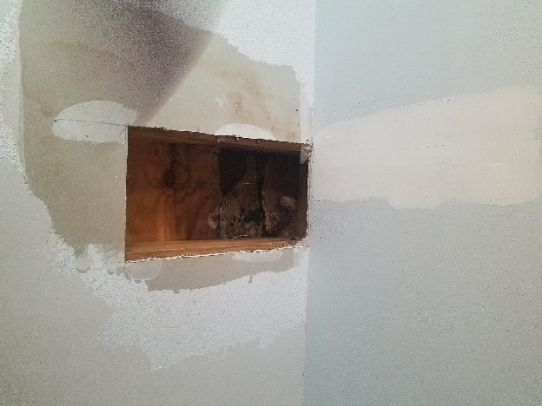
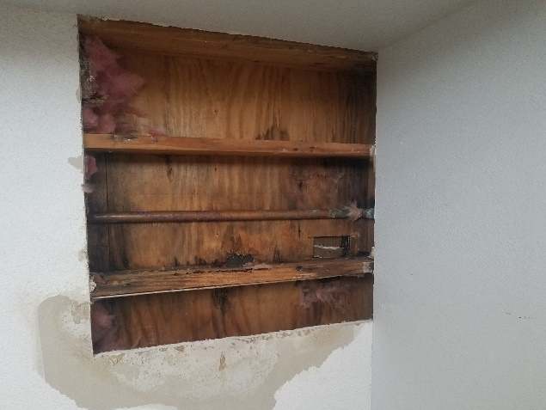

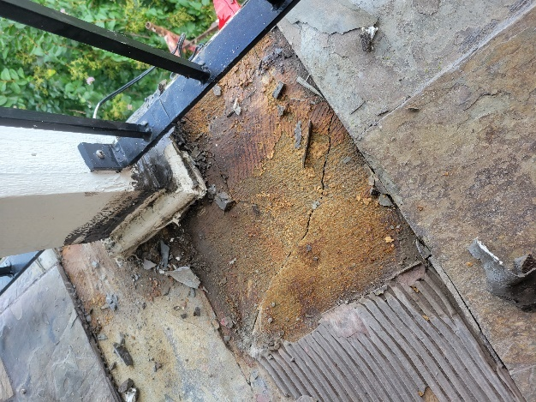
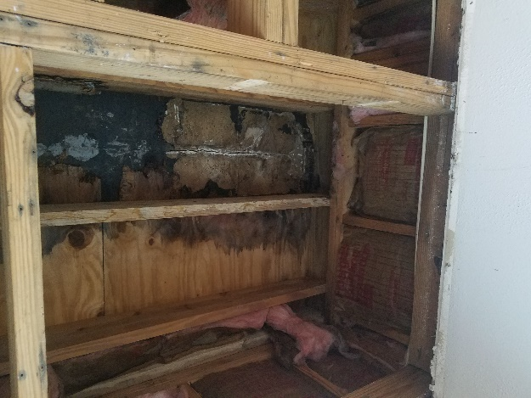

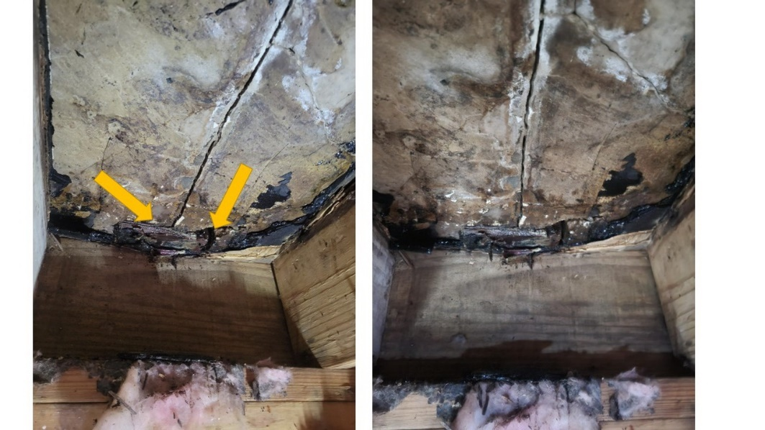

- The porch floor of Unit 1151 appears to be caving in near the building’s Southern corner. This flooring support, plywood and floor-joist, also support the ceiling of the porch below. An inspection of Unit 1141 porch ceiling shows that the ceiling joist appear to be giving way from the pressure above. (This must be corrected)

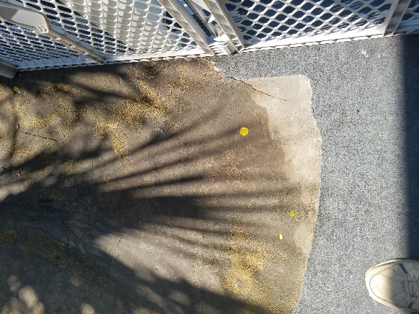
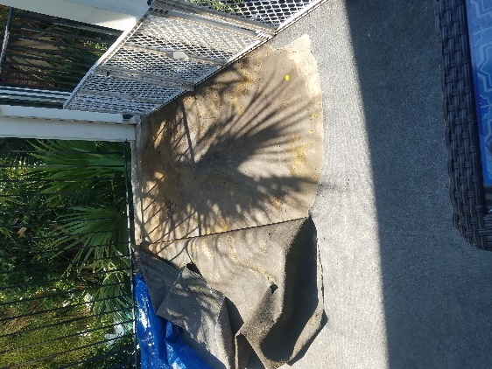

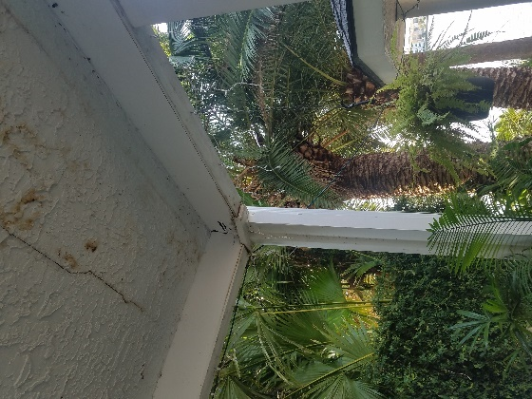
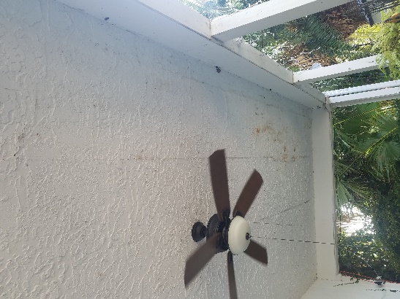

Conclusion:

This is a wood frame constructed building and it is taller than any other structures around it. This building abuts a lagoon at the rear which allows winds to hit the structure with full force without any obstacles to reduce the wind force pressure. During these high wind events this structure will bend and twist under the pressure from the force of the wind. During these events it can cause the concrete to crack. Concrete is excellent in compression but offers very little when subjected to a tension force. This building’s concrete was poured without any steel to take the tension force.

The drawings provided show that the porches were designed to have a slope of 0.7%. The drawings provided also shows a detail that all porches were designed to have a 26-gauge galvanized metal pan between the plywood and concrete. In the areas that were exposed to the underside of a porch, this metal pan was not installed; rather, a tar paper was installed instead. The metal pan and tar paper both provide an excellent vapor (moisture) barrier. Over time the cracks in the concrete have also torn the tar paper which allows the water to get to the plywood decking. Concrete although very impervious, is not totally impervious. Measurements of the 3rd floor side porches were taken and Unit 1161 side porch over Unit 1151 has a slope of 1.5% while the porch of Unit 1165 over Unit 1159 has a slope of 1.1%. These slopes were created when the lightweight concrete was poured. These slopes provide a sufficient slope for rainwater to properly shed from the porches without ponding; however, during a major rain event or a driving rain, the water will find any way to infiltrate through porous material or cracks in the concrete.

When the column on the porch of Unit 1165 was repaired with a 6” length of 2x4 placed between the column and the concrete, it applied pressure to the concrete causing the concrete to crack.

Recommendation:

Items to be addressed are as follows:

- Unit 1155 floor cracks should be floated to obtain a smooth surface to install new flooring.

- Unit 1159 ceiling /Unit 1165 porch floor needs to be repaired. Where the supporting plywood has deteriorated it must be cut out and replaced. See detail below for repairing damaged plywood.
- Unit 1165 porch has a column that was improperly repaired. The support for this column was inappropriately distributed to concrete around it, causing the concrete to crack. This column should be replaced with a 6”x6” post to match the type of wood originally installed. The base should receive its support of the perimeter Rim Joist above the exterior wall below. Additional full height blocking should also be installed. See detail and section below. (Note that the Building Cross Section provided shows these columns as 6x6 Post; however, the HOA have stated that the original posts were 4x6 cedar and somewhere around 30 +/- years ago some were replaced with 3-1/2 x 5-1/2.)

- Unit 1141 porch ceiling/Unit 1151 porch floor must be exposed to determine the extent of the structural damage. Replace damaged structure with like materials.

- Side porches on the 3rd floor in general are leaking to the unit below. The lightweight concrete, wear surface, appears to have cracked over time. These cracks have torn the tar paper, vapor barrier, allowing water to infiltrate to the plywood and over time as water sits on this plywood it will cause the plywood to deteriorate. Since it is not feasible to easily replace this vapor barrier on these porches, it is recommended that the top surface be treated with something that is UV resistant and exceptionally good at providing a vapor barrier. Also, it is recommended that these porches be maintained with this vapor barrier per the manufacturer's recommendations.

Sincerely,

Brian Mistich, P.E.

