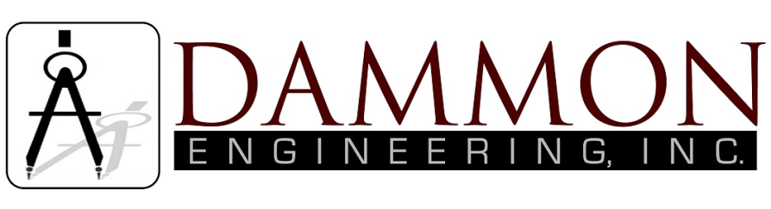
554 Old Spanish Trail
Slidell, LA 70458
Phone: 985-649-5832
dammonengineering.com
info@dammonengineering.com

May 26, 2016

Jefferson Parish
Inspections and Code Enforcement
400 Maple Ave.
Harvey, LA 70058

RE: Permit Application #16-350045
Blueline Rentals Wash Rack

Sir/Madam,

I have researched the building and related codes of Jefferson Parish and the Louisiana State Uniform Construction Code and to the best of my knowledge and belief the drawings for subject project are in compliance therewith.

Brian Mistich

