July 19, 2016
Dr. Jimmy Guidry,
State Health Officer

RE: Request for Variance to use an Underwater Seat Bench in the Swimming Pool
Project Name: Bayou Haven Pool
Mr. Guidry,
Please grant a variance of an underwater seat bench in the swimming pool as detailed in LAC 51 XXIV Swimming Pools paragraph 317 D. The underwater bench meets the guidelines from “Underwater Seat Bench Variance Criteria” listed as part of the LAC 51 XXIV Swimming Pools, specifically the following:
- Underwater seat bench on this pool is within less than 5’-0” water depth.
- There are no swim lanes within this pool
- The water depth above the underwater seat bench is 18 inches.
- The seat depth of the underwater seat bench from face of pool wall to the vertical face of the bench is 17 inches.
- A permanent colored band of dark, contrasting and slip resistant material shall be installed at the front edge of the seat edge, extending two inches on the horizontal and vertical surfaces.
- The front edge of the underwater seat bench shall have a 1 inch rounded edge.
- The underwater seat bench is in conjunction with the pool steps. The handrail shall be installed in accordance with LAC Title 51 Part XXIV.

We are attempting to create a safe and healthy environment for all in this hotel and to conform to the Louisiana State Code as close as possible.
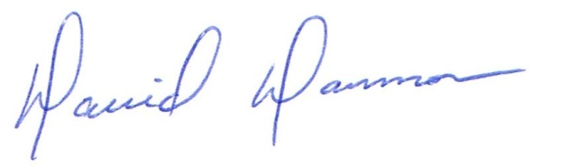
David Dammon
President
Dammon Engineering, Inc.
(985) 649-5832

