
554 Old Spanish Trail
Slidell, LA 70458
Phone: 985-649-5832
www.dammonengineering.com
info@dammonengineering.com

June 22, 2022

David Merlin, AIA
Made Design LLC
1100 Saint Andrew Street
New Orleans, LA 70130
dmerlin@made.design

Re: Copeland’s Canopy, Covington

Mr. Merlin,
Thank you for considering Dammon Engineering. We are pleased to propose our services for the subject project in Covington La.
Our understanding is that a new structural concrete slab with a wooden framed canopy will be constructed.
Our proposed scope of services will include the structural concrete slab & framing to support a single slope canopy.
We propose a fee of $5,000 for designing the slab and framing. If selected, we will bill 100% of the total after the plans have been provided to your office.
Our fee above do not include cost of designing sprinkler or fire alarm systems, soils analysis, survey, drainage studies, wetlands determination, or other engineering studies that may be required by government agencies nor does it include the cost of plan review or permits by the municipality. These items, if provided by Dammon Engineering, will be billed at a "cost plus" fee or if we provide a design our current engineering rate is $135 per hour.
We look forward to working with you on this project. Please indicate your acceptance of the above fee by signing below. If you have any questions, or require any further information, please feel free to call.
Sincerely,

If you have any questions, please contact me.

Thank You,

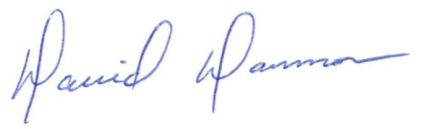
David Dammon __________________________________
President David Merlin

