
554 Old Spanish Trail
Slidell, LA 70458
Phone: 985-649-5832
Fax: 985-641-5950
dammonengineering.com
info@dammonengineering.com

March 8, 2019

Don McMath
McMath Construction
1125 N Causeway Blvd,
Mandeville, LA 70471

RE: Plumbing System(s) for the New Classroom Building @ Christ Episcopal School in Mandeville

Thank You for considering Dammon Engineering to design the plumbing system(s) for subject project.

We propose a fee of $3,955.00 for the design of the plumbing system(s) for the subject project.

We look forward to working with you on this project. Please indicated your acceptance of the above by signing below. If you have any questions, or require any further information please feel free to contact us.

Thank You,

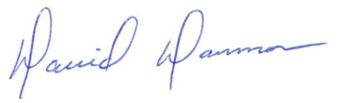
David Dammon
President
Dammon Engineering, Inc.
(985) 649-5832

Accepted: ___________________________ Date: ___________________
Don McMath

