
554 Old Spanish Trail
Slidell, LA 70458
Phone: 985-649-5832
Fax: 985-641-5950
dammonengineering.com
info@dammonengineering.com

March 20, 2019

Don McMath
McMath Construction
1125 N Causeway Blvd,
Mandeville, LA 70471

RE: Structural Framing for the New Classroom Building @ Christ Episcopal School in Mandeville

Thank You for considering Dammon Engineering to design the structural framing for subject project.

We propose a fee of $6,615.00 for the design of the structural framing for the subject project. 75% will be billed when construction documents are submitted for review; the remaining 25% will be billed when the review(s) have been completed and the permit has been issued.

We look forward to working with you on this project. Please indicated your acceptance of the above by signing below. If you have any questions, or require any further information please feel free to contact us.

Thank You,

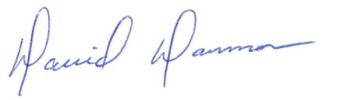
David Dammon
President
Dammon Engineering, Inc.
(985) 649-5832

Accepted: ___________________________ Date: ___________________
Don McMath

